Caesar Rodney School District
Board of Education School Board Meeting

The Caesar Rodney School District will host its December 13, 2022 School Board
Regular Meeting at 7:00 p.m. (Exec. Session 4:30 p.m.) at the W. B. Simpson Elem. School. Guests can also join the meeting electronically using Zoom.

Please click the link below to join the webinar: https://cr-k12-de-us.zoom.us/j/86381797111

Passcode: CRSDWS
Or One tap mobile :

US: +16465588656,,83134998343# or +13017158592,,83134998343#

Or Telephone:

Dial(for higher quality, dial a number based on your current location):

US: +1 646 558 8656 or +1 301 715 8592 or +1 312 626 6799 or +1 669 900 9128 or +1 253 215 8782 or +1 346 248 7799

Webinar ID: 831 3499 8343

Any attendee wishing to sign up for public comment via Zoom should email CRSDPublicComment@cr.k12.de.us or call 302-698-4830 prior to 3pm the day of the meeting. They can also sign in, at the meeting, in person before 7pm.

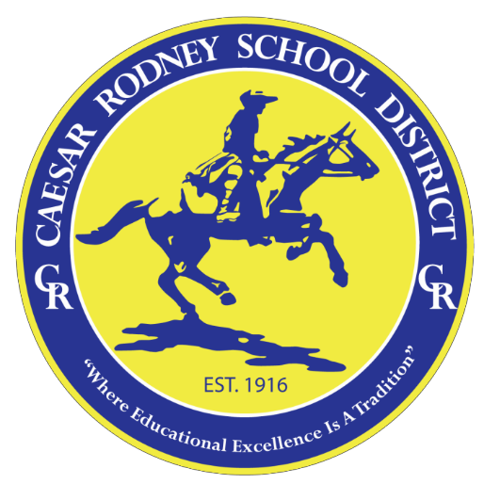
The Caesar Rodney School District is an Equal Opportunity Employer and does not discriminate in employment or educational programs, services or activities based on race, color, religion, national origin, veteran or marital status, age, disability, sexual orientation or genetic information in accordance with state and federal laws. Inquiries about compliance should be made to the Title IX, District 504 and ADA Compliance Officers:
Paul L. Dunbar Administration Building, 7 Front Street, Wyoming, DE 19934. Phone: (302) 698-4800.

