The Five Foods Groups Plus Oils – Foods are grouped into food groups because their nutrient content is similar. How can you be sure that you are getting all the nutrients your body needs?

Grains Group
- The Grains Group includes cereal, rice, pasta, breads, and grits.
- Key Nutrients: Carbohydrates, Fiber; B Vitamins, especially thiamin, niacin, folate; minerals, including iron
- Daily Amount: 6 ounce equivalents, at least half should be whole grains
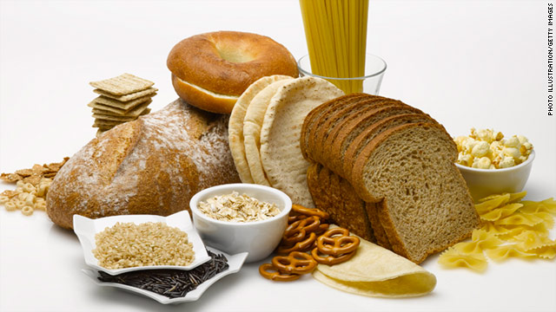
- 1 Ounce is: 1 slice of bread; 1 cup (250mL) ready to eat cereal; ½ cup (125 mL) cooked cereal, rice, pasta, or grits; 1 small muffin; 1 small tortilla

Vegetable Group
- The Vegetable Group includes broccoli, carrots, spinach, lettuce, asparagus, and beans
- Key Nutrients: carbohydrates; vitamins, especially vitamins A and C and folate; minerals, including potassium; fiber
- Daily Amount – 2 ½ cups
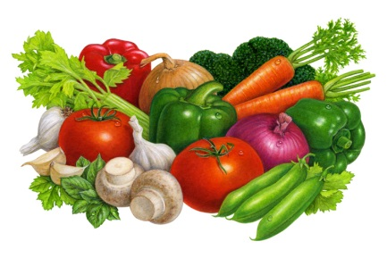
- 1 cup is: 2 cups (500mL) raw leafy vegetables; 1 cup (250mL) cooked or chopped raw vegetables; 1 cup (250mL) vegetables juice

Fruit Group
- The Fruit Group includes apples, oranges, tomatoes, avocados, blueberries, plums, and grapes.
- Key Nutrients: Carbohydrates; vitamins, especially vitamins A and C and folate; minerals, especially potassium; fiber.
- Daily Amount – 2 cups
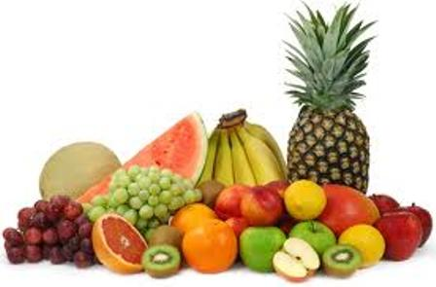
- 1 cup is: 1 cup (250 mL) cut up cooked or raw fruit; 1 cup (250mL) fruit juice; I large banana or orange, 1 small apple; ½ cup (125 mL) dried fruit.

Milk Group
- The Milk Group includes milk, yogurt, cheese, and some other dairy products.
- Key Nutrients: Protein, calcium, some other minerals, Vitamin B2 (riboflavin), Vitamin D
- Daily Amount: 3 Cups
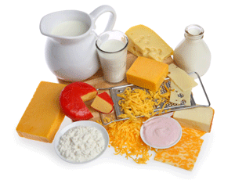
- 1 cup is: 1 cup (250 mL) milk or yogurt; 1 ½ ounces (42 g) natural cheese; 2 ounces (56 g) processed cheese

Meat and Beans Group
- The Meat and Beans Group includes all meats, poultry, fish, legumes, eggs, nuts, and seeds.
- Key Nutrients: protein, B vitamins (thiamin and niacin), iron, zinc
- Daily amount: 5 ½ ounces equivalents
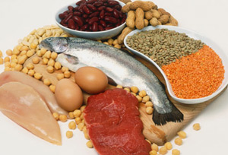
- 1 ounce is: 1 ounce (28 g) cooked lean meat, poultry, or fish, ¼ cup (60 mL) cooked dry beans (legumes); 1 egg; 1 table spoons (15mL) peanut butter; ½ ounce (14 g) nuts or seeds

Oils
- Healthful oils are not considered a food group. Some foods from the five food groups contain healthful oils. Healthful oils also include fish, vegetable, and olive oils; they are liquid at room temperature.
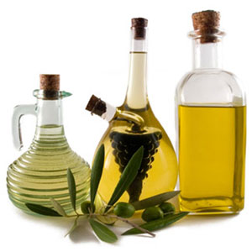
- Key Nutrients: Fats (unsaturated), Vitamin E
- Daily Amount: 6 tablespoons (from fish, nuts, and some vegetable oils)

