
Family and Consumer Sciences
FACS
8th Grade Eden Jr. / Sr. High School
Mrs. Stoneberg

COURSE DESCRIPTION AND CONTENT
The following are the basic units studied:
1. Career Exploration and Planning
2. Sewing Skills
3. Kitchen Skills
4. Kitchen safety and sanitation
5. Nutrition: Making Healthful Choices

SUPPLIES
A durable 2 pocket folder/ writing utensil
Sewing Supplies on last page

GRADING POLICY - grades are based on a combination of the following:
1. Classwork
2. Projects
2. Unit tests
3. Sewing project / Cooking Labs
4. Homework assignments
5. Behavior and participation

MAKE-UP POLICY
When absent, every effort should be made to find out what was done in class and what is due for the next class. If absent on the day of a test or quiz, the test/quiz will be given the next day the student is in school. It is the student’s responsibility to arrange a time for the make-up.

LATE ASSIGNMENTS
Assignments will be accepted up to 7 school days after the due date but will receive a 5 point deduction each day it is late.
Teacher Availability
1. During the school day where schedule permits
2. After school with prior arrangement
3. By email at any time during the school day at:
sstoneberg@edencsd.org

Academic and Behavioral Expectations

1. Be on time for class
2. Have folder and pen EVERYDAY
3. Have work neatly done and ready to be handed in
4. Demonstrate that sewing projects and cooking labs are taken seriously
5. Follow classroom rules
6. Have and use agenda for keeping track of all assignments
7. Have a pass when entering late or requesting to leave
8. NO CHEATING! Parents will be notified and a zero given for the work.

FACS 8
I have read, understand, and agree to the above expectations as well as getting my sewing supplies in on time.

Student name printed_____________________________________

Student Signature_____________________________________

Parent Signature _____________________________________

Parent Email & Phone #_____________________________________

Dear Parents or Guardian,
This semester we will be learning how to sew on a sewing machine. Students will be making pillow cases. Students will be able to keep the pillow case for themselves.
Supplies will be DUE in class Monday September 18th
Supplies needed:
Fabric must be COTTON!!!!! Please DO NOT purchase KNIT, as it is very difficult to work with. It should be a smooth cotton fabric.
3 DIFFERENT PATTERNS OF STUDENT’S CHOICE IN THE FOLLOWING MEASUREMENTS:
All fabric measurements listed are measured from coming off a standard Bolt.
- Main Piece 27” X width of fabric
- Border Piece 9” X width of fabric
- Accent Strip 3” X width of fabric
- 1 Spool of METTLER or Gueterman thread. (Pick a color that matches your 3 in piece of fabric)
- $2.00 for additional supplies
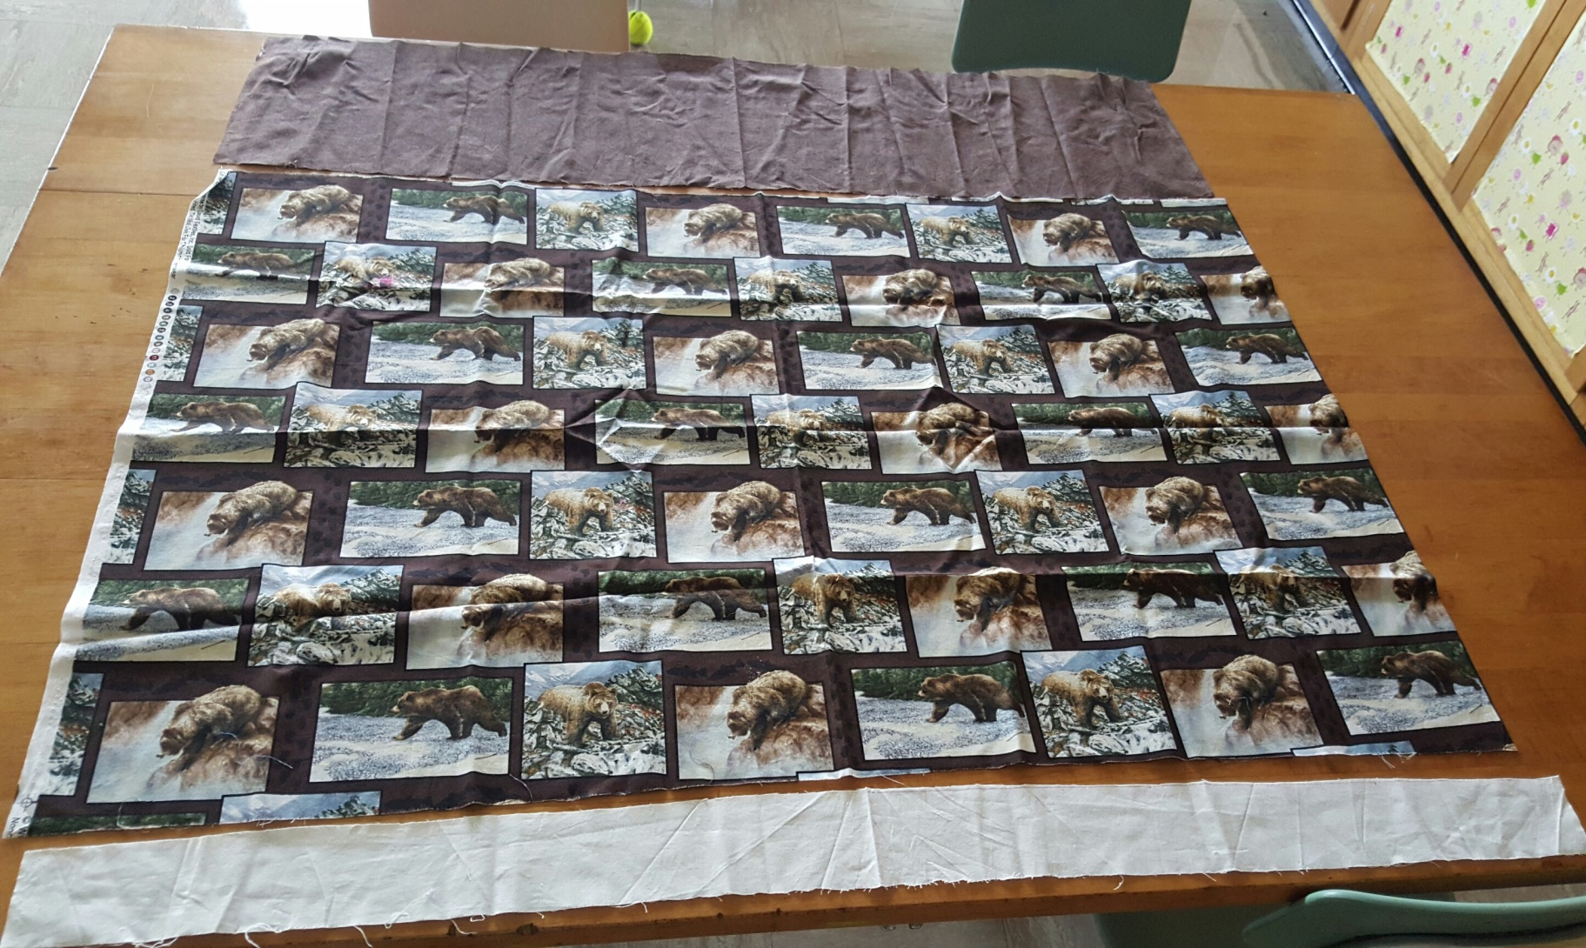
Border Piece 9”
Main Piece 27”
Accent Strip 3”

