Viewing and Changing Employee Information Through The
Employee Portal

Employees can view and update certain information in the employee portal. Payroll direct deposit information can viewed. Information that can be updated by employees include:
• Personal information
• Emergency contact information
• W-2 information

The only browsers that are compatible with the employee portal are Internet Explorer (versions 7, 8, 9, 10 and 11) and Safari (versions 4, 5, 6 and 7). Other browsers such as Chrome and Firefox are not compatible and may deliver erroneous results.

1. Click icon on your desktop or taskbar to open Internet Explorer or open Internet Explorer from your Start menu. On a Mac, open Safari.

2. Type: http://ep-bartlett.esd-cloud.com in the address bar and click enter.

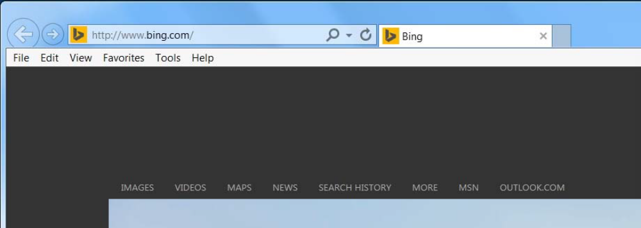

The Bartlett City Schools website also has a link to the Employee Portal when clicking on the Staff
Tab.

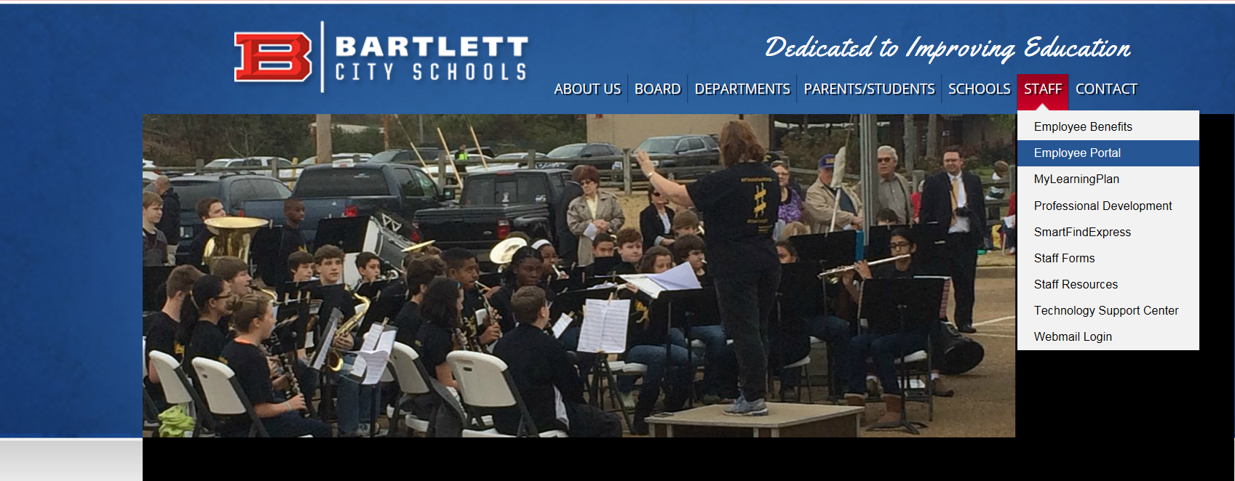

3. This will take you to the employee portal logon screen.

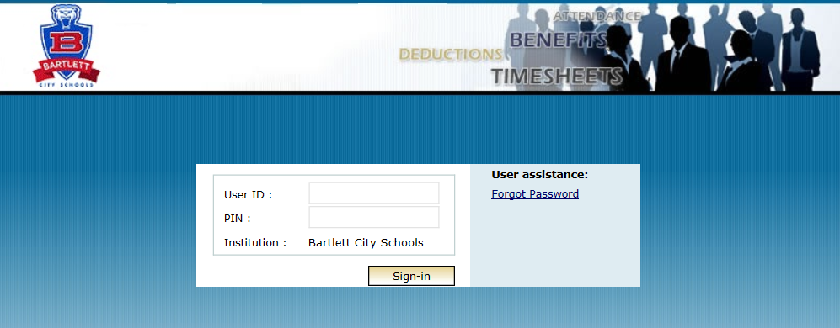

4. Enter your User ID and PIN, then click Sign-In. Your User ID is your employee ID number and your PIN has been pre-set to the last 4 digits of your social security number. Click the Sign-in button.

5. If you have not previously signed on the portal and agreed to the terms of use for the portal, you will see the portal terms agreement screen. Agree to the terms by clicking the I Accept button.

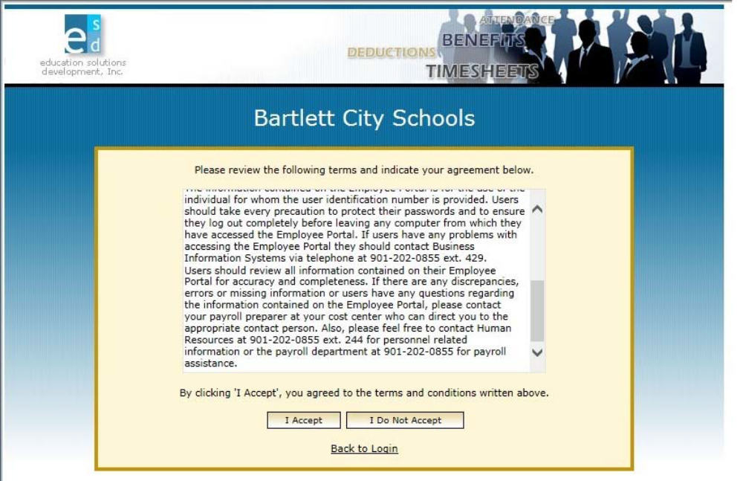

6. Select Payroll from the menu to view Paycheck History, view Direct Deposit information and print a W-2 form. Click on any item from the Payroll menu you wish to access.

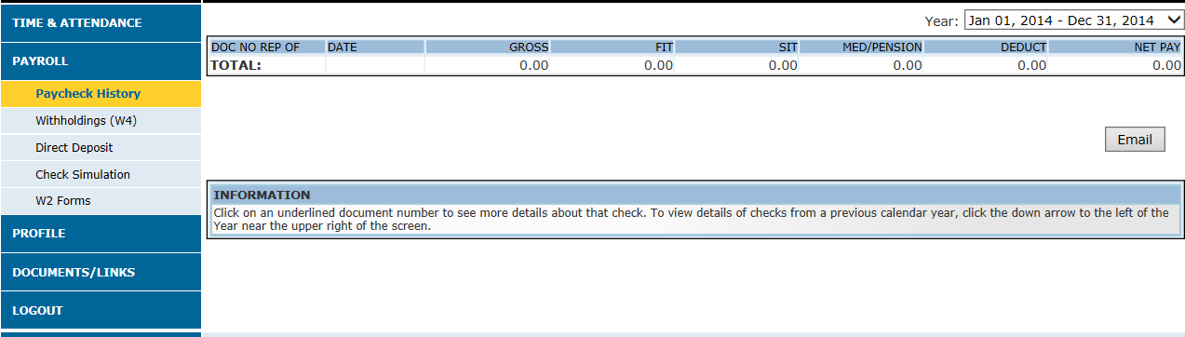

7. Click on Paycheck History to view each payment received.

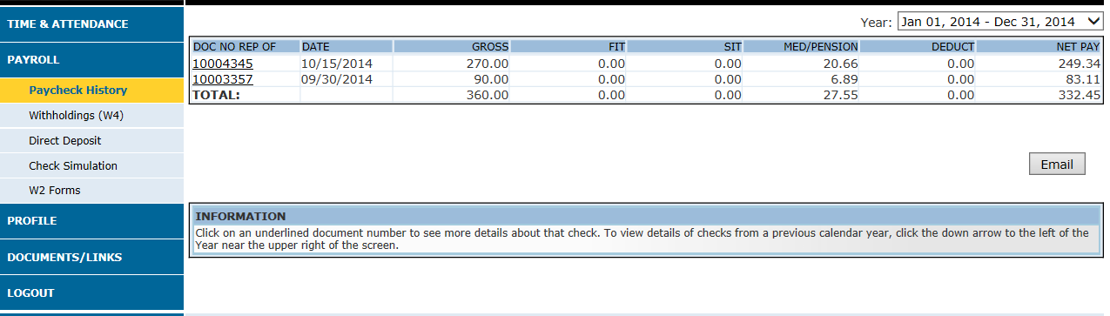

If the line under the Document number is clicked on, an employee can view a particular Direct Deposit stub. To print a copy of a Direct Deposit stub with the municipal logo, click on Print Check Image.

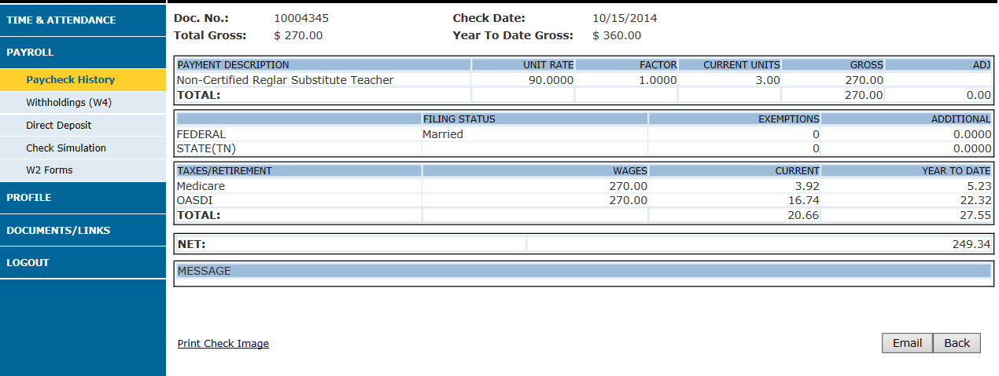

8. To enter or change your W4 withholding information, select Withholdings (W4). Complete the information in each block as needed. Click the Save button when done. If Check Simulation is chosen, an employee can view the net effects of the withholding change.

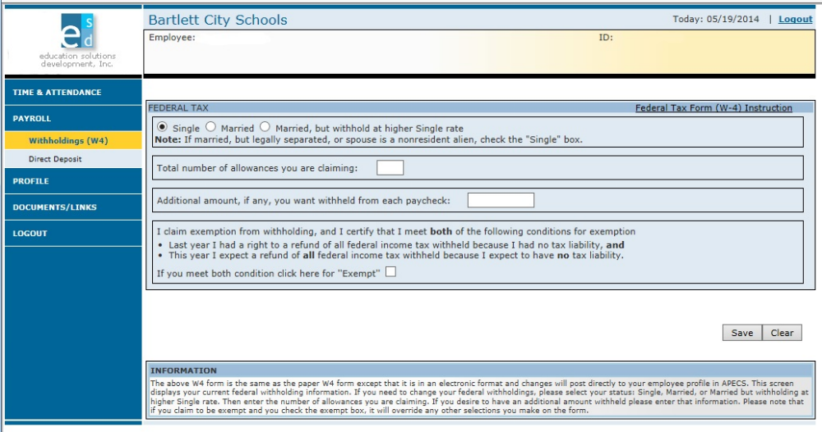

9. To change your personal information (address, city, state, zip code, telephone numbers and email addresses) via the employee portal, select Profile from the menu. The default screen will be the Addr/Phone/Email screen. Enter or change the information as necessary. When finished, click the Save button.

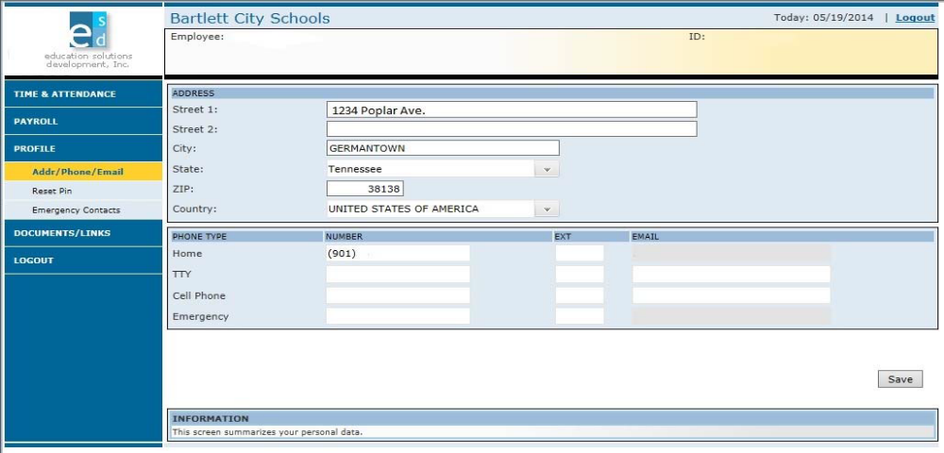

10. To add, change or delete emergency contact information via the portal, select Profile from the menu. Select Emergency Contacts. Enter new information or change existing information as needed. To change existing information, simply type over the existing information. When finished, click the Save button. To delete information, click the box to the left of the information to be deleted and click the Delete button. Be sure to click the Save button after all editing has been completed.

