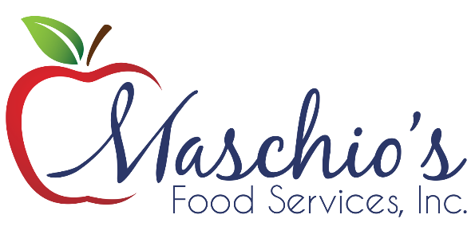
Maschio’s Food Services is Introducing a 
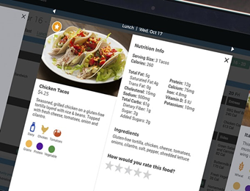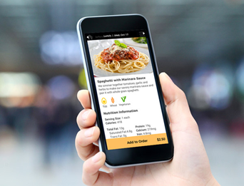
New Digital Menu Format!
Maschio’s has moved to a “paperless” digital menu format. We have a responsibility to our districts of being ADA compliant with our menus along with accommodating requests of being paperless.
The Nutrislice software produces menus which are ADA compliant and which meet the standards of the Web Content Accessibility Guidelines (WCAG) while conveying enough information about the food so customers can make healthy choices. This innovative and interactive site and mobile app make our menus more convenient and informative than ever before! Our menus are fully accessible on the food service link of your district website and are also available for print if needed.

yourschool.nutrislice.com/


