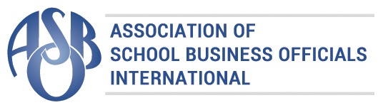
The Certificate of Excellence in Financial Reporting
is presented to

Southfield Public Schools

for its Comprehensive Annual Financial Report (CAFR)
for the Fiscal Year Ended June 30, 2016.
The CAFR has been reviewed and met or exceeded
ASBO International’s Certificate of Excellence standards.
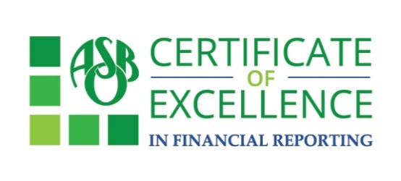

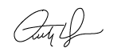
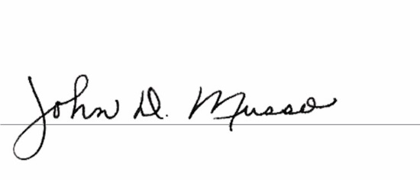
Anthony N. Dragona, Ed.D., RSBA John D. Musso, CAE, RSBA
President Executive Director

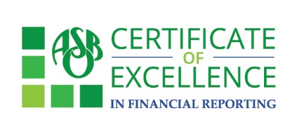

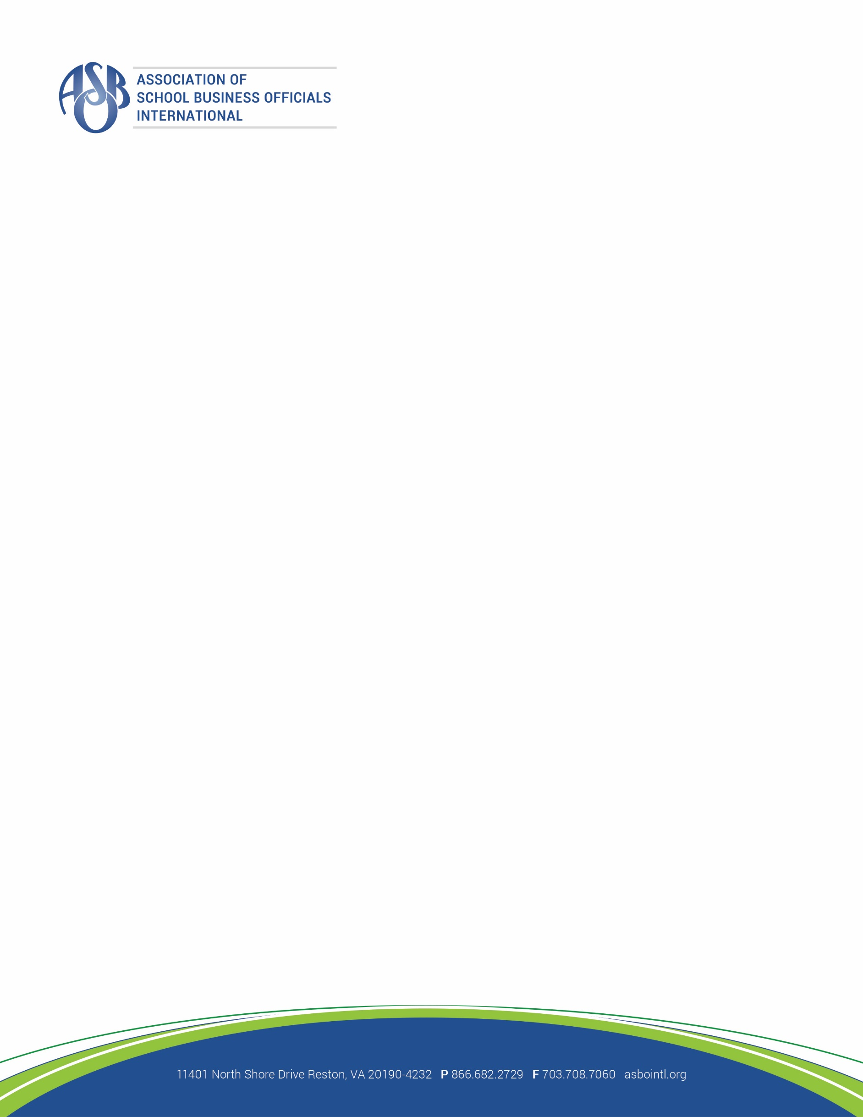

March 17, 2017

Kathryn Dankovich
Assoc. Supt. of Administrative Services
Southfield Public Schools
24661 Lahser Road
Southfield, MI 48033

Dear Ms. Dankovich:

Congratulations! On behalf of the Association of School Business Officials (ASBO) International, I am pleased to inform you that Southfield Public Schools has received ASBO’s Certificate of Excellence in Financial Reporting for the fiscal year ending 2016. This award represents a significant achievement and reflects your commitment to fiscal integrity and high-quality financial reporting.

The Certificate of Excellence (COE) Review Team has provided their comments for improvement regarding your Comprehensive Annual Financial Report (CAFR). It is important to keep the comments and address them when you prepare next year’s CAFR. Your district must include a copy of the original comments and the district’s written responses to the comments in next year’s application packet.

We hope you will use the attached press release to share this important achievement with your community.
Your award certificate is also attached.

Congratulations to you and the members of your staff who worked so hard to earn the COE this year. We look forward to your continued participation in the COE program.

Sincerely,
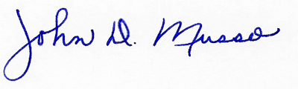
John D. Musso
Executive Director, CAE, RSBA

FOR IMMEDIATE RELEASE
For additional information, contact
Susan Lambert, ASBO International
slambert@asbointl.org, 866.682.2729 x7067

SCHOOL DISTRICT WINS THE
CERTIFICATE OF EXCELLENCE AWARD
Southfield Public Schools
Southfield, MI

RESTON, VA – 2017

The Association of School Business Officials (ASBO) International has awarded Southfield Public Schools its Certificate of Excellence in Financial Reporting for having met or exceeded the program’s high standards for financial reporting and accountability.

The district was recognized for its Comprehensive Annual Financial Report for the fiscal year ending 2016.

Sponsored by VALIC, the Certificate of Excellence (COE) award confirms the school business office’s commitment to financial accountability and transparency. Recognition through the COE program can help strengthen a district’s presentation for bond issuance statements and promotes high quality financial reporting.

For more than half a century, VALIC, a division of AIG, has served as a leading retirement plan provider for
K-12 schools and school districts, as well as for higher education, healthcare, government and other
not-for-profit institutions. As of December 31, 2015, VALIC has more than $83 billion in total assets
under management and manages plans for nearly 24,000 groups serving more than 2 million
participants. VALIC represents The Variable Annuity Life Insurance Company and its subsidiaries,
VALIC Financial Advisors, Inc. and VALIC Retirement Services Company.

American International Group, Inc. (AIG) is a leading global insurance organization serving customers
in more than 100 countries and jurisdictions. AIG companies serve commercial, institutional, and
individual customers through one of the most extensive worldwide property-casualty networks of any
insurer. In addition, AIG companies are leading providers of life insurance and retirement services in
the United States. AIG common stock is listed on the New York Stock Exchange and the Tokyo Stock
Exchange.

ASBO International, founded in 1910, is a professional organization of 5,000 members that provides programs and services to promote the highest standards of school business management practices, professional growth, and the effective use of education resources.
For more information about the COE award, visit asbointl.org/COE.

###

