How to Create a Parent Canvas Account

Parents can create a Canvas observer account using Lower Dauphin’s Canvas URL (https://ldsd.instructure.com)

To observe the student’s account, you must know the student’s pairing code which can be found in the student’s account settings.

These steps must be completed through the web version of Canvas. The signup process cannot be done through the mobile app.

To Find Your Student’s Pairing Code:
- Go to Lower Dauphin’s Canvas URL (https://ldsd.instructure.com)
- Have your student log onto his/her account.
- The username/password is the same as the username/password they use to log onto their district issued laptop

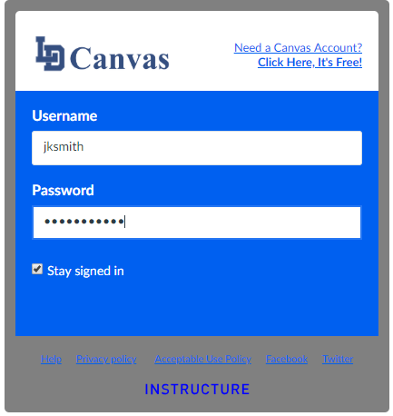
- Click on Account
- Click on Settings

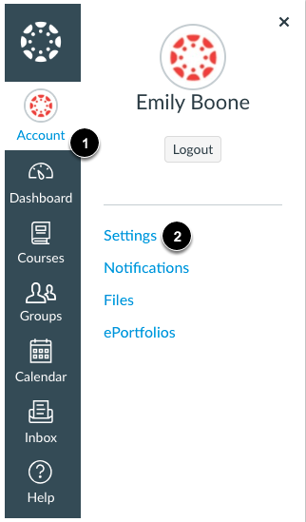

Click Pair with Observer (located in the lower right corner of the settings window)

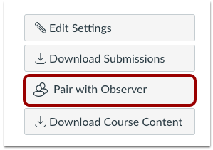

The code will appear for you to copy into your sign up information later.

**Note: Pairing Codes are Case Sensitive

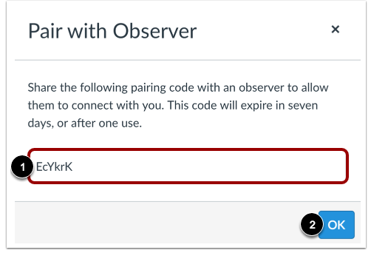

To Create Your Parent Observer Account

Open Canvas URL
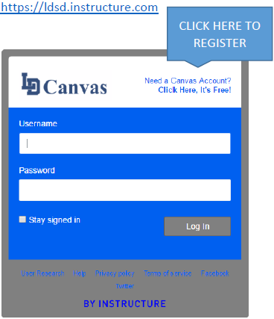

Sign Up As a Parent (Free Account)
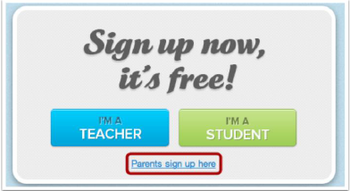

Click the Parents sign up here link.

You Must Enter the Required Information:
1) Your Name
2) Your Email Address
3) A Password (The password that you create must be 8 characters in length)
4) Student’s Pairing Code
5) Agree to the terms of use by clicking the You agree to the terms of use check box.

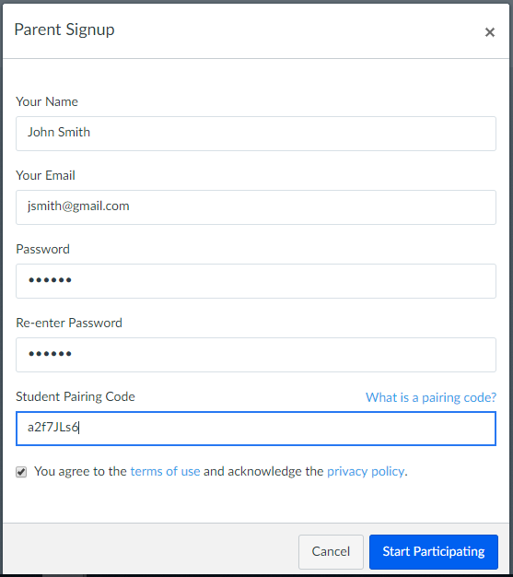

Click Start Participating

After you’ve clicked Start Participating, you will see your student’s dashboard exactly as they see it. You can now view their upcoming assignments, tests, quizzes etc.

*For help with this process, please call the district Help Desk at (717)566-5392

