How To Access Your Check-Stub on the Employee Service Portal

You can access the portal by clicking the link https://esp1.aliosolutions.net/STMARYK12/ or
Go to the school board website at www.stmaryk12.net and follow the below steps.
- Click “Employees”
- Click “Quick Links”
- Click “Employee Service Portal”

You will be taken to a site that looks like the image below. If you already have an account, you can log in using the credentials you created. If you have not created an account, please use the “create an account” shown by the red arrow in the image below. Make sure to use your PERSONAL EMAIL to create the account.
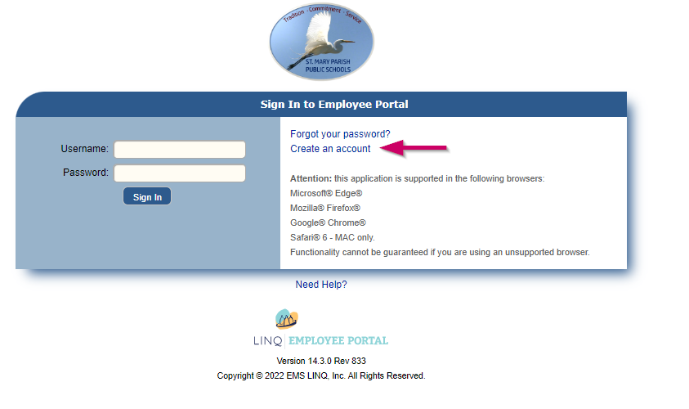

Logging in will take you to a screen with all your information, at the top of the screen there are tabs you can choose from, click “payroll”.
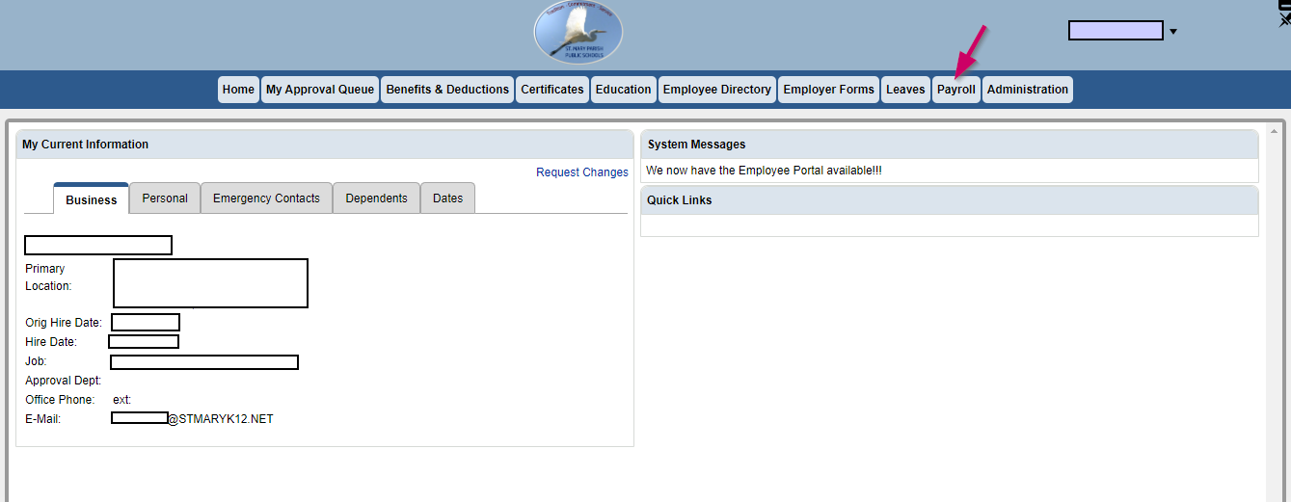

This will bring you to a calendar with green squares on pay dates. Click a green square to bring up that pay date’s check stub.
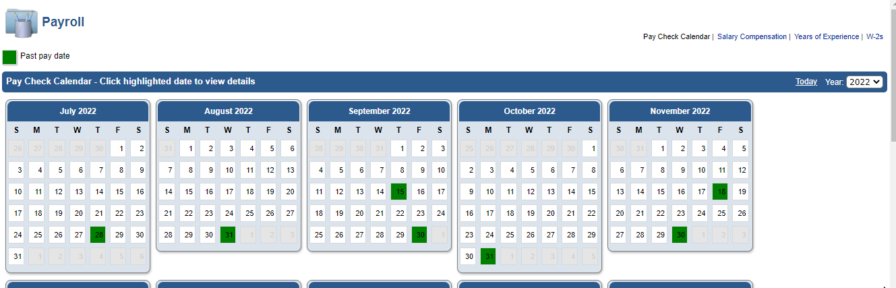

To print your check stub, click “print a copy” on the screen’s top right-hand corner.

