Exporting Calendar Events from a District Website Calendar to Microsoft Outlook Calendar
- From the homepage of the district website (or any school website), select Calendar from the channel bar. | 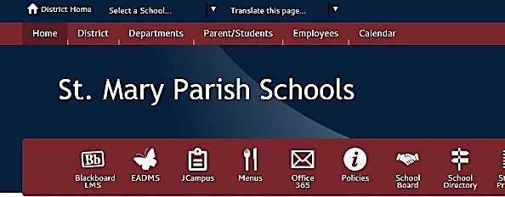
- Click the Export button to open the Calendar Export dialog box. | 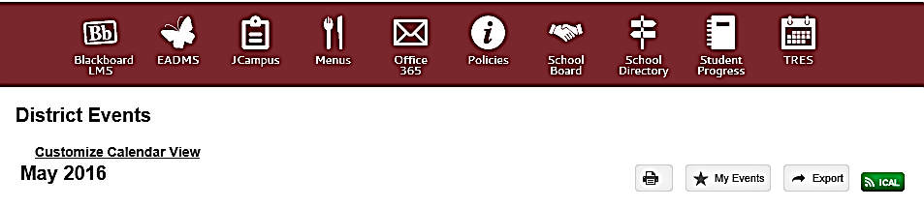
- Select your Start Date and End Date using the built-in calendar selector.  - Click Export. | 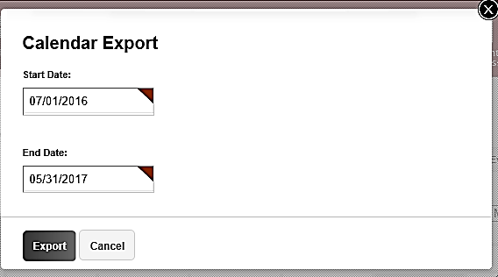
- At the bottom of your screen, you will see an indicator that shows the file has been downloaded. Select Open (Internet Explorer) or double-click the file name (Chrome). | 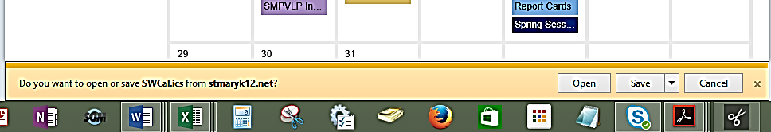
- Open the Calendar page of Microsoft Outlook. You will now see two calendars: Your current Calendar (left) and the Untitled calendar you have just downloaded (right) | 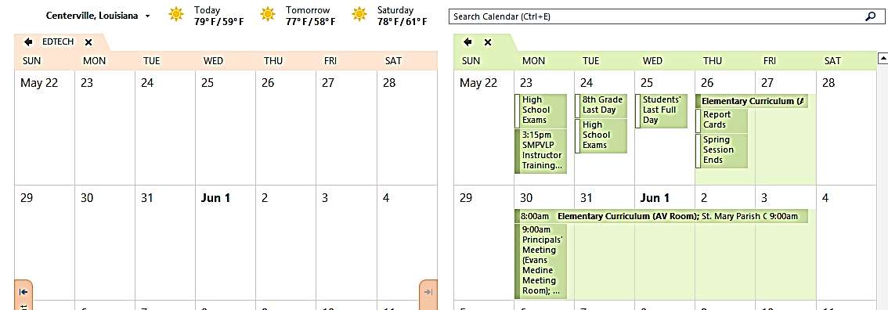
- Left-click an event, then drag it from the Untitled calendar (right) to your Calendar (left).  Continue to scroll down and move other events to your Calendar. | 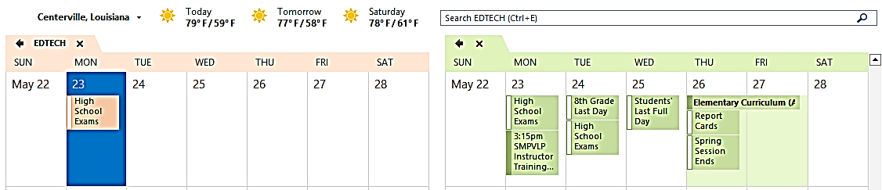
- When you are finished, find the list of calendars on the left. Right-click the Untitled calendar, and select Delete Calendar. Select Yes when asked if you want to move Untitled to your Deleted Items Folder. | 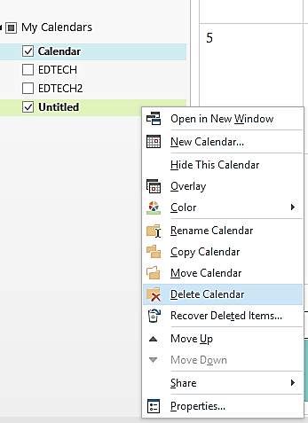
You can repeat this process at any time during the year to add additional items.

