MUSCOGEE COUNTY SCHOOL DISTRICT
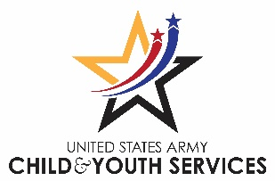

AYPYN After-School Clubs

Army Youth Programs in Your Neighborhood (AYPYN) is a partnership between the army and school districts for youth attending secondary schools off the installation. AYPYN supported after-school programs are available Monday through Friday at no cost to the student during the school year. AYPYN sponsors high interest clubs enhancing the academic achievement, health, and well-being of students. The program is supervised by certified district teachers and is available to all Muscogee County students in the designated AYPYN high schools. *Listed below.
AYPYN schools will offer a variety of academic, social, and health and wellness clubs dependent upon teacher availability and student interest. Please check your school calendar for the most current schedule. New club announcements, meeting times, and reminders will be provided to students during the school day.
Daily attendance is recorded, but all clubs are voluntary. Any student may attend the after-school clubs. Clubs are open most school days but are subject to cancellation at any time.
Please arrange for student pick-up prior to them attending a club.
All exterior doors remain locked after school. To be released early from a club, students need to make arrangements directly with the sponsor ahead of time or have a parent note.
Permission slips are valid for the current school-year only and will require a new form for the next school-year.
__________________________________________________________________________________________________

I give permission for ___________________________________________________ (student’s name) to stay after school to participate in the AYPYN after-school clubs at ___________________________ (school name). I understand that students are expected to follow school rules while they are participating in any after-school programs.
Parent/Guardian Signature:__________________________________________________________
Please check one that applies to any parent/guardian of the student:
_____ Army Active Duty _____ Dept of Army Civilian _____ Not Army affiliated
Note: Additional verification will be needed for all Army-affiliated parents (i.e. military ID card) and Department of.
Army Civilians’, to include employer name and address.

Parent/Guardian name (please print): _____________________________________________________________
Child’s Name (please print): _____________________________________________________________________
Relation to student: ___________________________________________________________________________
Emergency Contact Phone Number: ______________________________________________________________

*MCSD AYPYN sites: Columbus, Hardaway, Northside, Shaw, and Spencer High Schools.

