Infinite Campus Parent Portal Absence Request Instructions

- Log into the parent portal via the IC parent portal app on your mobile device, or through the Infinite Campus Website. Instructions for access the parent portal can be found at: https://www.iowacityschools.org/domain/31
- Select your student
- In the upper left hand corner, select the menu icon with 3 lines:
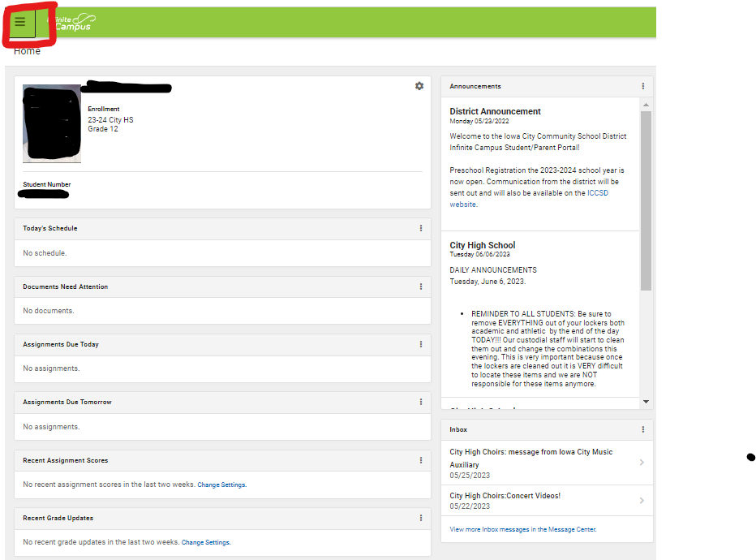
- Select “More” from the drop down menu
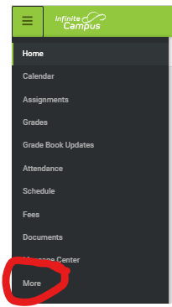
- Select “Absence Requests”
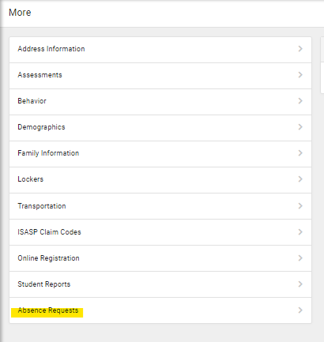
- Check the box for the student that you are making the request for:
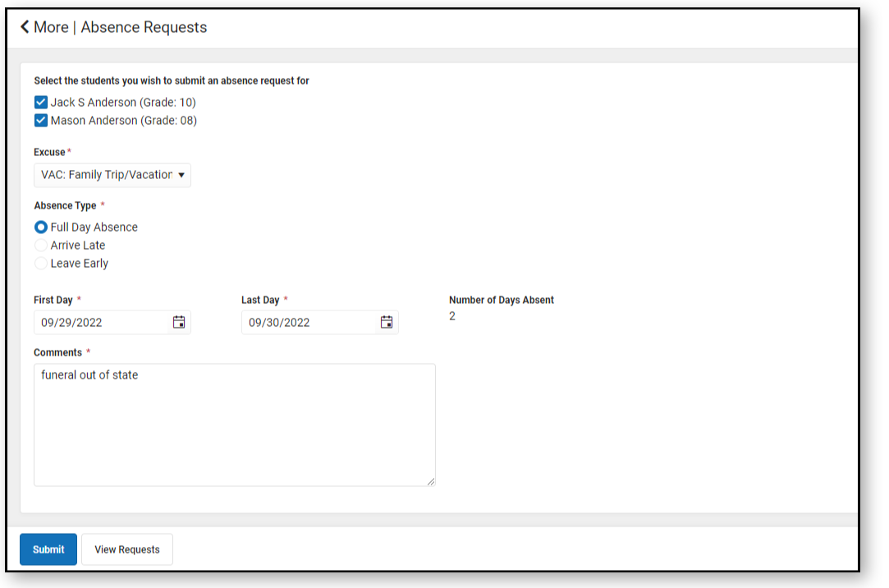
- Select the absence reason from the drop down menu
- Select absence type
- Enter date(s)/time of absence
- Enter additional information in Comments
- The school will review the request. If the absence is approved, they will enter the attendance information in Infinite Campus. If it is not approved, or they need additional information, they will contact the parent/guardian making the request.

