Vision Retreat Participant Handout

Vision Retreat Purpose

The Vision Retreat provides an opportunity for the strategic plan team to develop a shared understanding of the current mission, vision, core values and strategic themes and build upon those ideas to move the district forward in answering the question, “Where do we want to be five years from now that is different than where we are today?”

The Vision Retreat offers an opportunity for the plan team to review the components of a continuous improvement framework based on research best practices and benchmark where the district is in relation to those practices.

The outcome of the day is for the plan team to describe a clear vision for the future through a product known as a Preferred Future Statement.

Common Vocabulary

Core Values | The district’s beliefs and principles that articulate the culture of the organization. These are the standards that describe how employees and the organization are expected to behave internally and externally. They serve as the basis for decision-making and influence actions in everyday situations.
Mission | The district’s purpose is described in the language of the business, including who is served and what products, programs and services are provided to customers and stakeholders.
Strategic Theme | Three of four strategic focus areas that build on the customer value proposition to define the organization’s high-level business strategy; breaks down the vision and mission into action and focuses energy on desired strategic results.
Vision | A vivid, emotionally inspiring, time-specific picture of a future to which the organization aspires. A description of how the district will look, sound and feel differently that it is today.
Vision Result | An achievable stretch target identified in order to measure the success of an organization’s vision statement. Sometimes this is referred to an a Preferred Future Statement

Strategic Foundation or Preferred Future

When we complete our work today, we will have the concepts to produce a Strategic Foundation or Preferred Future Statement. We will share this product with those we represent and seek their feedback between the Vision Retreat and the Setting Direction Retreat.

Mission Statement- Our Core Purpose  Why do we exist? | Vision Statement- Our Future  Where we are headed?
Core Values - How we act and behave What we stand for? | Vision Description  What will it look like ?

A “vision” is a bold leap into the future, painting a vivid picture of a destination—a “north star” that guides collective action and shapes the strategies to make it a reality.

Feedback Review of Data Retreat SWOT from Stakeholders: Identify the top ten strengths, top ten weaknesses, top ten opportunities and top ten threats by examining the SWOT analysis from the Data Retreat and any feedback from stakeholders.

Carbondale Community High School District 165 Strategic Plan DRAFT SWOT Analysis
Strengths  o Graduation Rate  o Clarity and Variety in Academic and Course Offerings/Program Coherence  o Extracurricular Activities, Athletics, Clubs, & Offerings  o Financial Stability and Stewardship  o State Highest Recognition for Finance Management  o Diversity, Inclusion, Equity, Continuous Improvement  o Teacher-Student Trust  o Teacher Retention, Advanced Degrees and Talented Staff  o 1:1 Technology  o Belief in Continuous Improvement, Diversity, Inclusion and Equity | Weaknesses  o Student Achievement Gaps- Low Income and Black vs Others  o Math Instruction  o Demographic Disparity Among English and Math Tracks with Rigor  o Demographic Disparity Among Behavioral Referrals, In-School Suspensions, Tardies  o Chronic Absenteeism  o Schedule Flexibility- 6 period day, block schedules, opportunities to take electives, etc.  o Student Perception of Importance of High School  o Community and Family Involvement and Partnerships  o Student Perception of Family Supportiveness
Opportunities  o Reimagine Student Academic Interventions in mathematics and English  o Reimagine Student Behavior Interventions and Consequences  o Recruitment and Hiring of a more diverse staff  o Communication, Collaboration, Alignment with Feeder Districts  o Collaboration with SIU and JALC  o Expansion of Career Education and CTE options  o Use of space, building upgrade plans  o Professional Learning leading to innovation, project based, real world relevance and high quality of student discussion  o Expand learning opportunities for students, staff and families beyond the day and year  o Increase in inquiry-based 3-year science instruction for graduation | Threats  o False Perceptions of CCHS  o Increases in Low Income and Mobility Within Student Population  o Equalized Assessed Valuation decreasing and tax rate increasing  o Business Development and Residential Attraction  o Covid Slide and Recovery  o Teacher Shortage, Substitute Shortage  o State and National Funding and Stability/Political Climate

Activity One Part A: Characteristics of a Preferred Future Statement

Future Focused: | Provides the “Big Picture” and clearly describes what your district will be like in several years
Direction: | Serves as a guide to district goals and strategies
Specific: | Clear and focused enough to shape decision-making
Relevant and Purpose Driven: | Reflects the district’s response to the challenges of the day
Values-Based | Implies the set of values that are required to support the district
Challenging: | Inspires employees of the district to do great things and achieve a higher level of standards
Unique and Memorable: | Highlights what makes the district difference and why it matters
Inspiring: | Appealing and engages stakeholders to commit to a cause and mindset

Why is a Preferred Future Statement a necessary component of a district’s strategic plan? How might the district use mission, vision, and core values during the implementation of the strategic plan?

Which of the 8 Characteristics resonates best with you?

Activity One Part B: Investigating a great Preferred Future Statement

Illinois Vision 2020
We believe the key to continuous improvement in public education relies on the wisdom and innovation of public educators who work with students every day. This is a continuous process.
Through the Vision 20/20 process, four areas for prioritization emerged: highly effective educators, 21st century learning, shared accountability, and equitable and adequate funding.
Highly Effective Educators
21st Century Learning

Shared Accountability

Equitable and Adequate Funding
Other notes:

Activity One Part C: Greatest Hopes, Aspirations, Dreams for the Future

Dreams, Hopes Aspirations  Things to Change  Ideal School System Look Like | Why?  Difference Made

Activity Two: Investigating a great Preferred Future Statement

As part of our Vision Retreat for strategic planning we are providing everyone with a homework assignment.

The first part of the assignment is to read a short article to push your thinking about learning and the future. Each participant has been assigned an article with the new table team assignment. There are three articles. Each person is to read the article assigned and be ready to share five key takeaways to share with the team. Please see the table assignment chart for assigned readings and investigations. You have new table team assignments for the Vision Retreat.

Article 1: The 10 Principles of Modern Learning

Article 2: 9 Elements in The Classroom that Should “Unsettle” Us

Article 3: Forging the Future of Learning

The second part of the assignment is to explore electronically a high school that has a new definition of learning. If you read Article 1 you do Investigation 1, Article 2 you do Investigation 2, Article 3 you do Investigation 3.

Everyone will read the design principles of the XQ Super Schools and then do their investigation virtually

https://xqsuperschool.org/resource/xq-design-principles/
By redesigning traditional approaches to high school, XQ schools are working to prepare students for a brighter future. These six principles, updated in fall 2019 to reflect lessons learned since our launch in 2015, are fundamental to every XQ school. Each school manifests these principles in its own unique way.
We believe high schools are the next frontier in the fight for educational equity. And we know that equity demands action, not just aspiration. We take action by partnering with students, educators, families, leaders, and community members in schools, districts, and systems across the country who are ready to deliver on the tremendous promise that transforming our schools holds.

Investigation 1:
https://xqsuperschool.org/school/iowa-big/
Iowa BIG is a collaborative high school program operating among several school districts in Cedar Rapids, Iowa. Students choose from a pool of “initiatives” suggested by community partners or based on their own interests to address authentic problems and develop real solutions while earning core academic credits.

Investigation 2:
https://xqsuperschool.org/school/purdue-polytechnic-high-school/
Purdue Polytechnic High School exists to create a seamless transition from high school to college to the high-wage STEM jobs of the future.

Investigation 3:
https://xqsuperschool.org/school/washington-leadership-academy/
Washington Leadership Academy (WLA) prepares students to thrive in the world and change it for the better.

.

Key Concepts to share with those who have not read the article:
Article Read:

1

2

3

4

5

Other

Key Concepts to share with those who have not done the investigation:
School Investigated:

1

2

3

4

5

Other

Article/ Site Visited | 3-5 Key Ideas
10 Principles of Modern Learning | 1  2  3  4  5
Purdue Polytechnic High School | 1  2  3  4  5
9 Elephants in the Classroom that Should “Unsettle” Us | 1  2  3  4  5
Washington Leadership Academy | 1  2  3  4  5
Forging the Future of Learning | 1  2  3  4  5
Iowa BIG | 1  2  3  4  5

Activity Three: Student Agency

Student Agency is an important practice in executing 21st Century Skills.

What is Student Agency?

Why is Student Agency an important practice in executing 21st century skills?

What is the teacher’s role in fostering student agency?

What opportunities for professional development have been provided to promote student agency?

How is student engagement related to student agency?

DEEP ENGAGEMENT | ENGAGEMENT | ACTIVE / STRATEGIC COMPLIANCE | PASSIVE / RITUAL COMPLIANCE | PERIODIC COMPLIANCE  RETREATISM | RESITANCE / REBELLION
Students take full ownership of learning activities, displaying high levels of energy, a willingness to ask questions, pursue answers, consider alternatives, and take risks in pursuit of quality. Students persist with the task and will learn at high or profound levels. Learning transcends the formal educational structures. | Students begin taking ownership of learning activities. Their involvement shows concentration and effort to understand and complete the task as well as personal meaning. They do not simply follow directions but actively work to improve the quality of their performance. Students persist with the task and will learn at high levels. | Students participate in learning activities and stay on task without teacher intervention. However, their work has a routine or rote quality and significant thought or commitment to quality is not evident. The tasks have little inherent or direct value to the student, but the student associates it with outcome or results that do have value (such as grades). | Students follow directions in a rote or routine manner. Attention may be mildly distracted and they may need some added teacher attention or direction to remain on task. The student is willing to expend whatever effort is needed to avoid negative consequences. The emphasis is on meeting the minimum requirements. Students will learn at low, superficial levels. | Students do not attend to the work, but do not engage in activity that distracts others. The students often employ strategies to conceal lack of involvement. Students learn little or nothing from the task and when forced through the task either engages in ritual behavior or rebellion. | Students appear blocked, unable or unwilling to participate in learning activities. The refusal may involve cheating, refusing to do the work, or even doing other work in place of that which is expected. Alienation rather than commitment is evident. Students develop poor work and sometimes negative attitudes towards formal education.

Harvey F. Silver & Matthew J. Perini, The Eight C’s of Engagement; Phillip Schlechty, Engaging Students

Activity Four: Graduate, Adult, and System Portrait
Teams will explore Graduate, Adult, and System Portraits to describe a vision for the future.

VISION: The vision pillar asks “What?”—that is, “What must we become in order to accomplish our fundamental purpose?” In pursuing this question, the district attempts to create a compelling, attractive, realistic future that describes what they hope their district will become. Vision provides a sense of direction and a basis for assessing both the currently reality of the district and potential strategies, programs, and procedures to improve upon that reality. There is no more powerful engine driving an organization toward excellence and long-range success that an attractive, worthwhile and achievable vision of the future that is widely shared. (DuFour, DuFour, Eaker, and Many, Learning By Doing, Second Edition: Solution-Tree, 2010)

A vision:
- Describes where the organization wants to be, typically three to five year in the future. Focuses on the district’s “North Star.”
- Vividly captures the organization’s “picture of the future”.
- Is brief and easy to understand and communicates a message that is emotionally inspiring, to create a passion to contribute to the organization’s future success.
- It is audacious and takes you way beyond where you are to the “mountain top.”
- It builds on core competencies. It gives employees a larger sense of purpose so they see themselves as building a cathedral instead of laying stones.
- The vision takes the form of “Our vision is to become (achieve, improve, etc.) by (date).”

Criteria for evaluating a vision statement:
- Does it manifest our mission?
- Is it concise and compelling?
- Is it inspirational?
- Does it communicate promise?
- Does it create an image of something that cannot be seen today, but is possible tomorrow?
- Does it focus on ends not means?
- Does it manifest the mission and values

Graduate Portrait

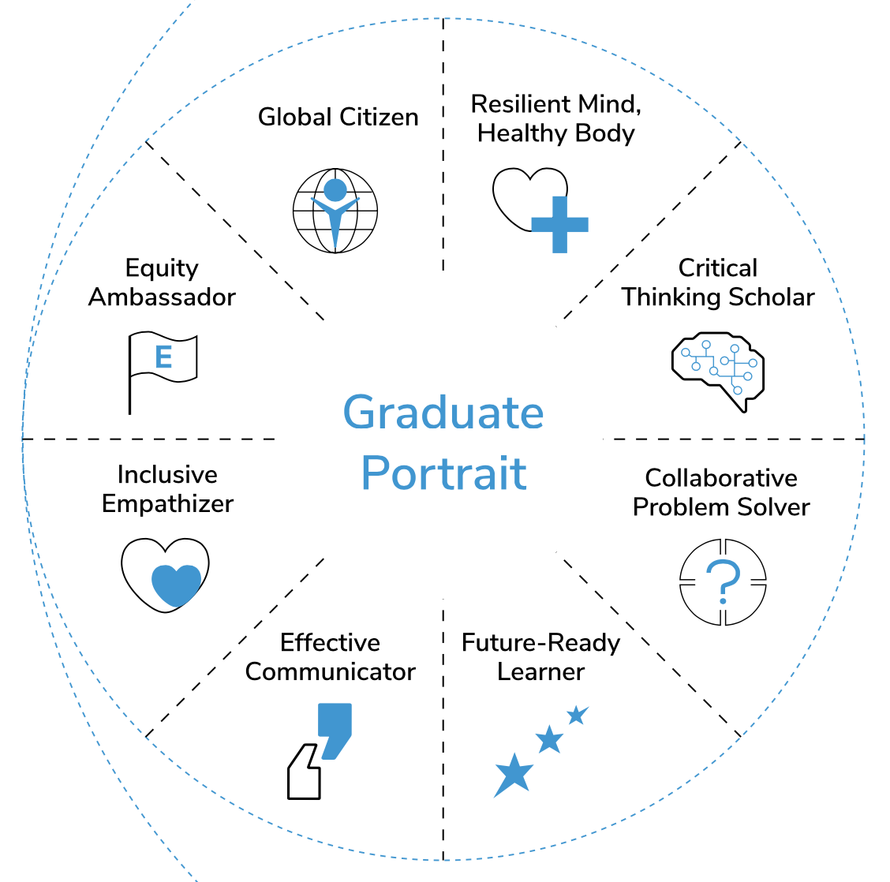

What 21st century skills, character traits, and/or social-emotional competencies do all students need to succeed in college, career, and life? How has the world changed, and how will it continue to change? What skills and mindsets will be necessary in a rapidly changing and complex world?
What are the skills and traits that community member take pride in and hope to pass on to their students and children?

Adult Portrait

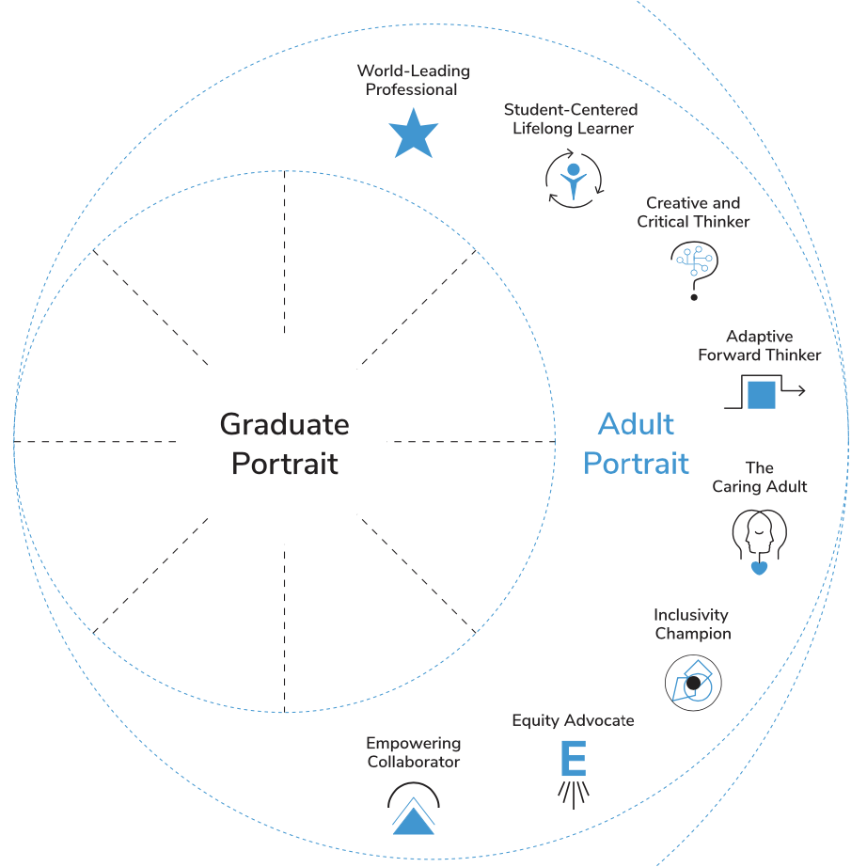

- What are the critical 21st Century characteristics of an effective team member? What 21st Century characteristics contribute to a successful and efficient culture or climate? What 21st Century adult characteristics contribute to the development of successful and passionate learners?

System Portrait

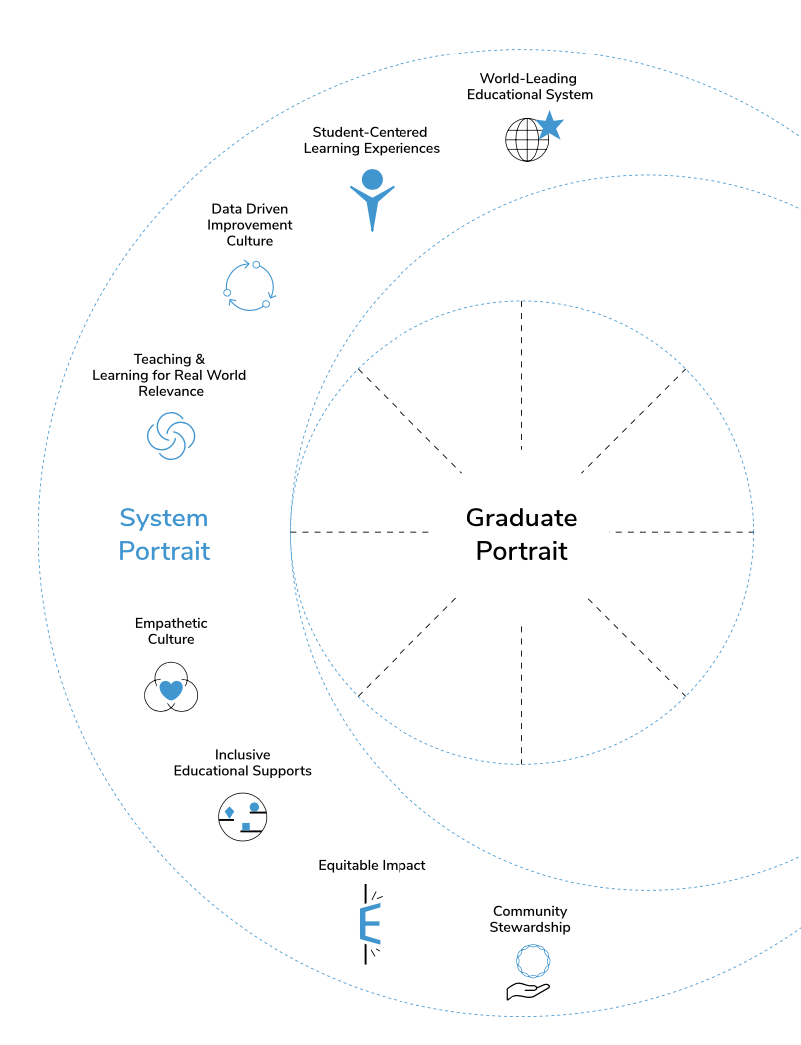

What 21st Century District System Characteristics define an effective 21st century school system?
What 21st Century District System Characteristics do we want to guarantee every student, every family, every staff member to ensure high productivity and satisfaction?

Graduate Portrait | Adult Portrait | System Portrait


Information – Understanding facts, figures, statistics and data
Media – Understanding the methods and outlets in which information is published
Technology – Understanding the tools and devices that make the information accessible

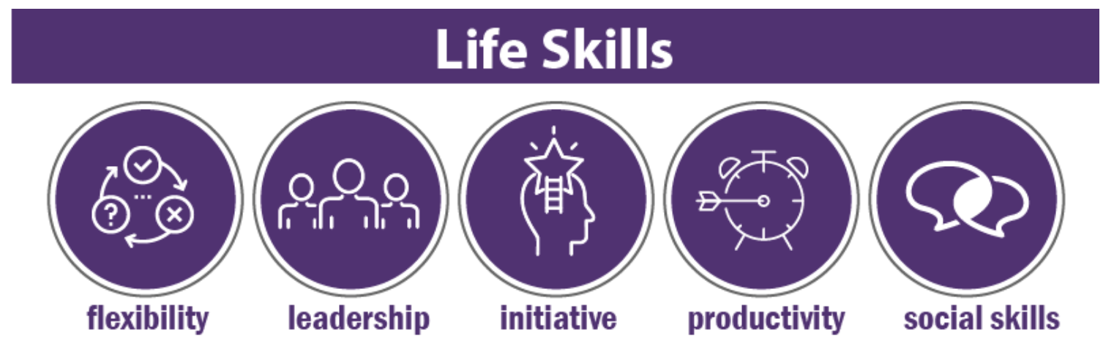
Flexibility – able to adapt to changing circumstances
Leadership – setting and achieving goals individually and collectively
Initiative – being a self-starter with confidence, commitment and ownership
Productivity- complete successful work in an appropriate amount of time
Social skills – meeting, networking, sharing with others for mutual benefit

Activity Five: Mission and Vision
BUILDING ON OUR CURRENT MISSION AND VISION STATEMENT

MISSION: The mission pillar asked the question, “WHY?” More specifically, it asks “Why do we Exist?” The intent of this question is to help reach agreement regarding the fundamental purpose of the organization. This clarity of purpose can help establish priorities and becomes an important factor to guide decisions.” Your mission statement is the best vehicle to get the word out about the “why” and the “wow” behind your district. In truth, your mission statement is no less important than your business plan. It needs to explain — eloquently, succinctly, and passionately — the core reasons for your existence. Your mission statement should inspire others to want to know more about your ideas, helping to position your district in the marketplace and to fuel growth. (DuFour, DuFour, Eaker, and Many, Learning By Doing, Second Edition: Solution-Tree, 2010)

A mission:
- Tells a story, in a few words that defines why the organization exits.
- Describes the core purpose of the organization that is persistent over time.
- Answers the following questions: Why does this organization serve and how are the served? What is the organizational purpose?
- Incorporates features of the organization that highlight its uniqueness and define its purpose.
- Helps define why the organization exits.
- Focuses on satisfying customer needs.
- Take the form of: “Our mission is to provide (what) to (whom) in order to (provide what benefit) while (maintaining what values).

Criteria for evaluating a mission statement:
- Is it clear and understandable?
- Is it brief enough for most people to remember and say in one breath?
- Does it clearly specify the school’s fundamental purpose?
- Does is have a primary focus on a single strategic thrust (such as learning)?
- Does it reflect the distinctive competence and culture of this school?
- Is it broad enough to allow flexibility in implementation, but not so broad as to create lack of focus?
- Will it help school personnel, parents, and community members make decisions?
- Is it energizing and compelling? Does it motivate and inspire employee commitment?
- Does it say what you want your district to be remembered for?

Current Mission Statement | Ideas and Concepts for Future Mission Statement
Carbondale Community High School strives to provide an education which enables and empowers its diverse students to develop their intellectual, emotional and physical gifts; to understand and respect the similarities and differences among themselves and others in their local and world communities; and to learn the habits of mind and self-discipline necessary to live with integrity and purpose as contributing members of society.

Activity Six: Core Values
Aligning Beliefs/Values/Collective Commitments to Mission and Vision

While creating a vision can be a helpful step in the improvement process, it is not sufficient. The board of education, administrators, and staff must tackle the collective values and commitments they must make and honor in order to achieve the shared vision for their district. Core values are the fundamental beliefs of an organization.

They are the district’s beliefs and principles that articulate the culture of the organization. They are the standards that describe how employees and the organization are expected to behave internally and externally. They serve as the basis for decision-making and influence actions in everyday situations.

CORE VALUES: The third pillar of the foundation, the values pillar identifies our beliefs and then clarifies those beliefs through collective commitments. It asks, “How must we behave to create the district that will achieve our purpose?” In answering the question, educators shift from offering philosophical musings on mission or the shared hopes for the district of the future to making commitments to act in certain ways. Clarity guides the individual work of each member and outlines how each person can contribute to the improvement initiative. Policy manuals and directives are replaced by commitments and covenants. Clarifying collective commitments is one of the most important strategies in building a PLC. (adapted from DuFour, DuFour, Eaker, and Many, Learning By Doing, Second Edition: Solution-Tree, 2010)

Core Values:
- Describe what the organization stands for in the context of its mission and vision.
- Guiding principles, defining the code of conduct and behavior that is expected of all employees.
- Provide ethical guidelines for decision-making and daily conduct.
- Are aligned with organization vision, mission and culture.
- Should be described in vivid behavioral terms.
- Are represented in a phrase but not a sentence or paragraph.
- Should not include more than 5-7 so they can be memorable.
- Supports mission and vision.

Criteria for evaluating a core value or belief:
- Does it manifest our mission and vision?
- Is it compelling and based on a belief we would not compromise?
- Is it a guiding principle that guides behaviors and actions?
- Is it clear and easy to understand?
- Does it create an unwavering and unchanging guide?
- Is it something we will hold each other responsible and accountable for our actions?
- Is it something we would want future staff members to support?
- Does it have a commitment to describe what we would do to move the belief to action?

Current Core Values/Beliefs | Ideas and Concepts for Future Core Values/Beliefs
To enable our students to achieve the highest proficiency in the skills and processes of learning to become responsible citizens of our society
To provide diversified and comprehensive programs that meet the specific needs of all students
To provide and maintain a positive learning environment to ensure conditions appropriate for creativity and growth
To instill an awareness of occupational responsibility and to nurture a respect for all careers
To foster in our students the realization of individual worth and dignity as a person enabling each student to achieve satisfying social relationships, and to live a productive life.
To make our students aware of the changeable nature of the world, to understand the process of change and to facilitate flexibility and adaptability
To offer educational experiences which will provide the resources to relate to others as well as to a larger society
To encourage students to think for themselves and to be responsible for their own actions.
To commit to achieve and mission, vision, goals and strategies of the district in a climate of cooperation and mutual respect.
To provide a physical climate which is conducive to learning.
To provide encouragement in opportunities for innovation to continuously improve individually and collectively.

Putting it ALL Together

Learn how the facilitator and Core/Edit Team will draft a Preferred Future State for review. Know we will revisit the mission, vision (Portraits) and core values at the beginning of the Setting Direction Retreat in December. We will also examine feedback from the ten district departments related to the Portraits. We will learn of their Best Hopes and Worst Fears.

Next Steps/ Preview of Setting Direction Retreat

Understand the work of the Core/Edit Team following this meeting. Preview the agenda for Setting Direction Retreat. Reflect on the Day.

