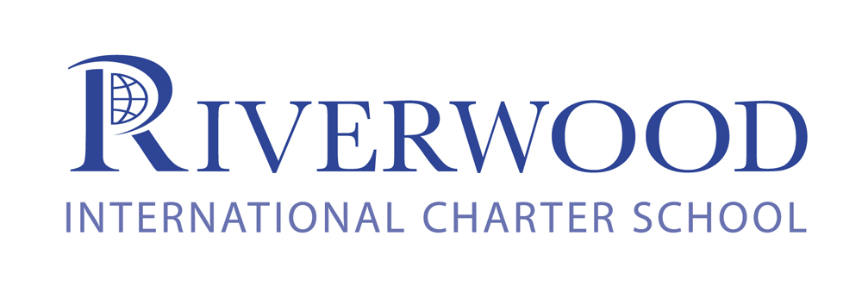
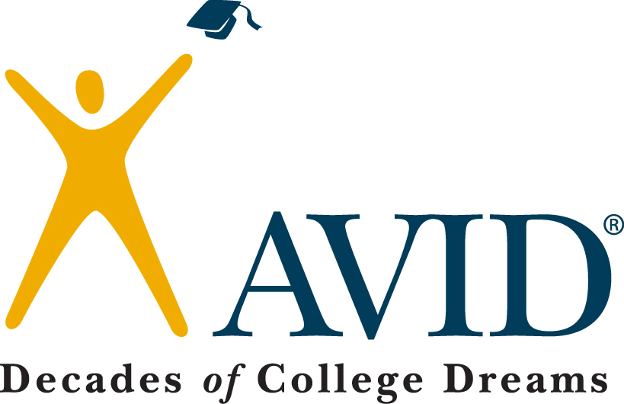

AVID—Advancement Via Individual Determination
WHAT IS AVID?
AVID is a college-readiness system designed to increase the number of students who enroll in and complete a degree at four-year colleges.
AVID is a regularly scheduled academic, elective class that focuses on developing the writing, inquiry, collaboration, organization and reading skills (WICOR) students will need to be successful throughout high school and beyond. The three main components of the program are:
- academic instruction
- tutorial support
- motivational and mentoring activities
WHAT IS AVID’s MISSION?
The mission of AVID is to ensure that ALL students, and most importantly the least served student who are in the academic middle, will:
- succeed in rigorous curriculum
- complete a rigorous college prep path
- develop the necessary skills to be successful in high school and beyond
- become confident and responsible participants and leaders in a global society
WHO IS AN IDEAL AVID STUDENT?
Students with academic potential and good work ethic-
- Strong DESIRE AND DETERMINATION
- Average to high test scores
- 2.0 – 3.5 GPA
- College potential with support
- Good citizenship and attendance
Student meets one or more of the following criteria-
- First in family to attend college
- Historically underserved in four-year colleges
- Low income
- Special circumstances
While all the criteria are considered for acceptance into the program, no criteria will eliminate a student from consideration. Ideally our AVID program will reflect the demographics of Riverwood International Charter School.
WHAT AVID IS NOT
- A remedial program
- A cure for failing student, those with poor attendance or with behavioral issues
- A good fit for students who have no desire to attend post-secondary school
- A quick fix or easy ride
WHY AVID WORKS
- Teaches academic skills not targeted in other classes
- Provides intensive support with in-class tutorials and a strong student/teacher relationship
- Accelerates under-achieving students into more rigorous courses
- Creates a positive peer group for students
- Develops a sense of hope for personal achievement gained through hard work and determination

AVID AT RIVERWOOD
For more information about the AVID program you can visit their web-site at: www.avid.org.
If you have any questions about AVID at Riverwood please contact:
Buck Jenkins
AVID Coordinator/Elective Teacher
jenkinsb1@fultonschools.org

