UNIT PLANNING
Working towards an IB Education
Teaching in IB Programmes is:
  - Inquiry Based – provoking curiosity in order to structure and sustain exploration
  - Concept Driven – planning and teaching through concept that are transferable to new contexts
  - Contextualized – reaching beyond the scope of individual subjects to establish relevance
  - Collaborative – promoting effective teamwork and purposeful/ productive collaboration
  - Differentiated – providing access to learning for a diversity of learners
  - Informed by Assessment - balancing assessment of, and for, learning
From MYP: Principles to Practice p, 72

In the context of the MYP curriculum, a unit can be defined as a period of study that concludes with a summative assessment. This section describes the process of planning inquiry-based, subject-specific units (disciplinary learning) using the MYP unit planner.

There are three aspects of developing an MYP unit: establishing the purpose of the unit; defining the process of teaching and learning through inquiry; and reflecting on the planning, process and impact of the inquiry. These aspects are developed by placing elements of “backwards planning” (Wiggins and McTighe 2005) in an MYP context. The relationship between these aspects of teaching and learning is dynamic, and any aspect might provide the point from which teachers begin their planning. In planning curriculum, teachers often move among inquiry, action and reflection; these inquiry-based aspects of curriculum planning are iterative and interrelated rather than strictly linear, as shown in figure 8.

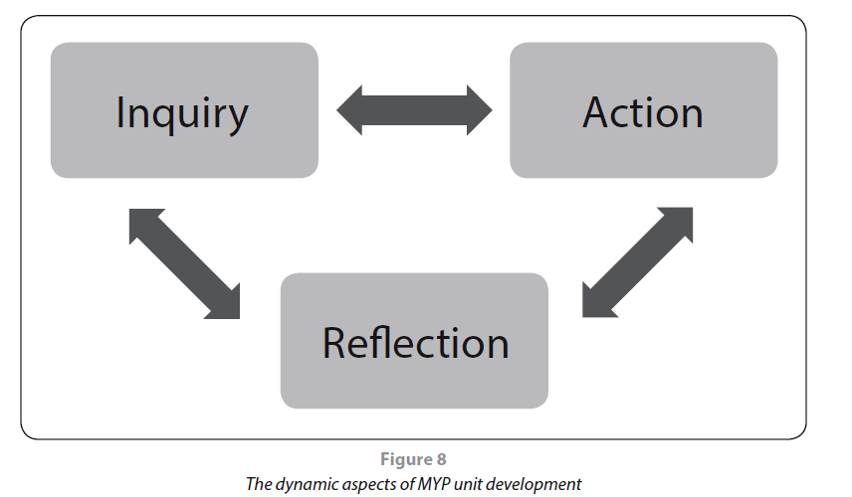

From MYP Principles to Practice p. 50

Unit plans are an essential component of the MYP written curriculum and must include the following elements.

Inquiry: Establishing the purpose of the unit
- Key and related concepts …………………………………………………….. p. 1
- Global contexts………………………………………………….……………….. p. 5
- Statement of inquiry………………………………….……………………….. p. 7
- Inquiry questions……………………………………………………………….. p. 11
- Subject-group objectives…………………………….……………………….. p. 15
- Summative assessment……………………………………………………….. p. 17
- Approaches to learning (ATL) …………………………….……………….. p. 21

Action: Teaching and learning through inquiry
- Content (selected or required) …………………………………………….. p. 29
- Description of the learning process
  - Learning experiences and teaching strategies……….…..….. p. 31
  - Formative assessment ………………………………….…………….. p. 35
  - Differentiation…………………………………………….…………….. p. 37
- Resources ………………………………………………………………………….. p. 39

Reflection: Considering the planning, process and impact of the inquiry
- Prior to teaching the unit
- During teaching ………………………………………………………………….p. 41
- After teaching the unit.

From MYP: Principles to Practice p. 50-51

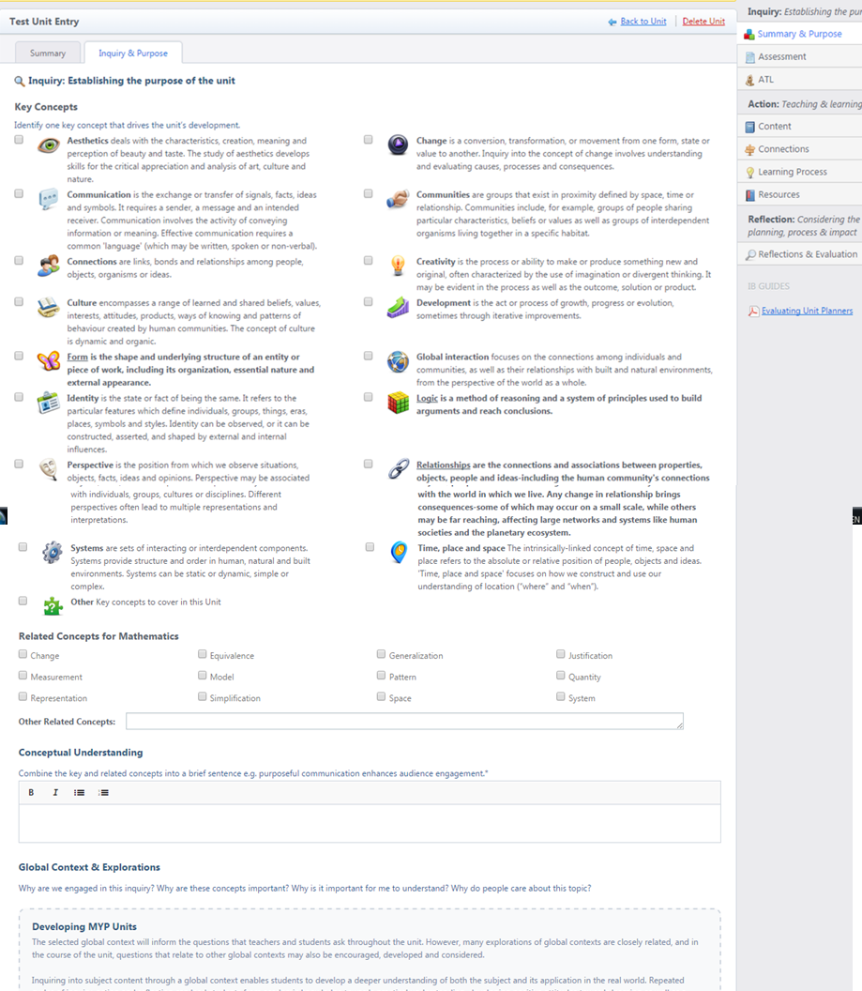
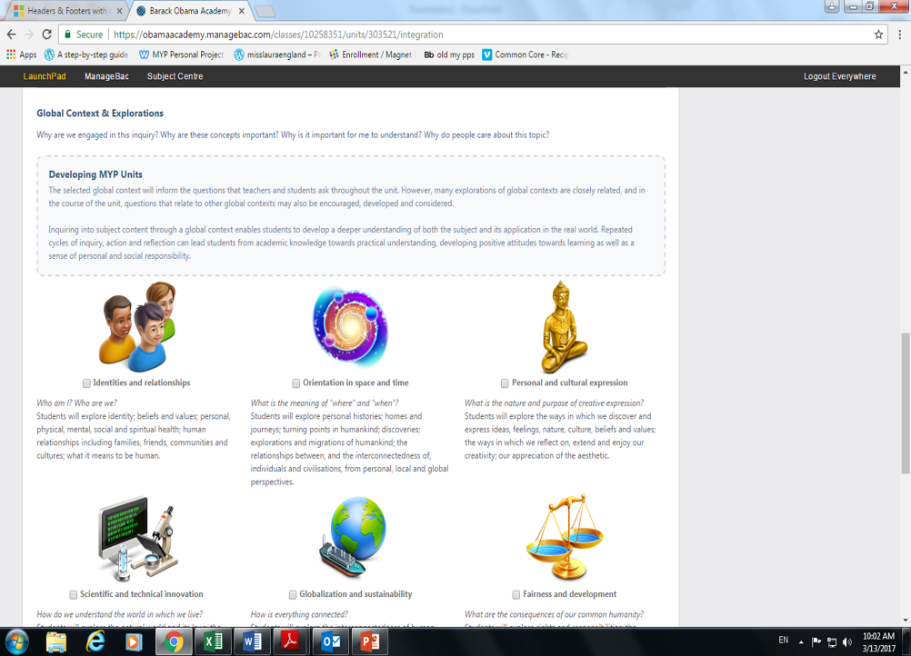
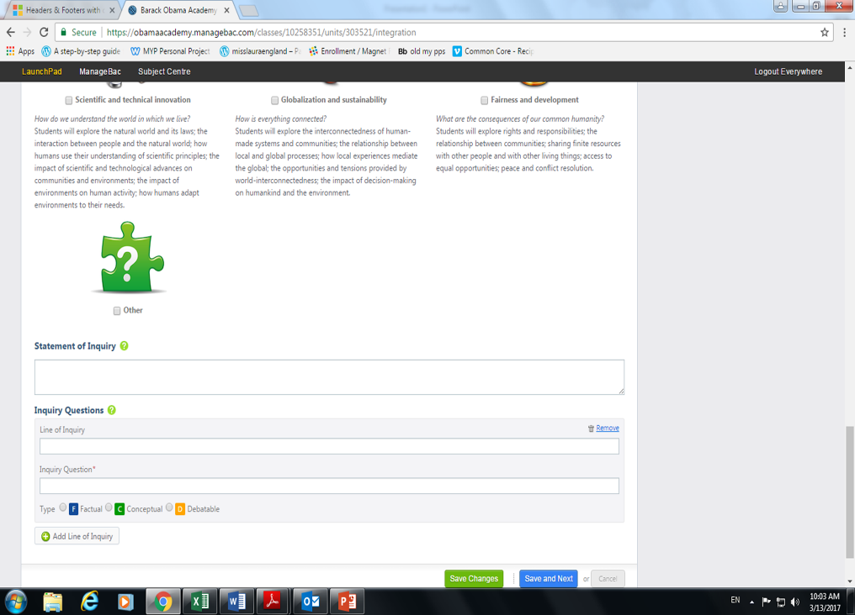
Inquiry Questions p. 11
Statement of Inquiry p. 7
Global Contexts p. 5
Key and Related Concepts p. 1
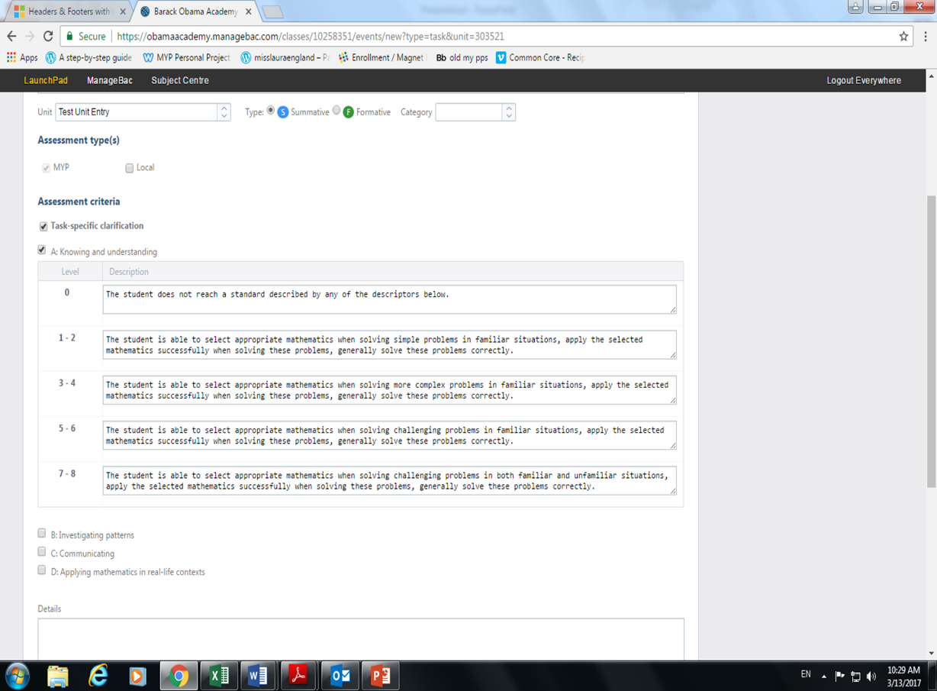
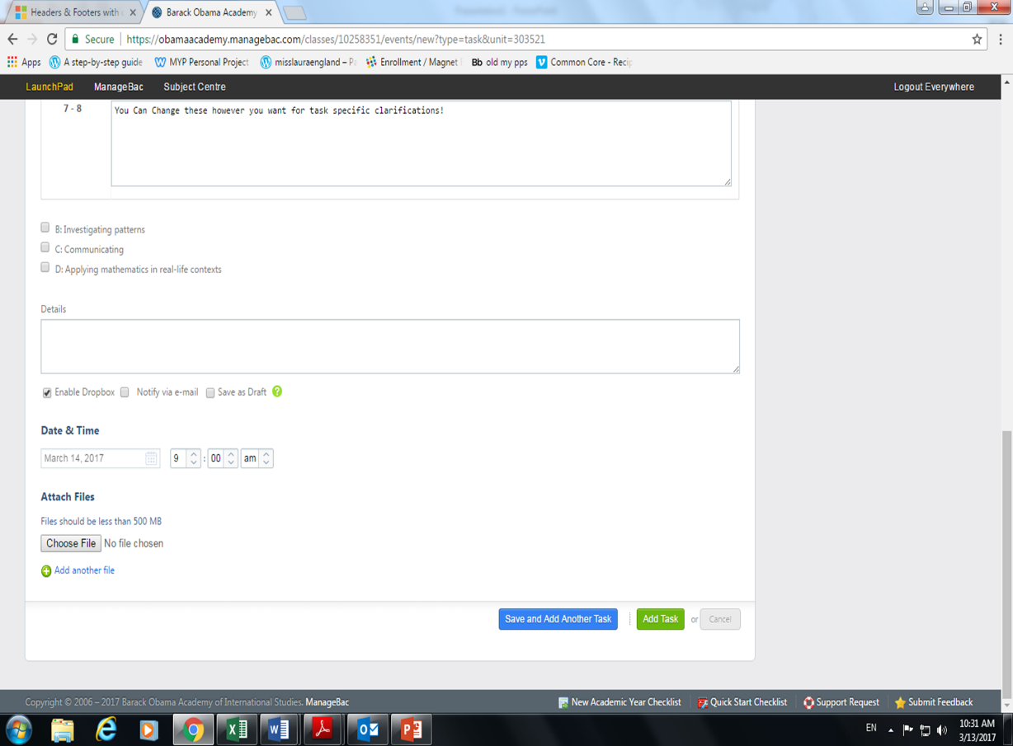
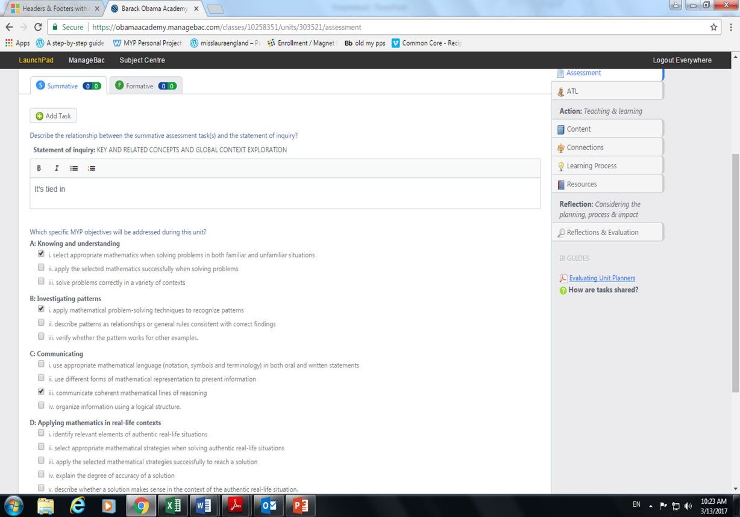
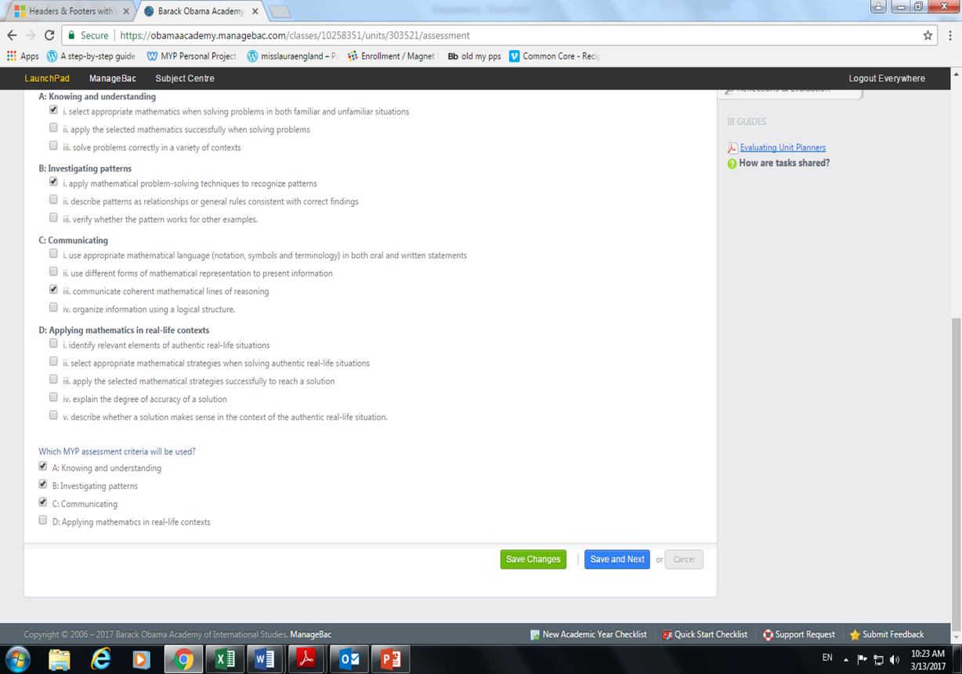
Summative Assessment p. 17
Subject-Group Objective p. 15
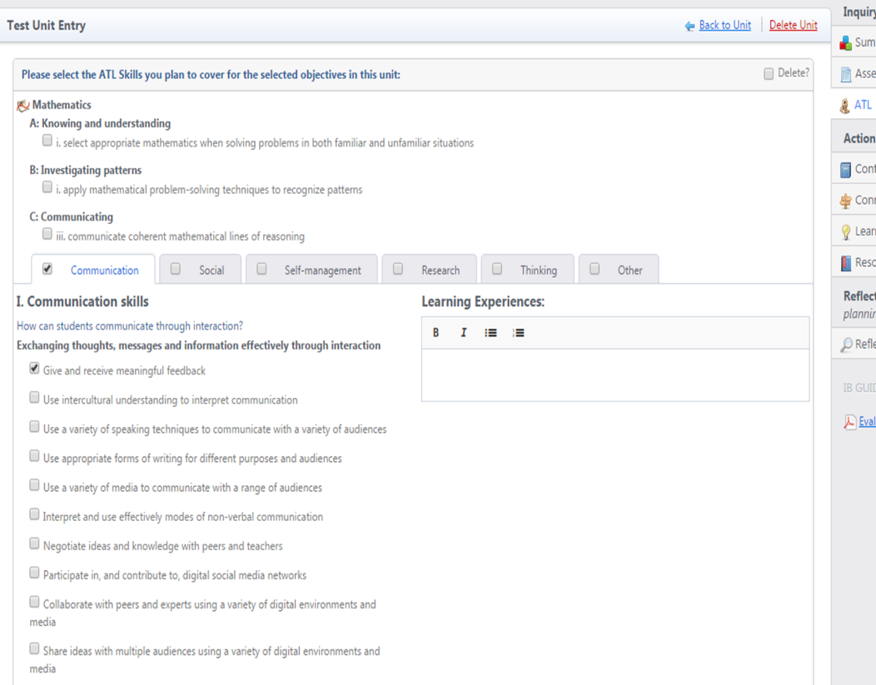
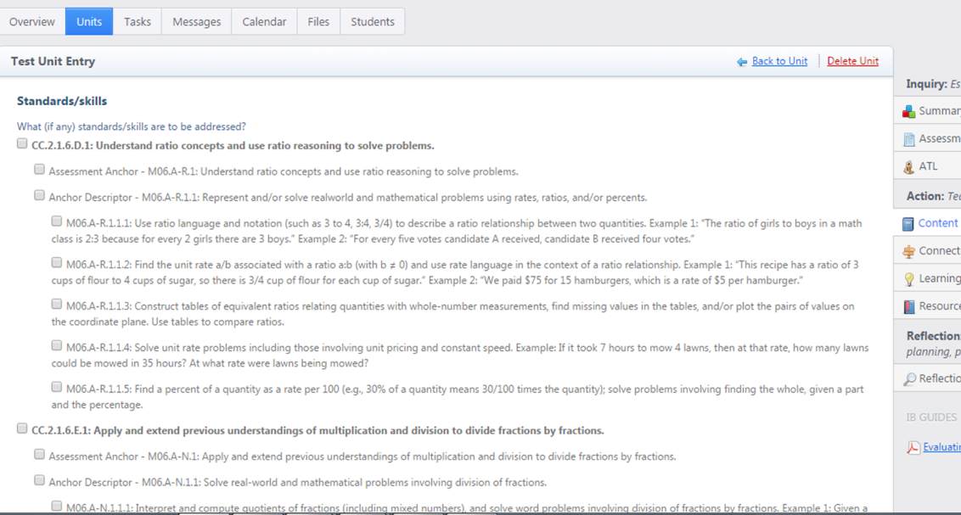
Approaches to
Learning p. 21
Content p. 29

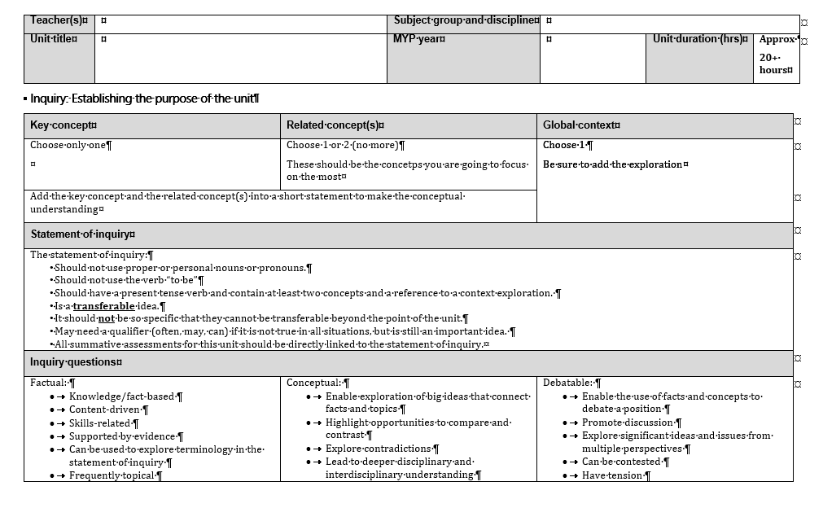
Annotated Unit Planner
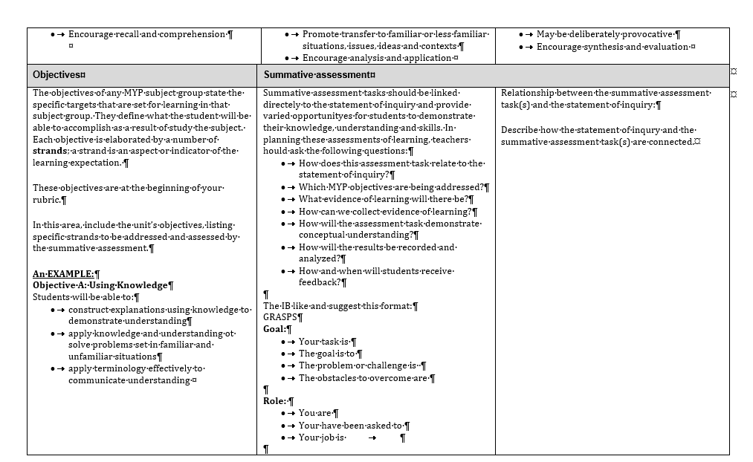
Annotated Unit Planner

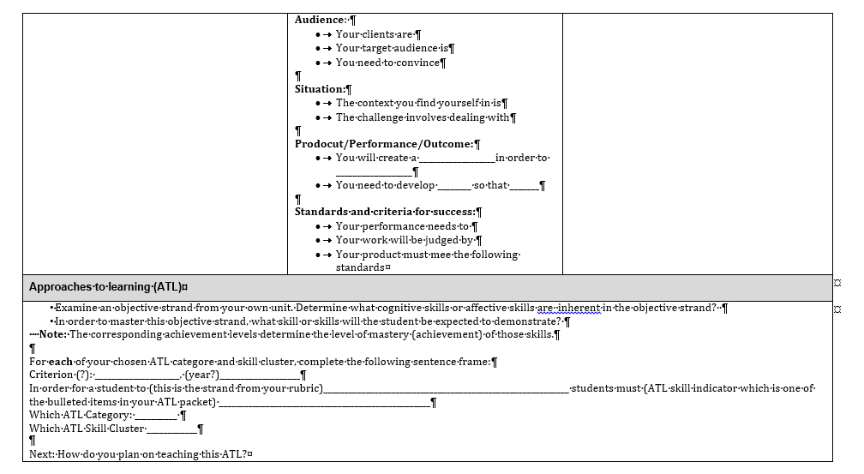
Annotated Unit Planner
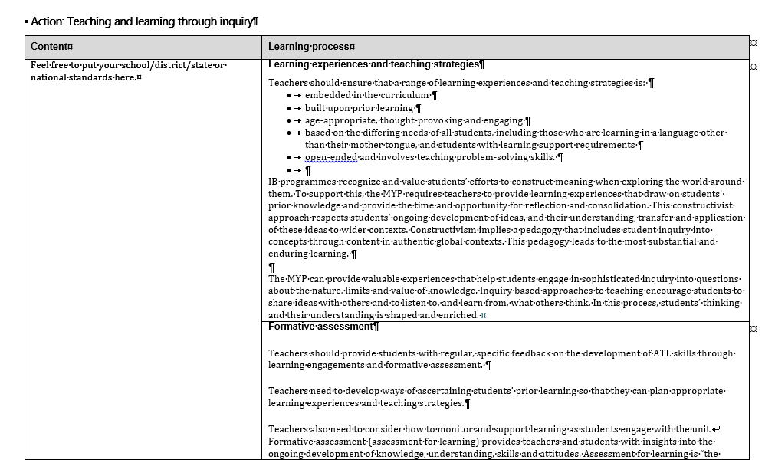
Annotated Unit Planner

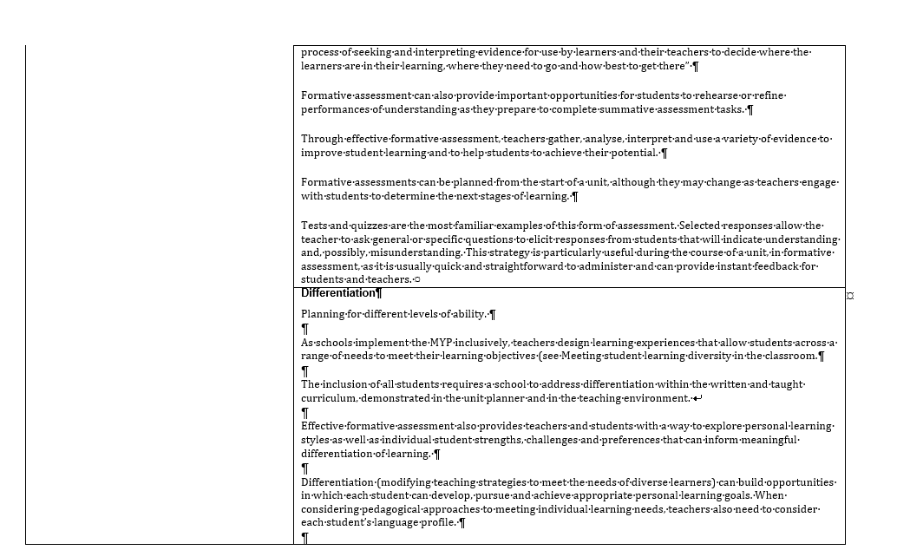
Annotated Unit Planner
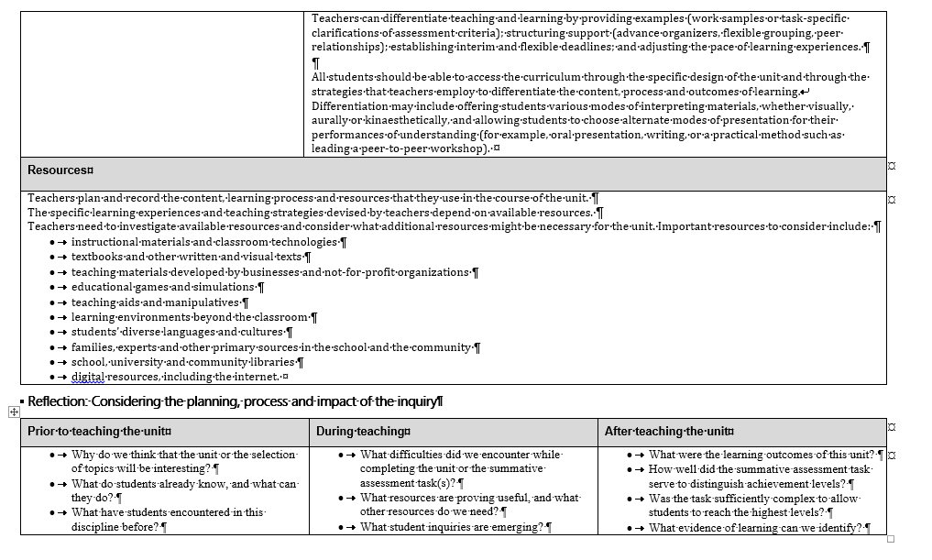
Annotated Unit Planner
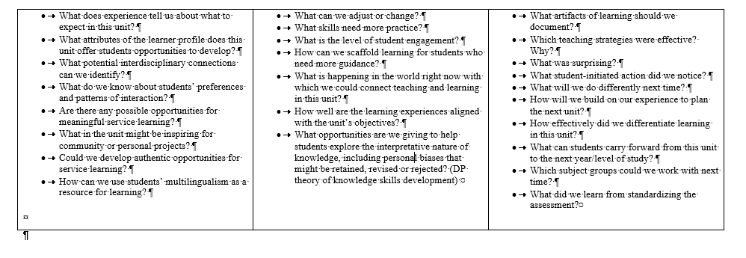

KEY and RELATED CONCEPTS
Philosophy and Place in the IB Contimuum
A concept is a “big idea” – a principle or notion that is enduring, the significance of which goes beyond particular origins, subject matter or a place in time (Wiggins and McTighe 1998). Concepts represent the vehicle for students’ inquiry into the issues and ideas of personal, local and global significance, providing the means by which they can explore the essence of a subject.
The exploration and re-exploration of concepts lead students towards:
  - Deeper understanding of the subject group
  - Appreciation of ideas that transcend disciplinary boundaries
  - Engagement with complex ideas, including the ability to transfer and apply ideas and skills to new situations (Erickson 2008).
From: MYP Principles to Practice p. 14
Although the Key and Related Concepts are unique to the MYP, the goal of Conseptual lesson design is central to the IB Philosophy
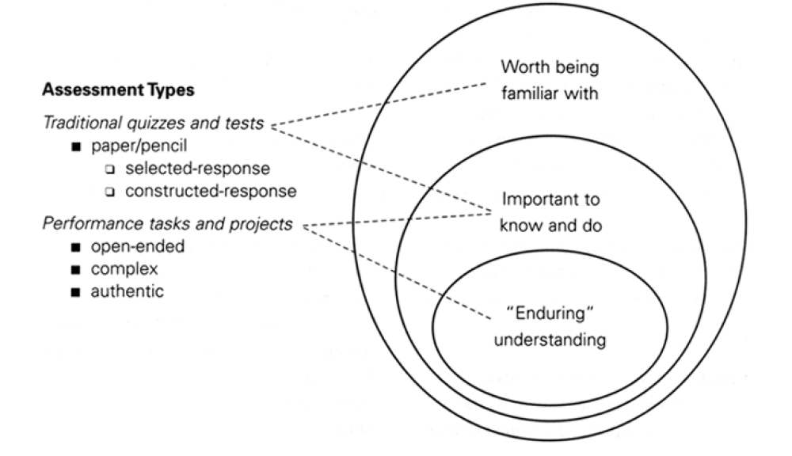
Taken from: Understanding by Design By Wiggins and McTighe

Key Concepts, contributed from each subject group, provide interdisciplinary breadth to the programme. Key concepts are broad, organizing, powerful ideas that have relevance within and across subjects and disciplines, providing connections that can transfer across time and culture.
Related concepts, grounded in specific disciplines, explore key concepts in greater detail, providing depth to the programme. They emerge from reflection into subject-specific content.
From: MYP Principles to Practice p. 15

What Does It Mean for Unit Planning?
Students need multiple opportunities to explore the concepts defined for each subject or discipline. Students should have meaningful inquiry into all of the key and related concepts for each relevant subject group at least once over the course of the MYP.
From: MYP Principles to Practice p. 58
Every Unit must have ONE Key and 1-3 Related concepts. They are incorporated into the Unit’s Statement of Inquiry, along with the Global Context.
MYP Key Concepts Across the Subjects
Arts | Individuals and Societies | Lang and Lit | Language Acquisition | Mathematics | P. E. | Sciences | Design
Change | Change |  |  |  | Change | Change
 |  |  |  | Relationships | Relationships | Relationships
Communication |  | Communication | Communication |  | Communication |  | Communication
 | Systems |  |  |  |  | Systems | Systems
 |  | Connections | Connections
 |  | Creativity | Creatively
Aesthetics | Global Interactions | Perspective | Culture | Form |  |  | Communities
Identity | Time Place and Space |  |  | Logic |  |  | Development

Key Concepts Defined

- Aesthetics deals with the characteristics, creation, meaning and perception of beauty and taste. The study of aesthetics develops skills for the critical appreciation and analysis of art, culture and nature.
- Change is a conversion, transformation or movement from one form, state or value to another. Inquiry into the concept of change involves understanding and evaluating causes, processes and consequences.
- Communication is the exchange or transfer of signals, facts, ideas and symbols. It requires a sender, a message and an intended receiver. Communication involves the activity of conveying information or meaning. Effective communication requires a common “language” (which may be written, spoken or non-verbal).
- Communities are groups that exist in proximity defined by space, time or relationship. Communities include, for example, groups of people sharing particular characteristics, beliefs or values as well as groups of interdependent organisms living together in a specific habitat.
- Connections are links, bonds and relationships among people, objects, organisms or ideas.
- Creativity is the process of generating novel ideas and considering existing ideas from new perspectives. Creativity includes the ability to recognize the value of ideas when developing innovative responses to problems; it may be evident in process as well as outcomes, products or solutions.
- Culture encompasses a range of learned and shared beliefs, values, interests, attitudes, products, ways of knowing and patterns of behavior created by human communities. The concept of culture is dynamic and organic.
- Development is the act or process of growth, progress or evolution, sometimes through iterative improvements.
- Form is the shape and underlying structure of an entity or piece of work, including its organization, essential nature and external appearance.
- Global interactions, as a concept, focuses on the connections among individuals and communities, as well as their relationships with built and natural environments, from the perspective of the world as a whole.
- Identity is the state or fact of being the same. It refers to the particular features that define individuals, groups, things, eras, places, symbols and styles. Identity can be observed, or it can be constructed, asserted and shaped by external and internal influences.
- Logic is a method of reasoning and a system of principles used to build arguments and reach conclusions.
- Perspective is the position from which we observe situations, objects, facts, ideas and opinions. Perspective may be associated with individuals, groups, cultures or disciplines. Different perspectives often lead to multiple representations and interpretations.
- Relationships are the connections and associations between properties, objects, people and ideas—including the human community’s connections with the world in which we live. Any change in relationship brings consequences—some of which may occur on a small scale, while others may be far-reaching, affecting large networks and systems such as human societies and the planetary ecosystem.
- Systems are sets of interacting or interdependent components. Systems provide structure and order in human, natural and built environments. Systems can be static or dynamic, simple or complex.
- The intrinsically linked concept of time, place and space refers to the absolute or relative position of people, objects and ideas. Time, place and space focuses on how we construct and use our understanding of location (“where” and “when”).
From MYP Principles to Practice p 56-57
Related Concepts by Subject Group

Language and Literature
Audience Imperatives | Character | Context | Genres
Intertextuality | Point of view | Purpose | Self-Expression
Setting | Structure | Style | Theme

Physical and Health Education
Adaptation | Balance | Choice | Energy
Environment | Function | Interaction | Movement
Perspectives | Refinement | Space | Systems

Individuals and Societies
Geography
Causality (cause and consequence) | Culture | Disparity and Equity | Diversity
Globalization | Management and Intervention | Networks | Patterns and Trends
Power | Processes | Scale | Sustainability
History
Causality (cause and consequence) | Civilization | Conflict | Cooperation
Culture | Governance | Identity | Ideology
Innovation and Revolution | Interdependence | Perspective | Significance
Language Acquisition
Phases 1-2
Accent | Audience | Context | Conventions
Form | Function | Meaning | Message
Patterns | Purpose | Structure | Word Choice
Phases 3-4
Audience | Context | Conventions | Empathy
Function | Idiom | Meaning | Message
Point of View | Purpose | Structure | Word Choice
Phases 5-6
Argument | Audience | Bias | Context
Empathy | Idiom | Inference | Point of View
Purpose | Stylistic Choices | Theme | Voice

Sciences
Biology
Balance | Consequences | Energy | Environment
Evidence | Form | Function | Interaction
Models | Movement | Patterns | Transformation
Chemistry
Balance | Conditions | Consequences | Energy
Evidence | Form | Function | Interaction
Models | Movement | Patterns | Transformation
Integrated Sciences
Balance | Consequences | Energy | Environment
Evidence | Form | Function | Interaction
Models | Movement | Patterns | Transformation

Mathematics
Change | Equivalence | Generalization | Justification
Measurement | Model | Pattern | Quantify
Representation | Simplification | Space | System

Arts
Visual Arts
Audience | Boundaries | Composition | Expression
Genre | Innovation | Interpretation | Narrative
Presentation | Representation | Style | Visual Culture
Performing Arts
Audience | Boundaries | Composition | Expression
Genre | Innovation | Interpretation | Narrative
Play | Presentation | Role | Structure

Design
Adaptation | Collaboration | Ergonomics | Evaluation
Form | Function | Innovation | Invention
Markets and Trends | Perspective | Resources | Sustainability

From: MYP Principles to Practice p. 105-107

GLOBAL CONTEXTS

Philosophy and Place in the IB Continuum

In broad terms, teaching and learning in global contexts requires MYP schools to develop the capacity and the inclination to place people, objects, situations with which {they} come into contact … within the broader matrix of our contemporary world … {to be} attuned to daily encounters with world cultures, landscapes and products; {to} place such encounters in a broader narrative or explanatory framework of contemporary global processes; and [to] perceive [themselves] as an actor in such a global context.

The MYP identifies six global contexts for teaching and learning that are developed from, and extend, the PYP’s trans disciplinary themes.

From MYP: Principles to Practice, p. 18

What Does it Mean for Unit Planning?

Every Unit must have a Global Context associated with it. It will be included in the Statement of Inquiry as an area of exploration.

It is not necessary for each Global Context to be used every year by each subject area, but every students must have opportunities to explore each Global Context over the course of the year.

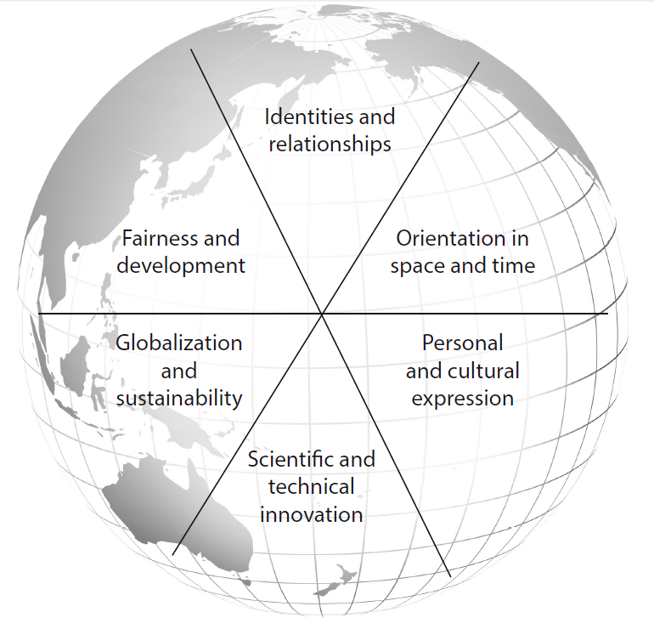
From MYP Principles to Practice p. 59
Global context | Focus question(s) and description | The Context Explores
Identities and relationships | Who am I? Who are we?  Students will explore identity; beliefs and values; personal, physical, mental, social and spiritual health; human relationships including families, friends, communities and cultures; what it means to be human. | - Identity formation; self-esteem; status; roles and role models  - Personal efficacy and agency; attitudes, motivation, independence; happiness and the good life  - Physical, psychological and social development; transitions; health and well-being; lifestyle choices  - Human nature and human dignity; moral reasoning and ethical judgment; consciousness and mind
Orientation in Space and Time | What is the meaning of “where” and “when”?  Students will explore personal histories; homes and journeys; turning points in humankind; discoveries; explorations and migrations of humankind; the relationships between, and the interconnectedness of, individuals and civilizations, from personal, local and global perspectives. | - Civilizations and social histories, heritage, pilgrimage, migration, displacement and exchange  - Epochs, eras, turning points and “big history”  - Scale, duration, frequency and variability  - Peoples, boundaries, exchange and interaction  - Natural and human landscapes and resources  - Evolution, constraints and adaptation
Personal and Cultural Expression | What is the nature and purpose of creative expression?  Students will explore the ways in which we discover and express ideas, feelings, nature, culture, beliefs and values; the ways in which we reflect on, extend and enjoy our creativity; our appreciation of the aesthetic. | - Artistry, craft, creation, beauty  - Products, systems and institutions  - Social constructions of reality; philosophies and ways of life; belief systems; ritual and play  - Critical literacy, languages and linguistic systems; histories of ideas, fields and disciplines; analysis and argument  - Metacognition and abstract thinking  - Entrepreneurship, practice and competency
Scientific and Technical Innovation | How do we understand the world in which we live?  Students will explore the natural world and its laws; the interaction between people and the natural world; how humans use their understanding of scientific principles; the impact of scientific and technological advances on communities and environments; the impact of environments on human activity; how humans adapt environments to their needs. | - Systems, models, methods; products, processes and solutions  - Adaptation, ingenuity and progress  - Opportunity, risk, consequences and responsibility  - Modernization, industrialization and engineering  - Digital life, virtual environments and the Information Age  - The biological revolution  - Mathematical puzzles, principles and discoveries
Globalization and Sustainability | How is everything connected?  Students will explore the interconnectedness of human-made systems and communities; the relationship between local and global processes; how local experiences mediate the global; the opportunities and tensions provided by world-interconnectedness; the impact of decision-making on humankind and the environment. | - Markets, commodities and commercialization  - Human impact on the environment  - Commonality, diversity and interconnection  - Consumption, conservation, natural resources and public goods  - Population and demography  - Urban planning, strategy and infrastructure
Fairness and Development | What are the consequences of our common humanity?  Students will explore rights and responsibilities; the relationship between communities; sharing finite resources with other people and with other living things; access to equal opportunities; peace and conflict resolution. | - Democracy, politics, government and civil society  - Inequality, difference and inclusion  - Human capability and development; social entrepreneurs  - Rights, law, civic responsibility and the public sphere  - Justice, peace and conflict management  - Power and privilege  - Authority, security and freedom  - Imagining a hopeful future

STATEMENT of INQUIRY

Philosophy and Place in the Continuum

This statement expresses the relationship between concepts and context; it represents a transferable idea supported by factual content. Statements of inquiry facilitate synergistic thinking, synthesizing factual and conceptual levels of mental processing and creating a greater impact on cognitive development than either level of thinking by itself (Erickson 2007; Marzano 2009)

The statement of Inquiry:
  - Represents a contextualized, conceptual understanding
  - Describes a complex relationship that is worthy of inquiry
  - Explains clearly what students should understand and why that understanding is meaningful
  - Can be qualified (using phrases such as “often”, “may” and “can”) if it is not true in all situations, but is still an important idea
  - Can be formulated at different levels of specificity

Teachers can make very broad statements more specific, age-appropriate and focused by asking themselves “Why/ how does this relationship or principle occur?” and “What are the implications of this understanding?” However, statements of inquiry should not be so specific that they cannot be transferable beyond the content of the unit.

From MYP: Principles to Practice p. 62-63

What Does It Mean For Unit Planning

Every unit must have a Statement of Inquiry, made up of

1 Key Concept
Conceptual Statement
1-3 Related Concepts
1 Global Context

The Statement of Inquiry should serve as the anchor for your unit, and be referred to throughout.

The statement of inquiry:
- Should not use proper or personal nouns or pronouns.
- Should not use the verb “to be”
- Should have a present tense verb and contain at least two concepts and a reference to a context exploration.
- Is a transferable idea.
- It should not be so specific that they cannot be transferable beyond the point of the unit.
- May need a qualifier (often, may, can) if it is not true in all situations, but is still an important idea.
All summative assessments for this unit should be directly linked to the statement of inquiry.
Statement of Inquiry Worksheet
Title of the Unit:________________________________
1 Key Concept: __________________________
1 or 2 related concepts: ____________________________________
____________________________________
Combine Key and Related Concepts into a sentence: (This is your Conceptual Understanding)
_____________________________________________________________
_____________________________________________________________-
- This should be free of content
- This should not use the verb “to be”
- This should be in the present tense

Select a Global Context:___________________________________________
Choose a Global Context Exploration: ______________________________________
Combine the GC exploration with conceptual Understanding
___________________________________________________________________
___________________________________________________________________
Tips for your Statement of Inquiry
- Should not use proper or personal nouns or pronouns
- Should not use the verb “to be”
- Should have a present tense verb and contain at least two concepts and a reference to a Global Context exploration
- Is a transferable idea
- May need a qualifier (often, may, can) if it is not true in all situations, but is an important idea.

EVALUATING STATEMENTS OF INQUIRY

Statement of inquiry
Beginning/developing  Emergent | Using  Capable | Sharing  Exemplary
The statement of inquiry:  • offers limited potential for transferring understanding beyond the content of this unit  • does not clearly include an identified MYP key concept, related concepts and global context  • may mechanically connect programme elements, with limited description of the unit’s purpose and significance  • uses language that might overwhelm students, limit their ability to engage with the inquiry, or articulate for themselves its purpose and value. | The statement of inquiry:  • clearly explains a significant conceptual understanding of appropriate complexity  • identifies a specific global context and exploration  • communicates in student-friendly language that invites inquiry and engagement  • has potential for the development of transferrable understanding. | The statement of inquiry:  • establishes the unit’s relevancy and long-term value by articulating a clear, meaningful purpose for the inquiry  • establishes the unit’s purpose within a specific, relevant and engaging exploration of a global context  • effectively connects key (broad) and related (deep disciplinary) concepts in ways that students can understand and remember  • represents creativity and complexity in its synthesis of MYP concepts and the chosen global context  • develops specific disciplinary knowledge that supports transferable understanding.

INQUIRY QUESTIONS

Philosophy and Place in the IB Continuum

Inquiry Questions are drawn from, and inspired by, the statement of inquiry. Teachers and students develop these questions to explore the statement of inquiry in greater detail. Students can develop their own questions in ways that satisfy curiosity and deepen understanding. The strands of subject-specific objectives can also be helpful in formulating inquiry questions.

Inquiry questions give shape and scope to a unit of study, and they help to scaffold the objectives that students should strive to achieve. As the unit progresses, both teachers and students can develop additional questions to explore.

From MYP Principles to Practice p. 63

Factual | Conceptual | Debatable
Can use starter ‘What...’  Open question that students might be able to Google but find many variations | Can use starters ‘How....’ or ‘Why...’  Open ended questions which unpack a concept or a relationship between concepts | Can use starters that provoke debate  ‘Do...’ ‘Can...’ ‘Should...’ or ‘Is...”  Debatable questions provoke discussion
From Seattle MYP Training

Factual Questions | Conceptual Questions | Debatable Questions
• Knowledge/fact-based  • Content-driven  • Skills-related  • Supported by evidence  • Can be used to explore  terminology in the  statement of inquiry  • Frequently topical  • Encourage recall and  comprehension | • Enable exploration of big  ideas that connect facts  and topics  • Highlight opportunities to  compare and contrast  • Explore contradictions  • Lead to deeper disciplinary  and interdisciplinary  understanding  • Promote transfer to  familiar or less familiar  situations, issues, ideas  and contexts  • Encourage analysis and  application | • Enable the use of facts  and concepts to debate a  position  • Promote discussion  • Explore significant ideas  and issues from multiple  perspectives  • Can be contested  • Have tension  • May be deliberately  provocative  • Encourage synthesis and  evaluation

From MYP Principles to Practice p. 63

What Does It Mean for Unit Planning?

Each Unit must have a series of Inquiry questions to guide the work of the students. Not all of the questions need to be listed before the start of the unit. It can be a powerful tool to have the students create their own questions as they go through the process of inquiry themselves.

On the following page is a list of possible question started based on Bloom’s revised taxonomy. This is not an exhaustive list, but can get you started thinking about the kinds of questions you can ask.

Factual Questions |  | Conceptual Questions |  | Debatable Questions
Remembering | Understanding | Applying | Analyzing | Evaluating | Creating
What is...?  Where is ...?  Who were the main ...?  Why did ...?  When did ...?  How would you show ...?  How did ...happen?  Which one ...?  How is ...?  When did ...happen?  List three ...  How would you describe ...?  What do you recall about ...?  Select ...  How would you explain ...?  Who was ...? | How would you explain ...?  How would you identify ...?  How are these alike? Different?  How would you differentiate between ...?  What do you conclude from  What characteristics identify ...?  What is the difference between ...?  What relationship exists between ...?  What patterns exist ...?  What could be a reason for ...?  What can you interpret from the graph/table?  Which does not belong?  What would happen if ...? | How would you make use of ...?  How does ...apply to ...?  How would you modify ...?  Under what conditions would you ...?  How could you apply what you have read to construct ...?  How would you use the facts to investigate ...?  Using what you know, how would you design ...?  Utilize ...to ...  Illustrate a way to ...  What other way would you demonstrate ...?  Identify the results if ...?  Predict what would happen if ...?  What would result if ...?  Show me a way to organize ...  Why does ...work?  Using what you have learned, how would you solve ...? | Determine what could have caused ...?  Discuss the pros and cons of ...?  Explain why it is not possible for ...  How would you order ...?  How would you document ...?  Justify your conclusion.  Why do you think ...?  What fallacies influenced ...?  What are the components of ...?  What is the reason for ...?  What observations can you make from ...?  What evidence will support/refute...?  What relationship exists between ...?  What inference can you make/were made from ...? What assumptions can you make/were made about ...?  What is your analysis of ...?  What ideas validate ...?  What conclusions can you deduce ...?  Under what conditions ...? | Create/propose an alternative to ...?  How would you improve ...?  Devise a way to ...?  Hypothesize the reason for ...?  Design a fair test for ...  Predict the outcome of ...?  Develop a theory to explain ...  Propose a hypothesis/an experiment for ...  Develop a model to represent ...  Think of an original way to represent ...  Develop an experiment to determine ...  What solutions would you suggest for ...?  Elaborate on ...  What could be done to integrate ...?  How would you test ...?  What would happen if ...?  How would you combine ...to create a different ...?  What changes would you make to revise ...? | Based upon the evidence, explain your choice.  Compare the ideas of ...  How else would you ...?  How would you critique ...?  How would you interpret ...?  How would you verify ...?  How would you determine the facts about ...?  How would you prove/disprove ...?  Rate the ...  State a case that would support/reject ...  What is the most important ...?  What data was used to evaluate ...?  What would you conclude about ...?  What is the significance of ...?  What criteria would you use to assess ...?  What choice would you have in ...situation?  What data was used to evaluate ...?  What is your opinion of ...?  Which ...is valid?  Would it be better if ...? Why/why not?
Question stems taken from http://webcache.googleusercontent.com/search?q=cache:HMb3DDT_NicJ:www.rcboe.org/site/handlers/filedownload.ashx%3Fmoduleinstanceid%3D33812%26dataid%3D27972%26FileName%3Dblooms_question%2520stems%2520version%25202.doc+&cd=8&hl=en&ct=clnk&gl=us
EVALUATIONG INQUIRY QUESTIONS
Here is a rubric from IB we can use to evaluate our Inquiry Questions.
Inquiry Questions
 | Using  Capable | Sharing  Exemplary
  Beginning/developing
  Emergent
 | Inquiry questions:  • include examples of factual, conceptual and debatable questions  • are clearly relevant to the purpose of the unit  • are developed to address the needs of diverse learners  • are appropriately rigorous. | Inquiry questions:  • demonstrate clear understanding of the relationship between facts, concepts and debates  • provide variety, generate interest, establish relevance and represent appropriate complexity  • include teacher- and student-generated questions that lead to deeper understanding  • identify structured or scaffolded learning pathways  • develop sophisticated critical and creative thinking  • help to prepare students to undertake summative assessment.
  Inquiry questions:
  • show less understanding of the distinction between factual, conceptual and debatable questions
  • may be disconnected from each other and the purpose of the unit
  • represent a single approach to the unit’s subject matter/topic
  • develop too many or too few questions, that may be too simple or too complex for the intended learners.

Subject Group Objectives
Philosophy and Place in the IB Continuum

Each MYP subject-group framework encompasses specific aims and objectives. The aims of all MYP subject groups state what teachers may expect to teach and what students may expect to experience and learn. The objectives of any MYP subject group state the specific targets that are set for learning in that subject group. They define what the student will be able to accomplish as a result of studying the subject. Each objective is elaborated by a number of strands; a strand is an aspect or indicator of the learning expectation.

The objectives of each subject group represent the use of knowledge, understanding and skills that must be taught. They encompass the factual, conceptual, procedural and metacognitive dimensions of knowledge. MYP objectives reflect and offer opportunities to develop the attributes of the IB learner profile.

The objectives for years 1, 3 and 5 of the programme are provided in MYP subject-group guides, and their use is mandatory.

From MYP Principles to Practice p. 62-63

What Does This Mean For Unit Planning?
Each Unit must have specific of Objectives that are guiding the assessments and inquiry. These Objectives should be reflected in the final Criteria that we use to evaluate the summative assessments. Formative assessments, learning experiences and ATL should all refer back to the Objectives.

How are Criteria related to the Objectives?

In figure 11, a graphic representation of a particular subject group, MYP objectives are described in terms of what students should know, understand and be able to do at the end of the programme. Each objective is aligned with its corresponding assessment criterion: objective A is aligned with criterion A, objective B with criterion B, and so on.
The general description of objective A is reflected in the general information provided about criterion A. The general information gives teachers guidance on how the criterion should be used to design appropriate tasks and how it should be applied to measure student performance. This alignment is shown by arrow 1.
Arrow 2 shows how the various strands of objective A, shown in bulleted form, are aligned with the descriptors of one of several achievement levels. Each achievement level describes student performance in ways that teachers can use to determine how successfully each student has met the objective.

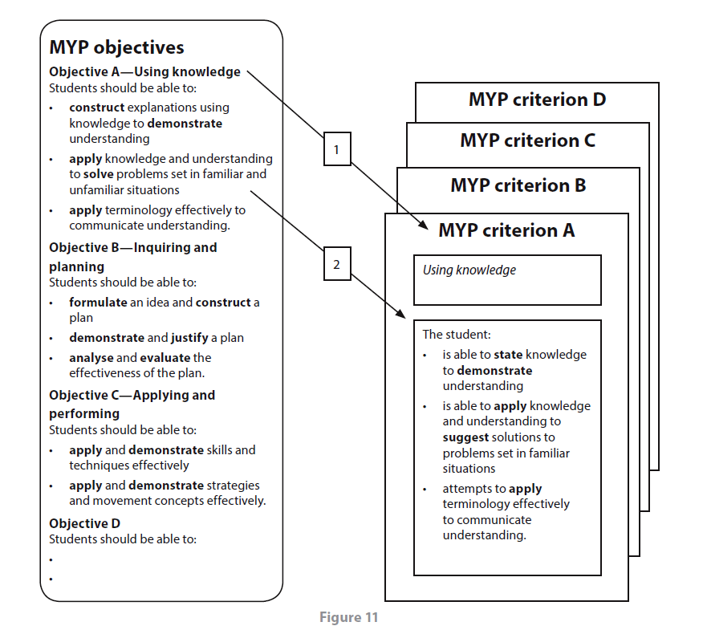
What Does This Mean For Unit Planning?
Although the wording of the Objectives cannot be changed, the language of the MYP Criteria can be modified to make it more comprehensible and clearer for the students.

SUMMATIVE ASSESSMENTS

Philosophy and Place in the IB Continuum

Summative assessment tasks should be directly linked to the statement of inquiry and provide varied opportunities for students to demonstrate their knowledge, understanding and skills. In planning these assessments of learning, teachers should ask the following questions.
- How does this assessment task relate to the statement of inquiry?
- Which MYP objectives are being addressed?
- How can we create meaningful performances of understanding?
- What evidence of learning will there be?
- How can we collect evidence of learning?
- How will the assessment task demonstrate conceptual understanding?
- How will results be recorded and analysed?
- How and when will students receive feedback?

From MYP Principles to Practice p. 64

What Does This Mean for Unit Planning?

Summative assessments should tie directly into the Statement of Inquiry, MYP Objectives and the skills that and knowledge that are addressed during the Unit. If there is not a strong link to all three components, that it is likely that the Summative assessment does not represent what the students learned during the unit itself.

EVALUATING SUMMATIVE ASSESSMENTS
Summative Assessments
 | Using  Capable | Sharing  Exemplary
  Beginning/developing
  Emergent
 | The summative assessment task(s):  • relates to the statement of inquiry  • offers students a meaningful opportunity to demonstrate what they understand (know and can do)  • addresses MYP subject-group objectives  • can be differentiated to meet individual student needs. | The summative assessment task(s):  • thoughtfully connects with the statement of inquiry  • allows open-ended and multiple ways for students to communicate their understanding  • thoroughly explains what students will do to demonstrate understanding  • uses relevant MYP subject-group criteria to judge student achievement  • represents an appropriate degree of challenge  • balances manageability with authenticity  • takes into account students with inclusive assessment arrangements.
  The summative assessment task(s):
  • has a limited connection with the statement of inquiry
  • may represent an assignment that is not challenging enough or too complex for most learners
  • does not clearly address MYP subject-group objectives.
From Evaluating MYP Unit Planners p.5

Task Specific Clarifications

Summative tasks must be assessed with MYP Criteria. These criteria can be modified to allow for clarification and guidance for the students. BOLD WORDS CAN NOT BE CHANGED.

For a Language Acquisition Criterion C, Communicating in Response to Spoken, Written and Visual Text, the Criterion may be adapted as follows.

ORIGINAL 7–8 The student:
- responds in detail and appropriately to simple short phrases and basic information in spoken language
ii. interacts confidently in simple and rehearsed exchanges, using verbal and non verbal language
- uses basic phrases effectively to communicate ideas, feelings and information on a variety of aspects of everyday topics
iv. communicates with an excellent sense of audience.

ADAPTED RUBRIC 7–8 The student:
- responds in detail and appropriately to simple short phrases and basic information in spoken language using relevant research from sources to explain the environmental problem and desired action

- interacts confidently in simple and rehearsed exchanges, using verbal and non verbal language employing eye contact, nodding, rephrasing given statements, clear loud speaking voice,

- uses conditional and transitional phrases effectively to communicate ideas, feelings and information on a variety of aspects of the environmental issue of the presentation

- communicates with an excellent sense of formality suited for a board of county supervisors.

APPROACHES to LEARNING
Philosophy and Place in the IB Continuum
Through ATL in IB programmes, students develop skills that have relevance across the curriculum that help them “learn how to learn”. ATL skills can be learned and taught, improved with practice and developed incrementally. They provide a solid foundation for learning independently and with others. ATL skills help students prepare for, and demonstrate learning through, meaningful assessment. They provide a common language that students and teachers can use to reflect on, and articulate on, the process of learning.
IB programmes identify five ATL skill categories, expanded into developmentally appropriate skill clusters
ATK Skill Categories | MYP Skill Clusters
Communication | - Communication
Social | - Social
Self-Management | - Organization
Self-Management | - Affective
Self-Management | - Reflection
Research | - Information Literacy
Research | - Media Literacy
Thinking | - Critical Thinking
Thinking | - Creative Thinking
Thinking | - Transfer
From MYP: Principles to Practice, p. 20

What Does it Mean for Unit Planning?
Every MYP unit identifies ATL skills that students will develop through their inquiry and demonstrate in the unit’s formative (if applicable) and summative assessments. Many ATL skills directly support the attainment of subject-group objectives
From MYP: Principles to Practice, p. 64
For each of your chosen ATL categories and skill cluster, complete the following sentence frame:

Criterion : ________, year_______________

In order for a student to (this is the strand from your rubric) ________________ students must (ATL skill indicator which is one of the bulleted items in your ATL packet) ________________

Which ATL Category: __________

Which ATL Skill Cluster ____________

How Do ATL Fit Into Instruction?
Make sure that the ATL can be tied back to your Objectives, Summative Assessments and learning experiences.

You should only select an Approach to Learning if you will explicitly teach the skill and provide students feedback on it over the course of the unit.

How can students demonstrate their developing ATL skills?
Communication
- Communication Skills
How can students communicate through interaction?  Exchanging thoughts, messages and information effectively through  interaction | • Give and receive meaningful feedback  • Use intercultural understanding to interpret communication  • Use a variety of speaking techniques to communicate with a variety  of audiences  • Use appropriate forms of writing for different purposes and audiences  • Use a variety of media to communicate with a range of audiences  • Interpret and use effectively modes of non-verbal communication  • Negotiate ideas and knowledge with peers and teachers  • Participate in, and contribute to, digital social media networks  • Collaborate with peers and experts using a variety of digital  environments and media  • Share ideas with multiple audiences using a variety of digital  environments and media
How can students demonstrate communication through language?  Reading, writing and using language to gather and communicate  information | • Read critically and for comprehension  • Read a variety of sources for information and for pleasure  • Make inferences and draw conclusions  • Use and interpret a range of discipline-specific terms and symbols  • Write for different purposes  • Understand and use mathematical notation  • Paraphrase accurately and concisely  • Preview and skim texts to build understanding  • Take effective notes in class  • Make effective summary notes for studying  • Use a variety of organizers for academic writing tasks  • Find information for disciplinary and interdisciplinary inquiries, using  a variety of media  • Organize and depict information logically  • Structure information in summaries, essays and reports

Social
- Collaboration Skills
How can students collaborate?  Working effectively with others | • Use social media networks appropriately to build and develop  relationships  • Practice empathy  • Delegate and share responsibility for decision-making  • Help others to succeed  • Take responsibility for one’s own actions  • Manage and resolve conflict, and work collaboratively in teams  • Build consensus  • Make fair and equitable decisions  • Listen actively to other perspectives and ideas  • Negotiate effectively  • Encourage others to contribute  • Exercise leadership and take on a variety of roles within groups  • Give and receive meaningful feedback  • Advocate for one’s own rights and needs

Self Management
- Organization Skills
How can students demonstrate organization skills?  Managing time and tasks effectively | • Plan short- and long-term assignments; meet deadlines  • Create plans to prepare for summative assessments (examinations/performances)  • Keep and use a weekly planner for assignments  • Set goals that are challenging and realistic  • Plan strategies and take action to achieve personal and academic goals  • Bring necessary equipment and supplies to class  • Keep an organized and logical system of information files/notebooks  • Use appropriate strategies for organizing complex information  • Understand and use sensory learning preferences (learning styles)  • Select and use technology effectively and productively
- Affective
How can students manage their own state of mind?  Managing state of mind | • Mindfulness awareness  –– Practice focus and concentration  –– Practice strategies to develop mental focus  –– Practice strategies to overcome distractions  –– Practice being aware of body–mind connections  • Perseverance  –– Demonstrate persistence and perseverance  –– Practice delaying gratification  • Emotional management  –– Practice strategies to overcome impulsiveness and anger  –– Practice strategies to prevent and eliminate bullying  –– Practice strategies to reduce stress and anxiety  • Self-motivation  –– Practice analyzing and attributing causes for failure  –– Practice managing self-talk  –– Practice positive thinking  • Resilience  –– Practice “bouncing back” after adversity, mistakes and failures  –– Practice “failing well”  –– Practice dealing with disappointment and unmet expectations  –– Practice dealing with change
- Reflective Skills
How can students be reflective?  (Re)considering the process of learning; choosing and using ATL skills | • Develop new skills, techniques and strategies for effective learning  • Identify strengths and weaknesses of personal learning strategies (self-assessment)  • Demonstrate flexibility in the selection and use of learning strategies  • Try new ATL skills and evaluate their effectiveness  • Consider content  –– What did I learn about today?  –– What don’t I yet understand?  –– What questions do I have now?  • Consider ATL skills development  –– What can I already do?  –– How can I share my skills to help peers who need more practice?  –– What will I work on next?  • Consider personal learning strategies  –– What can I do to become a more efficient and effective learner?  –– How can I become more flexible in my choice of learning strategies?  –– What factors are important for helping me learn well?  • Focus on the process of creating by imitating the work of others  • Consider ethical, cultural and environmental implications  • Keep a journal to record reflections
Research
- Information Literacy Skills
How can students demonstrate information literacy?  Finding, interpreting, judging and creating information | • Collect, record and verify data  • Access information to be informed and inform others  • Make connections between various sources of information  • Understand the benefits and limitations of personal sensory learning  preferences when accessing, processing and recalling information  • Use memory techniques to develop long-term memory  • Present information in a variety of formats and platforms  • Collect and analyze data to identify solutions and make informed decisions  • Process data and report results  • Evaluate and select information sources and digital tools based on their appropriateness to specific tasks  • Understand and use technology systems  • Use critical-literacy skills to analyze and interpret media communications  • Understand and implement intellectual property rights  • Create references and citations, use footnotes/endnotes and construct a bibliography according to recognized conventions  • Identify primary and secondary sources
- Media Literacy Skills
How can students demonstrate media literacy?  Interacting with media to use and create ideas and information | • Locate, organize, analyze, evaluate, synthesize and ethically use information from a variety of sources and media (including digital social media and online networks)  • Demonstrate awareness of media interpretations of events and ideas (including digital social media)  • Make informed choices about personal viewing experiences  • Understand the impact of media representations and modes of presentation  • Seek a range of perspectives from multiple and varied sources  • Communicate information and ideas effectively to multiple audiences using a variety of media and formats  • Compare, contrast and draw connections among (multi)media resources

Thinking
- Critical Thinking Skills
How can students think critically?  Analyzing and evaluating issues and ideas | • Practice observing carefully in order to recognize problems  • Gather and organize relevant information to formulate an argument  • Recognize unstated assumptions and bias  • Interpret data  • Evaluate evidence and arguments  • Recognize and evaluate propositions  • Draw reasonable conclusions and generalizations  • Test generalizations and conclusions  • Revise understanding based on new information and evidence  • Evaluate and manage risk  • Formulate factual, topical, conceptual and debatable questions  • Consider ideas from multiple perspectives  • Develop contrary or opposing arguments  • Analyze complex concepts and projects into their constituent parts and synthesize them to create new understanding  • Propose and evaluate a variety of solutions  • Identify obstacles and challenges  • Use models and simulations to explore complex systems and issues  • Identify trends and forecast possibilities  • Troubleshoot systems and applications
- Creative Thinking Skills
How can students be creative?  Generating novel ideas and considering new perspectives | • Use brainstorming and visual diagrams to generate new ideas and inquiries  • Consider multiple alternatives, including those that might be unlikely or impossible  • Create novel solutions to authentic problems  • Make unexpected or unusual connections between objects and/or ideas  • Design improvements to existing machines, media and technologies  • Design new machines, media and technologies  • Make guesses, ask “what if” questions and generate testable hypotheses  • Apply existing knowledge to generate new ideas, products or processes  • Create original works and ideas; use existing works and ideas in new ways  • Practice flexible thinking—develop multiple opposing, contradictory and complementary arguments  • Practice visible thinking strategies and techniques  • Generate metaphors and analogies
- Transfer Skills
How can students transfer skills and knowledge across disciplines and subject groups?  Using skills and knowledge in multiple contexts | • Use effective learning strategies in subject groups and disciplines  • Apply skills and knowledge in unfamiliar situations  • Inquire in different contexts to gain a different perspective  • Compare conceptual understanding across multiple subject groups and disciplines  • Make connections between subject groups and disciplines  • Combine knowledge, understanding and skills to create products or solutions  • Transfer current knowledge to learning of new technologies  • Change the context of an inquiry to gain different perspectives
From MYP: Principles to Practice p. 99-103
EVALUATING ATL

Approaches to learning (ATL)

Beginning/developing  Emergent | Using  Capable | Sharing  Exemplary
ATL skills in this unit:  • identify skills from one or more MYP skill clusters  • are chosen in relationship to the unit’s objectives and assessment tasks  • connect with a larger plan for developing students’ ATL skills  • develop too many or too few ATL skills that may be too simple or too complex for the intended learners. | ATL skills in this unit:  • develop general and subject-specific competencies  • are taught explicitly and practiced in the course of the unit  • help students to reach higher achievement levels for the unit’s summative assessment task(s)  • provide a focus for student self-evaluation and reflection on personal growth and development  • are vertically articulated. | ATL skills in this unit:  • support and develop MYP subject-group objectives  • offer students opportunities to develop responsibility for their own learning through independent practice  • integrate meaningfully with learning engagements and assessment tasks  • support a clearly identified progression of learning across the MYP years  • articulate ATL skills in the unit with other subject groups, year levels or school-wide plans (documented in the school’s ATL chart).

From: Evaluating MYP Unit Planners p. 6

CONTENT
There is space in this section of the planner to list subject-specific content. This content may be mandated by state or national systems; it may come from school-based requirements or the school’s curriculum overview; or it may be derived from a range of education standards.

At the subject-group overview level of planning, content constitutes the disciplinary knowledge and skills to be taught and learned in each year of the programme. Such an overview develops a clear progression of learning, including the disciplinary topics that students encounter in the course of their MYP experience.

The starting point for identifying significant content is students’ current understanding. The goal of teaching and learning in the MYP is the active construction of meaning in which students build connections between their prior understanding and new information and experience that they gain through inquiry. “Front-loading” content (efficiently building background knowledge) can be important, introducing a base from which to teach skills or practise critical thinking. Effective inquiry often is not possible without facts and prior knowledge.

Schools that follow a national, state or local curriculum need to align the content standards (aims and objectives) or programme of study with MYP requirements. For schools with no required curriculum, teachers are responsible for choosing appropriate content that will enable students to reach MYP subject group aims and objectives. Schools can expand the scope of topics and depth of treatment according to their individual needs, preferences and possibilities.

From MYP Principles to Practice p. 66

EVALUATING CONTENT

Content
Beginning/developing  Emergent | Using  Capable | Sharing  Exemplary
 | The unit’s subject matter/content:  • lists subject-group knowledge that illustrates or is informed by the unit’s chosen key and related concepts  • aligns with the MYP subject-group aims and objectives chosen for the unit  • represents an appropriate level of challenge. | The unit’s subject matter/content:  • includes disciplinary knowledge and skills to be taught and learned that are solidly connected with the chosen key and related concepts  • begins with students’ prior understanding and builds necessary background knowledge  • connects MYP objectives with any local requirements, standards or subject-group content  • represents reasonable developmental and practical demands  • if relevant, establishes links with MYP topics
  The unit’s subject matter/content:
  • may not be clearly aligned with the unit’s key and related concepts
  • does not clearly connect with MYP subject-group aims and objectives
  • suggests inappropriate expectations (too low or too high).

Learning Experiences
Philosophy and Place in the IB curriculum
Teachers should purposefully choose strategies and learning experiences that are aligned with the unit’s statement of inquiry; help students meet subject-group objectives; support the development of effective ATL skills; and meaningfully prepare students to achieve high levels of performance in the unit’s summative assessment. The specific learning experiences and teaching strategies devised by teachers depend on available resources, the content to be taught and on the subjects themselves.
Teachers should ensure that a range of learning experiences and teaching strategies is:
- embedded in the curriculum
- built upon prior learning
- age-appropriate, thought-provoking and engaging
- based on the differing needs of all students, including those who are learning in a language other than their mother tongue, and students with learning support requirements
- open-ended and involves teaching problem-solving skills.

Teachers should choose strategies that provide for learning through disciplined inquiry and research; involve communication of ideas and personal reflection; and give students the opportunity to practise and apply their new understandings and skills.
From Principles to Practice, p. 67

Learning Experiences Chart
Subject Objectives | Strands of the subject objectives | Possible learning experiences | ATL Skill | Resources
A
Subject Objectives | Strands of the subject objectives | Possible learning experiences |  | Resources
B
Subject Objectives | Strands of the subject objectives | Possible learning experiences |  | Resources
C
Subject Objectives | Strands of the subject objectives | Possible learning experiences |  | Resources
D

EVALUATING LEARNING EXPERIENCES
a) Learning experiences and teaching strategies
Beginning/developing  Emergent | Using  Capable | Sharing  Exemplary
Learning experiences and teaching strategies:  • do not clearly align with the unit’s purpose and content  • offer limited variety and more teacher-centred classroom activities  • are not developed in sufficient detail. | Learning experiences and teaching strategies:  • align with the unit’s purpose  • include some inquiry-based approaches to teaching  • are developmentally (age) appropriate  • provide variety that sustains student engagement. | Learning experiences and teaching strategies:  • are appropriate for the unit’s content and aligned with its purpose  • build on prior learning  • are developmentally (age) appropriate, thought-provoking and engaging  • use inquiry-based strategies for teaching and learning  • are sufficiently detailed to understand what students will do, and in what order.

Formative assessment
Formative assessment can take place before, during and after the substance of a unit is taught. Teachers need to develop ways of ascertaining students’ prior learning so that they can plan appropriate learning experiences and teaching strategies.
Teachers also need to consider how to monitor and support learning as students engage with the unit. Formative assessment (assessment for learning) provides teachers and students with insights into the ongoing development of knowledge, understanding, skills and attitudes. Assessment for learning is “the process of seeking and interpreting evidence for use by learners and their teachers to decide where the learners are in their learning, where they need to go and how best to get there” (Black et al. 2002). Effective formative assessment also provides teachers and students with a way to explore personal learning styles as well as individual student strengths, challenges and preferences that can inform meaningful differentiation of learning.
Formative assessment can also provide important opportunities for students to rehearse or refine performances of understanding as they prepare to complete summative assessment tasks.
Peer and self-assessment are often valuable formative assessment strategies.
From Principles to Practice, p 67

EVALUATING FORMATIVE ASSESSMENTS
(b) Formative assessment
Beginning/developing  Emergent | Using  Capable | Sharing  Exemplary
Formative assessment:  • provides few opportunities to monitor and support student learning  • is not clearly connected with the knowledge, understanding and skills required for success in summative assessment  • offers few opportunities to create evidence that teachers can use to adjust their teaching plans. | Formative assessment:  • provides opportunities for practice and explicit feedback for learning  • aligns with knowledge, understanding and skills required for success in summative assessment  • creates evidence that teachers can use to adjust teaching and learning in ways that promote student achievement. | Formative assessment:  • provides opportunities for practice and explicit feedback for learning  • provides multiple opportunities to monitor and support student learning  • comprehensively aligns with knowledge, understanding and skills required for success in summative assessment  • creates evidence that teachers can use to make adjustments to planned experiences and teaching strategies  • considers opportunities for peer assessment and self-assessment.

Differentiation
Differentiation (modifying teaching strategies to meet the needs of diverse learners) can build opportunities in which each student can develop, pursue and achieve appropriate personal learning goals. When considering pedagogical approaches to meeting individual learning needs, teachers also need to consider each student’s language profile.
The IB identifies four important principles to promote equal access to the curriculum for all learners and to support the development of the whole person through differentiated teaching and learning, as illustrated in figure 10.

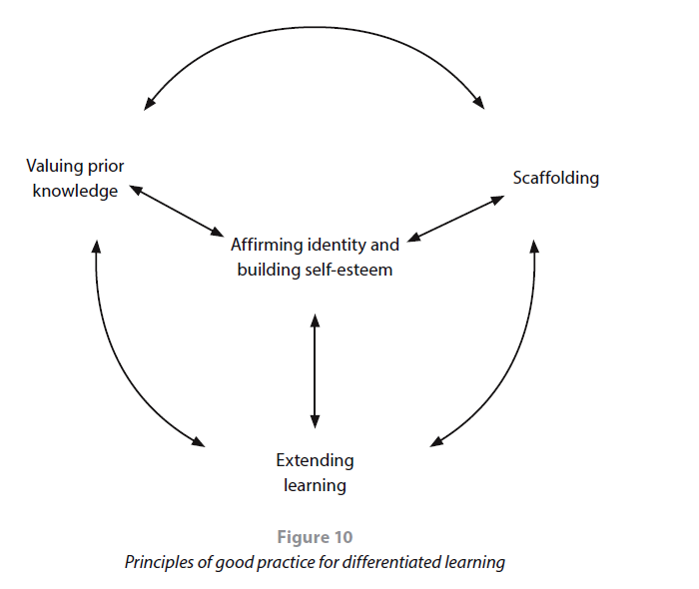

From Principles to Practice p. 68

EVALUATING DIFFERENTIATION

Differentiation
Beginning/developing  Emergent | Using  Capable | Sharing  Exemplary
Differentiation:  • documents limited strategies for accommodating learning diversity. | Differentiation:  • considers content, process and product  • takes into account students’ language profiles and learning support requirements. | Differentiation:  • offers opportunities in which each student can develop, pursue and achieve appropriate learning goals  • considers content, process and product  • takes into account students’ language profiles and learning support requirements, using student diversity as a resource for all students’ learning.

Resources
Teachers need to investigate available resources and consider what additional resources might be necessary for the unit. Important resources to consider include:
- instructional materials and classroom technologies
- textbooks and other written and visual texts
- teaching materials developed by businesses and not-for-profit organizations
- educational games and simulations
- teaching aids and manipulatives
- learning environments beyond the classroom
- students’ diverse languages and cultures
- families, experts and other primary sources in the school and the community
- school, university and community libraries
- digital resources, including the internet.

From Principles to Practice p 69

EVALUATING RESOURCES

7) Resources
Beginning/developing  Emergent | Using  Capable | Sharing  Exemplary
Resources:  • provide some of the information and learning environments necessary for achieving the unit’s purpose. | Resources:  • provide the information and learning environments necessary for achieving the unit’s purpose  • represent culturally responsive and diverse points of view  • support differentiated learning. | Resources:  • represent a wide range of creative springboards to learning  • integrate technology effectively  • create opportunities for hands-on learning  • utilize people, organizations and facilities from the community  • take into account students’ experiences and literacies  • use multilingualism as a resource  • promote further student inquiry.

Reflection
The “Reflection” section of the MYP unit planner provides teachers with an invitation to record their reflection at three important periods in the unit’s development and implementation. Reflection in the unit planner can provide a starting point for collaborative planning, an ongoing reminder for reflective practice throughout the teaching process, and a format in which to evaluate teaching strategies and learning outcomes.
Reflection involves individual and collaborative consideration of the unit’s planning, process and impact. Reviewing each of the required elements of MYP unit planning is a valuable strategy for reflection. Teachers can profitably reflect prior to teaching the unit, during teaching and after the unit has been taught. Including students in reflection on the unit is an important strategy to promote the student-centred approach to education valued in IB programmes.

Prior to teaching the unit
- Why do we think that the unit or the selection of topics will be interesting?
- What do students already know, and what can they do?
- What have students encountered in this discipline before?
- What does experience tell us about what to expect in this unit?
- What attributes of the learner profile does this unit offer students opportunities to develop?
- What potential interdisciplinary connections can we identify?
- What do we know about students’ preferences and patterns of interaction?
- Are there any possible opportunities for meaningful service learning?
- What in the unit might be inspiring for community or personal projects?
- Could we develop authentic opportunities for service learning?
- How can we use students’ multilingualism as a resource for learning?

During teaching
- What difficulties did we encounter while completing the unit or the summative assessment task(s)?
- What resources are proving useful, and what other resources do we need?
- What student inquiries are emerging?
- What can we adjust or change?
- What skills need more practice?
- What is the level of student engagement?
- How can we scaffold learning for students who need more guidance?
- What is happening in the world right now with which we could connect teaching and learning in this unit?
- How well are the learning experiences aligned with the unit’s objectives?
- What opportunities are we giving to help students explore the interpretative nature of knowledge, including personal biases that might be retained, revised or rejected? (DP theory of knowledge skills development)

After teaching the unit
- What were the learning outcomes of this unit?
- How well did the summative assessment task serve to distinguish achievement levels?
- Was the task sufficiently complex to allow students to reach the highest levels?
- What evidence of learning can we identify?
- What artifacts of learning should we document?
- Which teaching strategies were effective? Why?
- What was surprising?
- What student-initiated action did we notice?
- What will we do differently next time?
- How will we build on our experience to plan the next unit?
- How effectively did we differentiate learning in this unit?
- What can students carry forward from this unit to the next year/level of study?
- Which subject groups could we work with next time?
- What did we learn from standardizing the assessment?

Evaluating Reflections

Before, during and after the unit
Beginning/developing  Emergent | Using  Capable | Sharing  Exemplary
Reflection before, during and after teaching:  • documents reflection that includes at least one phase of the teaching process  • partially considers connections to other programme components  • captures general observations about what went well and what might be improved. | Reflection before, during and after teaching:  • documents reflection on the planning, process and impact of the inquiry  • notes possible links with other subject groups and opportunities for student-led action and service learning  • considers student engagement  • notes potential future development (opportunities for improvement)  • considers how the unit supports MYP philosophy. | Reflection before, during and after teaching:  • demonstrates thorough and meaningful reflection throughout the teaching and learning process  • encompasses the written, taught and assessed curriculum  • makes interdisciplinary connections  • documents the unit’s reflection of the IB’s mission and values (including the IB learner profile)  • links the unit with appropriate opportunities for student-led action and service learning  • includes information about standardization of assessment and data analysis  • considers the unit in relation to horizontal and vertical articulation of the subject group.

Overall Unit Evaluation

 |  | Beginning | Using | Exemplary
Inquiry: Establishing the purpose of the unit
1 | Statement of inquiry
2 | Inquiry questions
3 | Summative assessment task
4 | Approaches to learning
Action: Teaching and learning through inquiry
5 | Content
6 | Learning process
(a) Learning experiences and teaching strategies

(b) Formative assessment

(c) Differentiation

7 | Resources
Reflection: Considering the planning, process and impact of the inquiry
8 | Before, during and after teaching

