Gibbsboro Home and School Association
November 10, 2020
- Sign attendance
  - If possible please record name in google meet chat
- Call to order
- Review of Minutes- October 2020
  - Link: https://www.gibbsboroschool.org/Page/714
- Approval of Minutes
  - Please record name and approval 1^{st-} and 2nd in google meet chat
- Treasurer’s Report
  - Link: https://www.gibbsboroschool.org/Page/714
  - Funding Request
    - Teacher and Staff Boxed Lunches
    - Holiday Gift for Secretaries and Custodial Staff
    - Mrs. Bereheiko- Funding request for alternative seating
  - Additional Treasurers reports can be viewed on https://www.gibbsboroschool.org/Page/202
- Chat with Mr. Marcellus
  - Please email any additional questions you may have to jmarcellus@gibbsboroschool.org
- Correspondence
  - Thank you card from Mrs. Jungclaus
  - 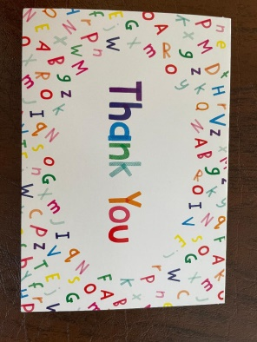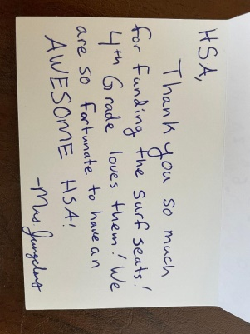
- Membership Drive
  - 63 Members
  - Class Contest Winners
    - 3A- Atkinson’s Class
- Ongoing Fundraisers
  - Box Tops for Education- Karista
    - https://www.gibbsboroschool.org/Page/197
  - Shutterfly Storefront
    - GibbsboroHSA.ShutterflyStorefront.com
    - https://www.gibbsboroschool.org/Page/726
  - Coca Cola Gives
- Upcoming Events & Fundraisers
  - Five Below- November 23rd-30th
    - Shop at Deptford, Marlton or Moorestown Locations!
    - Show or Bring in Flyer- 10% back to Gibbsboro HSA
  - Facebook Events
    - Turkey Decorating Contest
  - Winter Goodie Bags
  - Virtual Designer Bag Raffle
- Dinners Out
  - https://www.gibbsboroschool.org/Page/203
- Sunshine
  - Please email the HSA or reach out to our Sunshine Committee Member, Barbara Gerace
- New Business
- Adjournment
  - Have a fantastic holiday season! We hope to see you at our next meeting on January 12th.
Mission Statement: The mission of this organization shall be to coordinate the efforts of parents, teachers, students and community members to further enhance Gibbsboro School in the academic education, character education and recreational needs of its students.

