Gibbsboro Home and School Association
January 12, 2021
- Sign attendance
  - Please record name in google meet chat
- Call to order
- Review of Minutes- Unavailable
- Approval of Minutes
  - Review November & January Minutes during February Meeting
- Treasurer’s Report
  - Link: https://www.gibbsboroschool.org/Page/714
  - Additional Treasurers reports can be viewed on https://www.gibbsboroschool.org/Page/202
- Chat with Mr. Marcellus
  - Please email any additional questions you may have to jmarcellus@gibbsboroschool.org
- Correspondence
  - Thank you card from Jack Juckett
  - 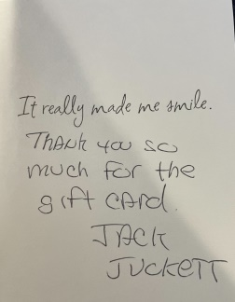
  - Holiday & Thank you card from Jeff Sproul
  - 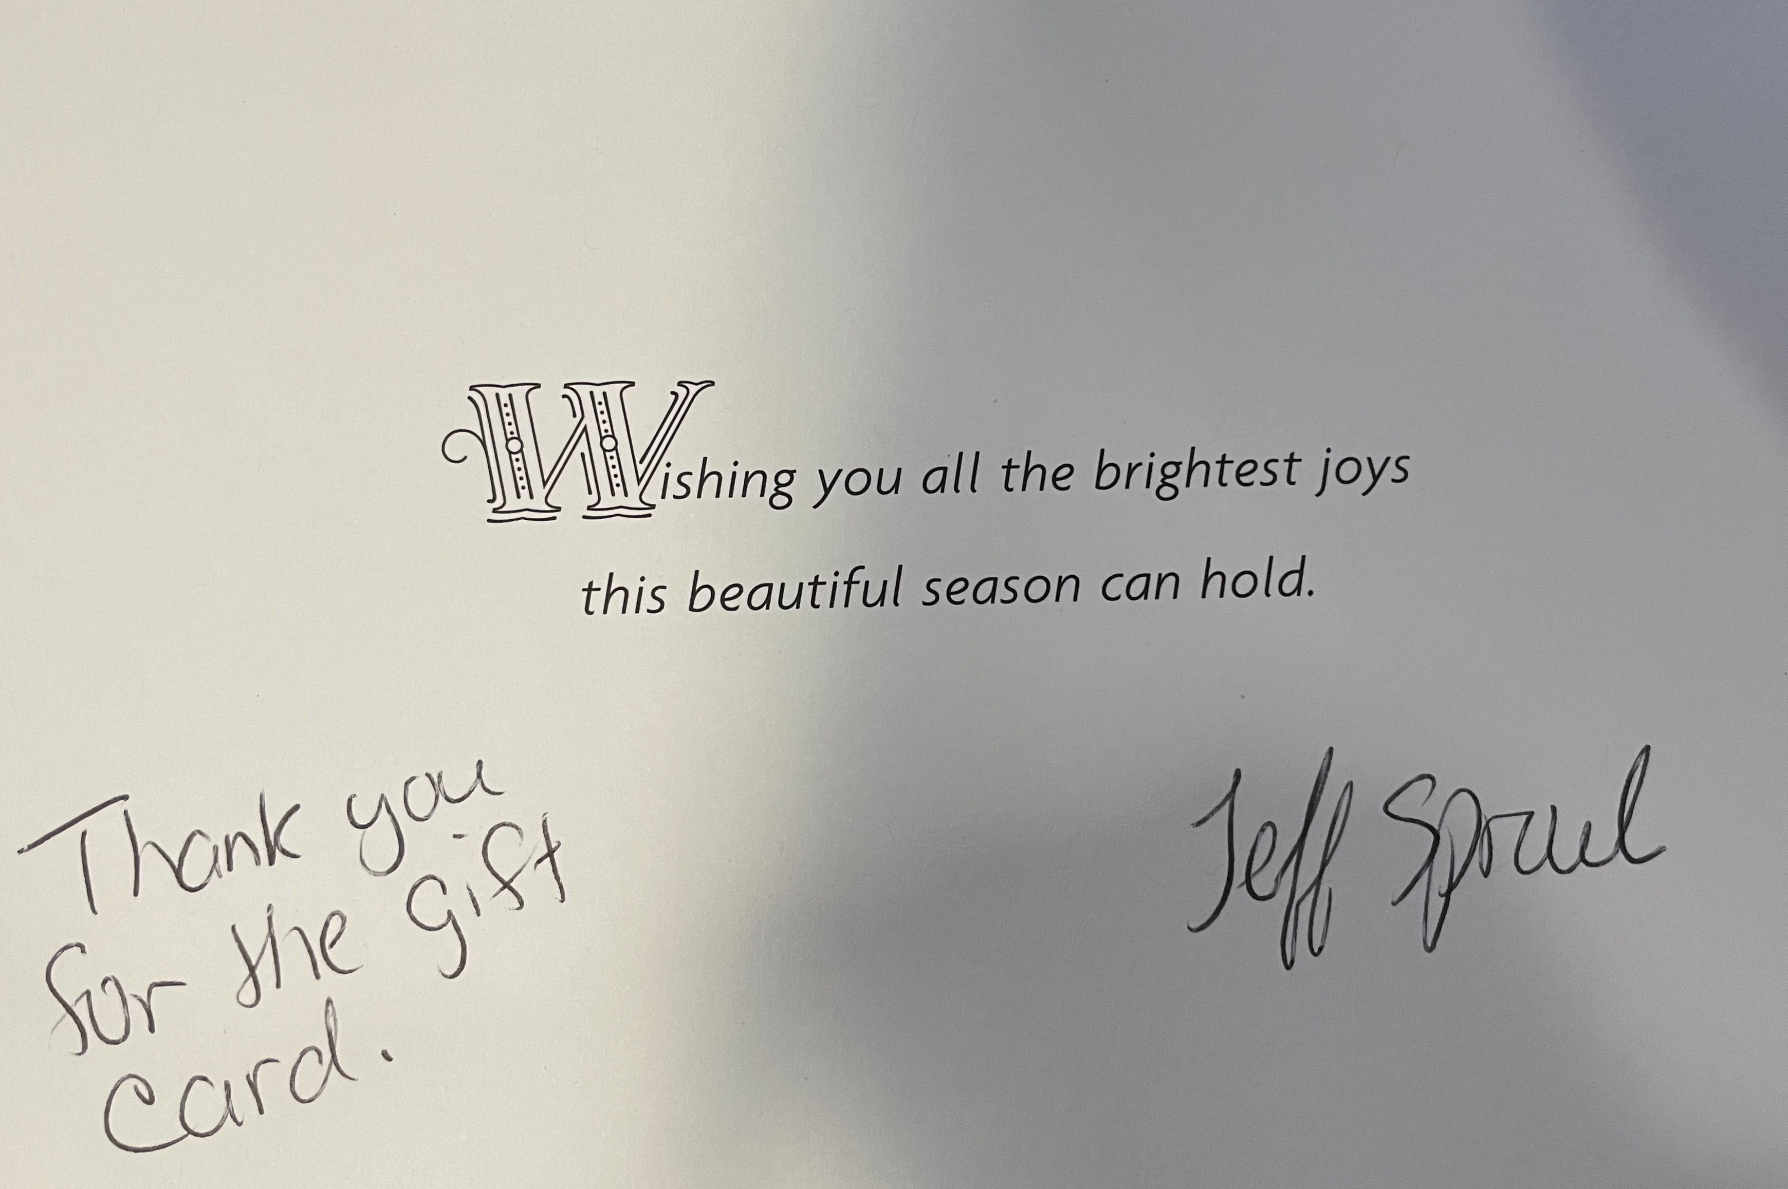
  - Holiday & Thank you card from Ro Aversa
  - 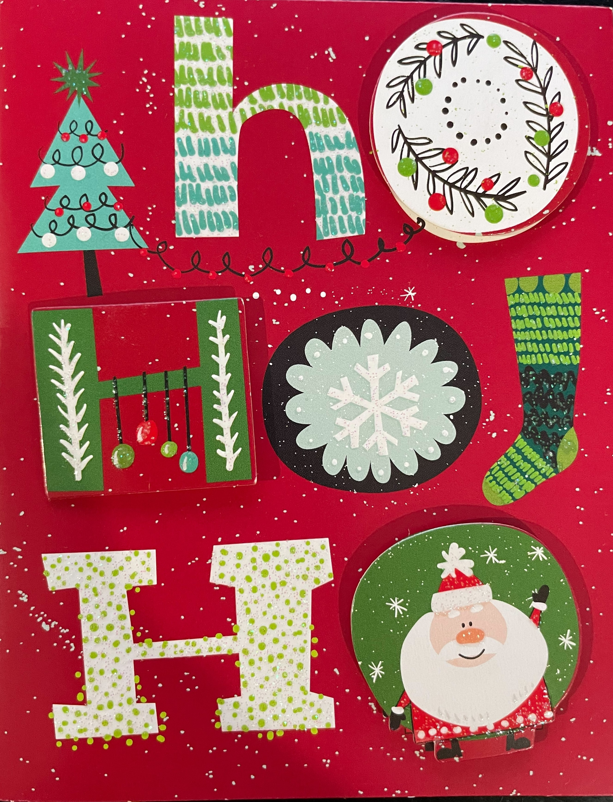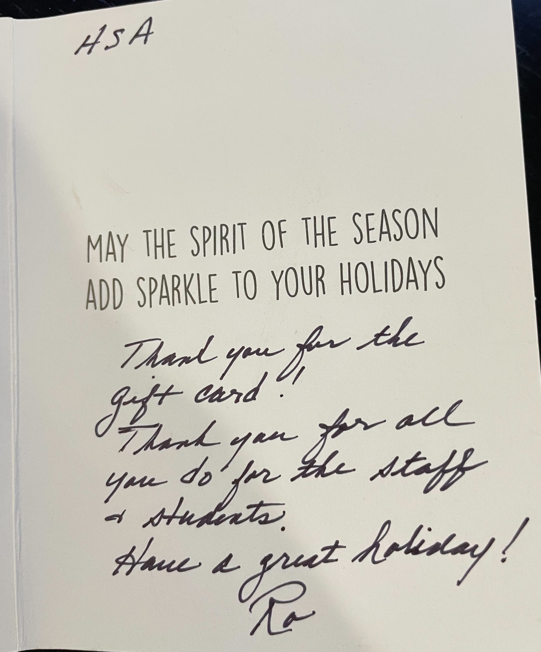
  - Thank you card from Mallory Pollock
  - 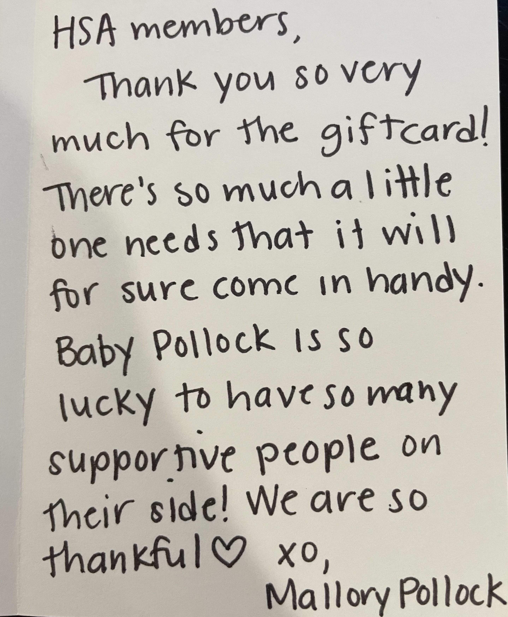
  - Holiday & Thank you card from Dave Savidge, Dave Earling, Jack the Hat, Jack Juckett, and Jeff Sproul
  - 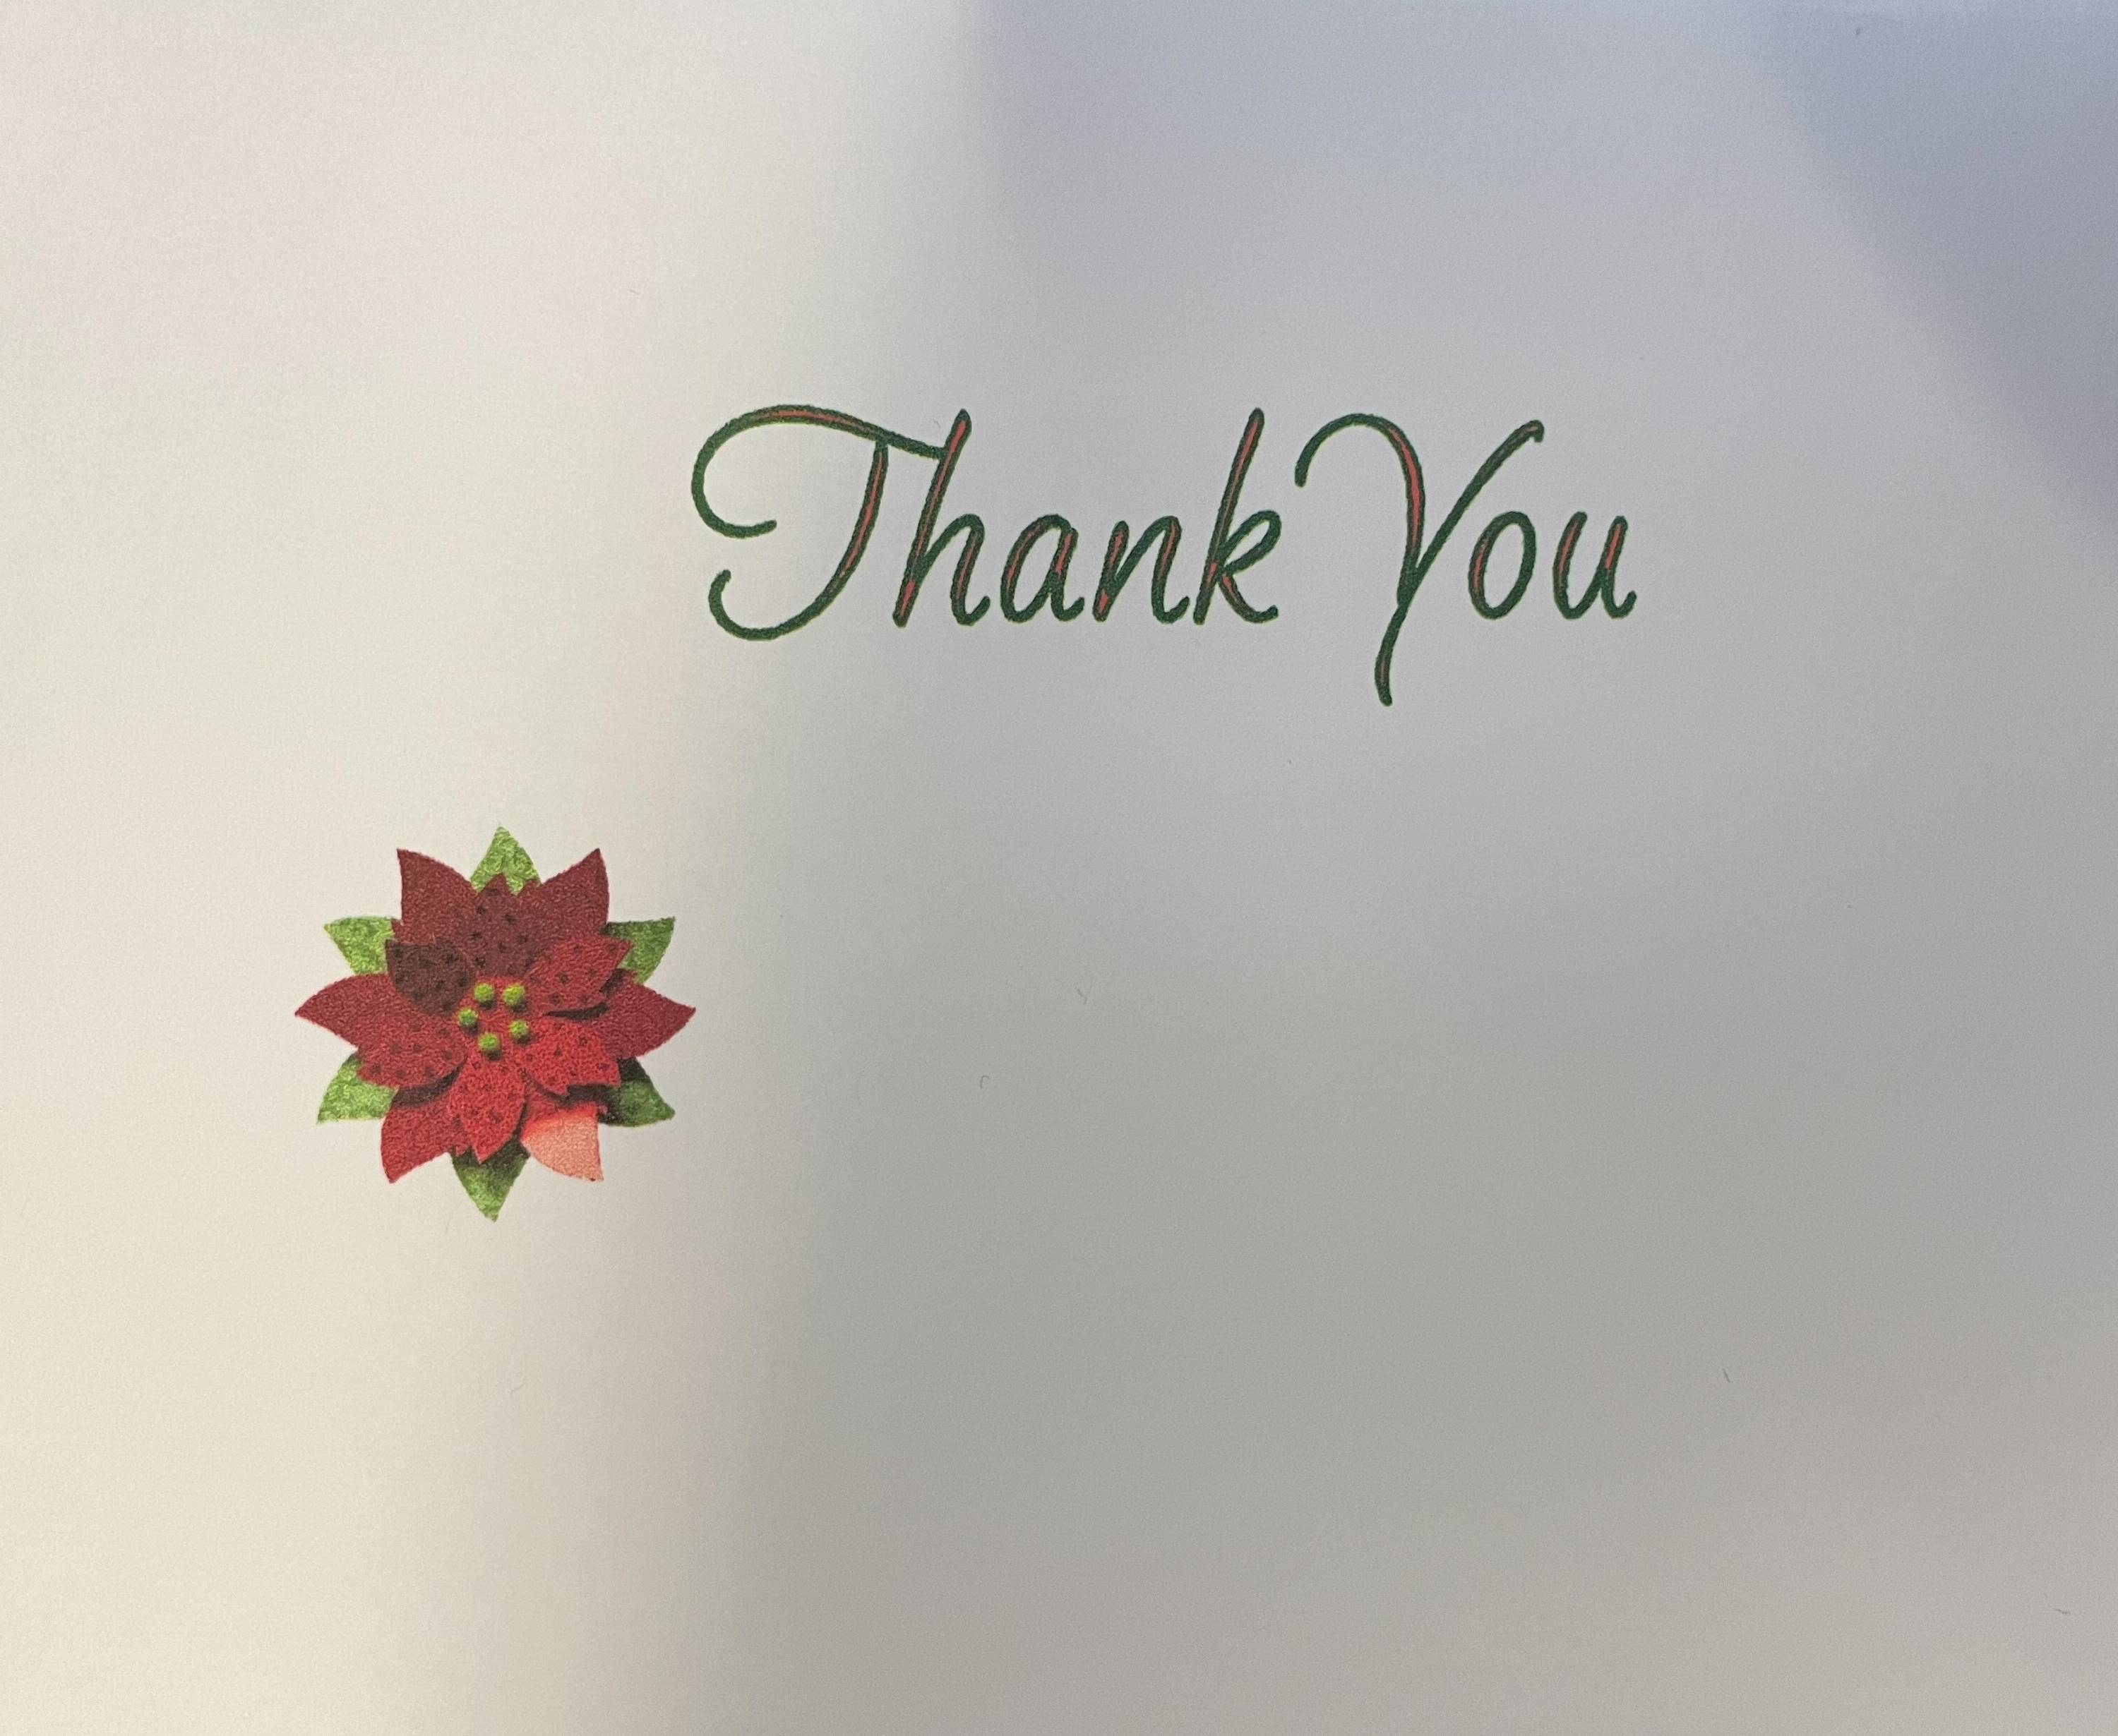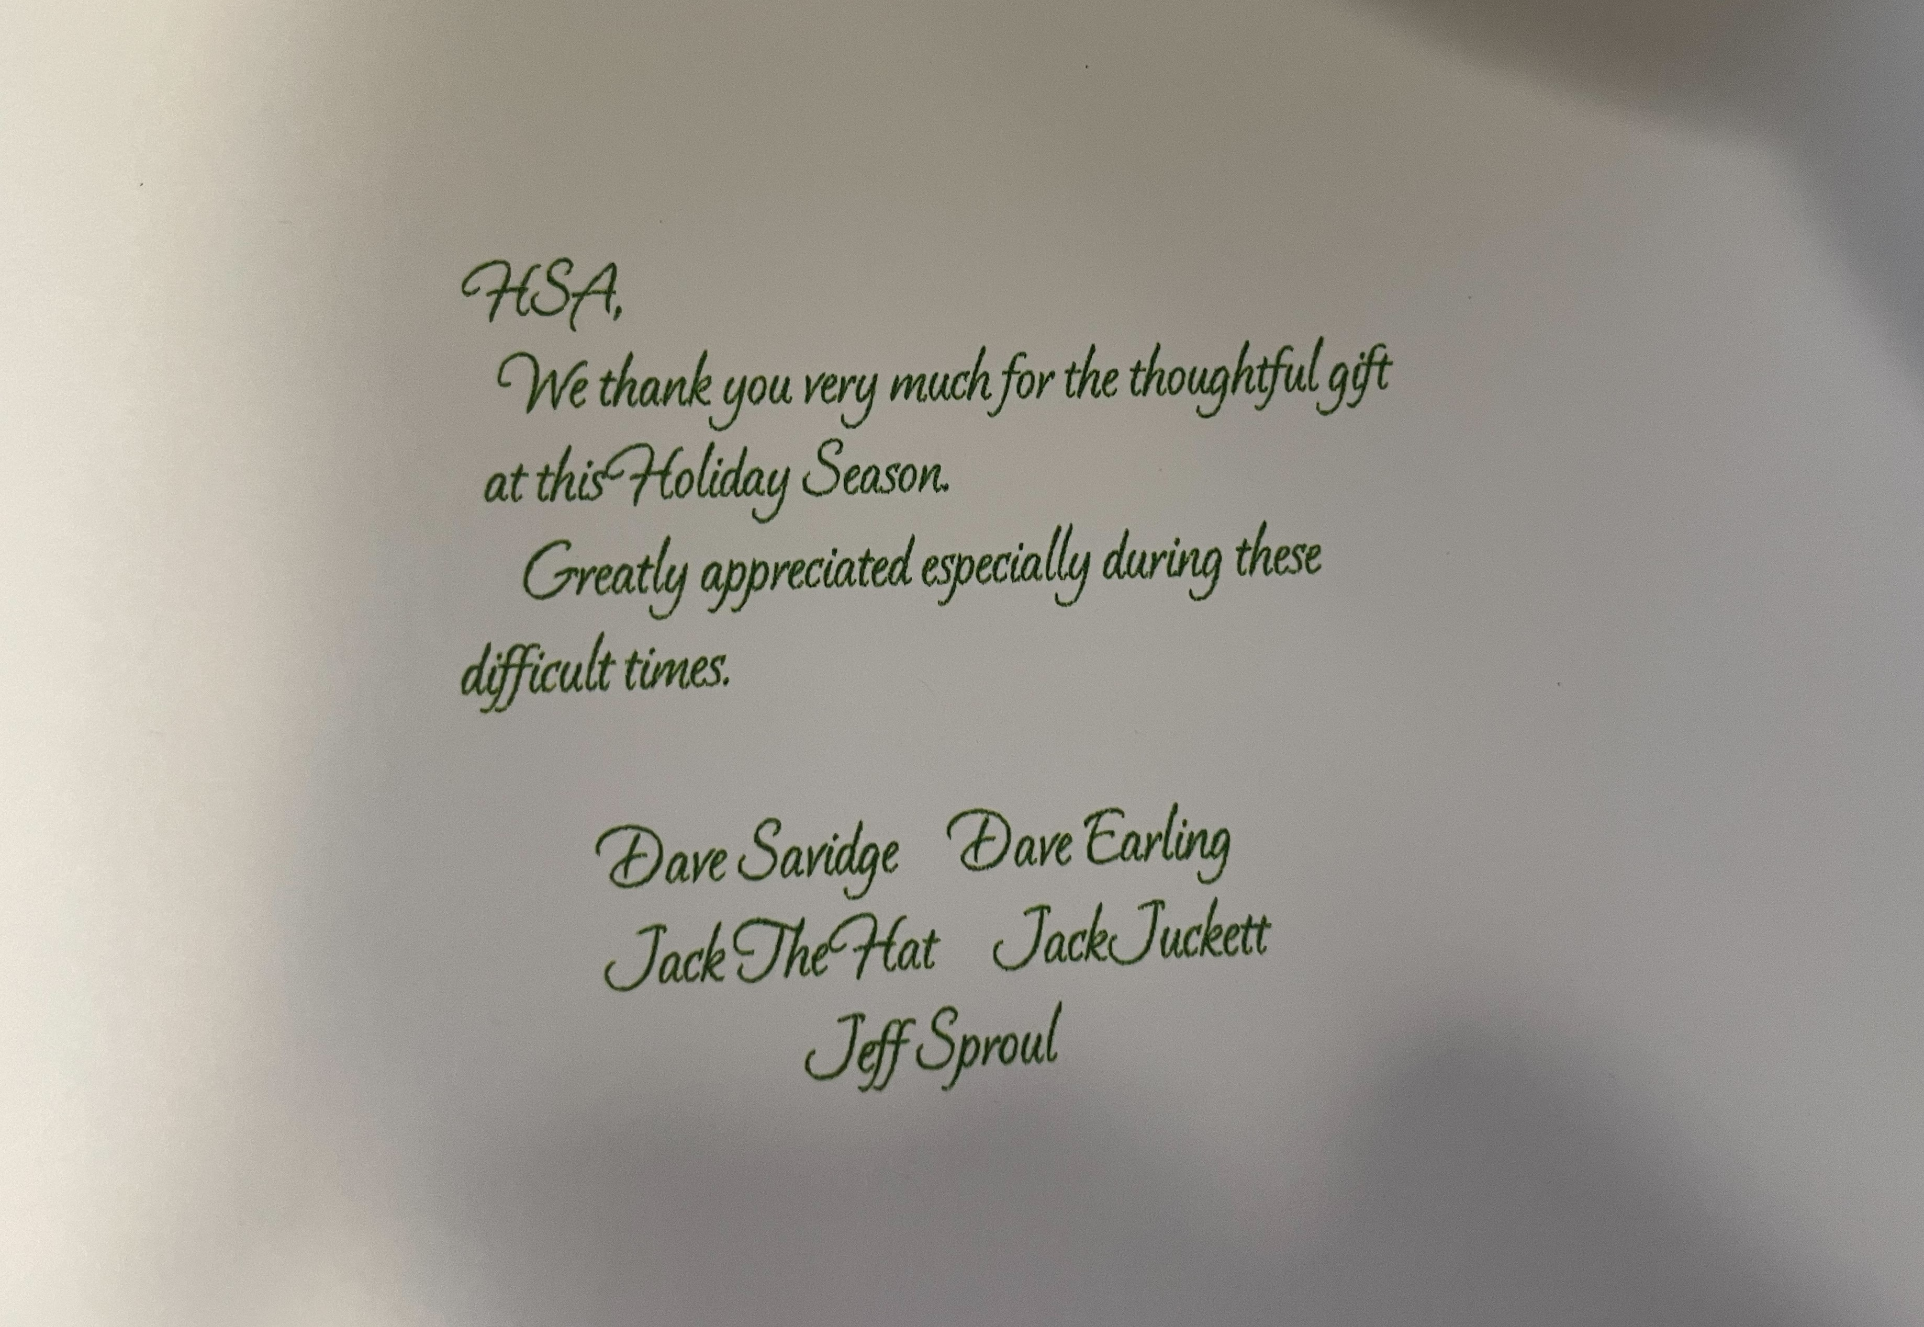
  - Holiday & Thank you card from Carol Didonato
  - 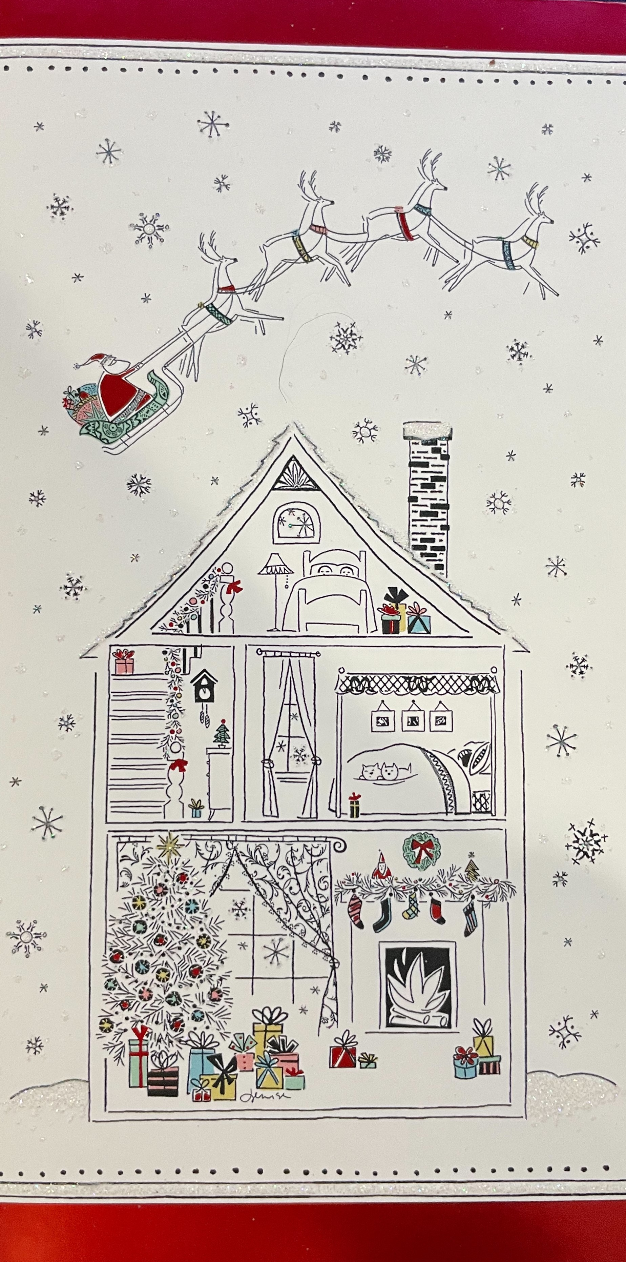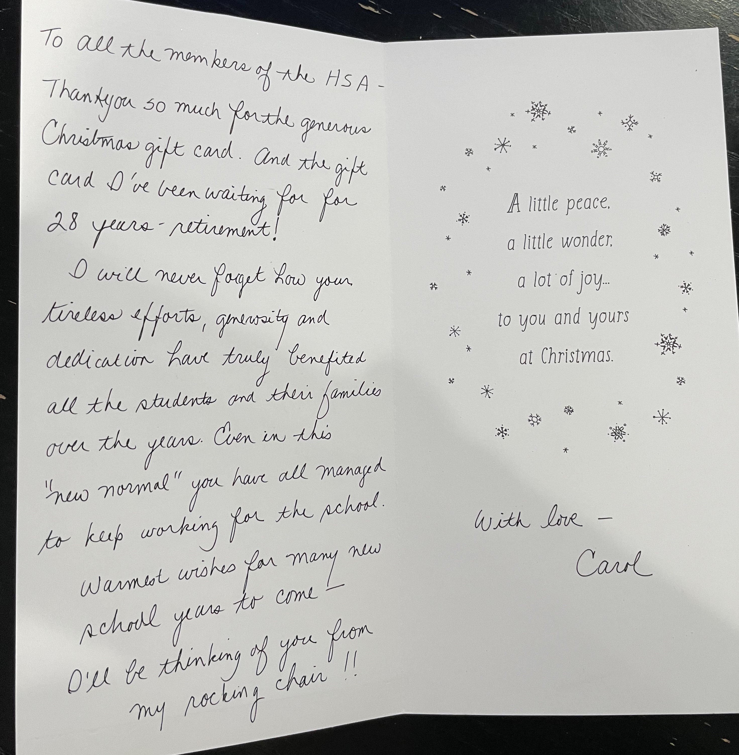
- Ongoing Fundraisers
  - Box Tops for Education
    - https://www.gibbsboroschool.org/Page/197
  - Shutterfly Storefront
    - Earned $38.48 so far
    - GibbsboroHSA.ShutterflyStorefront.com
    - 8% back to HSA for purchases made through the storefront
    - Able to use coupons and promotions
    - Not available through the app
    - https://www.gibbsboroschool.org/Page/726
  - Coca Cola Gives
- Upcoming Events & Fundraisers
  - Virtual Designer Bag Raffle
    - March 12th starting at 7pm
    - 20 Designer Bags and accessory items
    - Tickets are $20 each
- Dinners Out
  - Panera Bread- 1/15 from 4pm-8pm
  - Panda Express- 1/29 from 11am-9pm
  - https://www.gibbsboroschool.org/Page/203
- Sunshine
  - Please email the HSA or reach out to our Sunshine Committee Member, Barbara Gerace
- New Business
- Adjournment
Mission Statement: The mission of this organization shall be to coordinate the efforts of parents, teachers, students and community members to further enhance Gibbsboro School in the academic education, character education and recreational needs of its students.

