
Governance Team
January 23rd, 2024

- Welcome
- Agenda Approval
- School Improvement Plan Goals
  - Overarching Needs & Goals:
    - Need: Cultivate a climate and culture of achievement through reading that supports students as independent thinkers who are successful through all aspects of the Science of Reading.
      - Goal: At Ben Hill County Primary School, 60% of students will be reading at or above grade level at the end of the SY24 according to Acadience data.
    - Need: Cultivate a climate and culture of achievement through math instruction and student achievement.
      - Goal: At Ben Hill County Primary School, 60% of students will meet expected growth in mathematics from Fall assessment until Spring assessment using MAP.
    - Need: Cultivate a climate and culture to improve student growth from the beginning of the year writing samples to the end of the year writing samples.
      - Goal: Increase all students’ writing skills to improve reading comprehension.
    - Need: Cultivate a culture and climate that prioritizes communication and collaboration with all stakeholders that aligns with achievement for all students.
      - Goal: Increase communication with all stakeholders to occur on a weekly (staff) and monthly (parents/guardians) basis to support academic involvement and achievement for all students.
- Safety Update:
  - Silent Dismissal in place
    - Jan. 22nd, 2024
- School Data
  - Acadience:

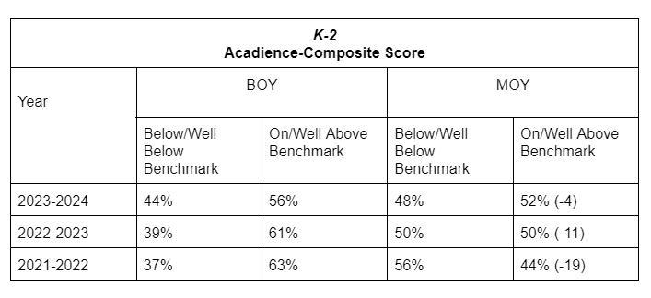

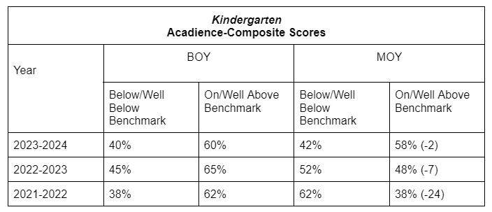

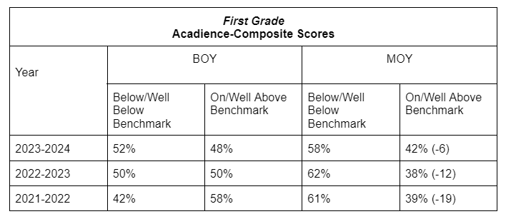

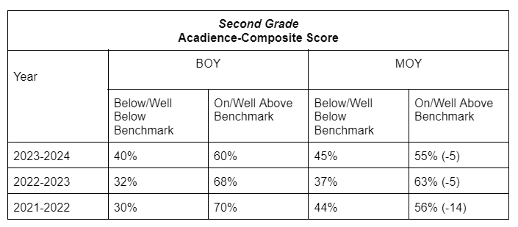

- Curriculum Update & Grades
  - My Math Academy- Need 2
    - Supportive app for students during independent stations based on their individual level.
  - My Reading Academy- Need 1
    - Supportive app for students during independent stations based on their individual level.

- Communication:
  - Parent Monthly Curriculum Newsletters & Parent Involvement Opportunities
    - January Curriculum Letter Sent

- Budget:
  - $9850.00 Remaining
    - Silent Dismissal:
      - Trial: $150.00- 45 Days
      - Full cost through Aug. 30th: $1403.50
    - Sensory Proposal
    - In Kind Letters
      - Sent 19 letters to Fortune 500 Companies
        - Specialized Learning Resources: Acquiring resources and materials that cater to the diverse learning needs of our students to include manipulatives, incentives, and other essential resources teachers are currently purchasing with their personal funds but not limited to these specifically. (Desired Donation: $10,000.00)

        - Outdoor Patio for School and Community Events: Establishing a fully covered and fenced-in outdoor patio will create a versatile space for school and community events. This addition will enhance our capacity to host a variety of activities, fostering a sense of community and engagement. (Desired Donation & Estimated Cost: $200,000.00)

        - Staff Appreciation Initiatives: Recognizing the devotion of our teachers and staff is paramount to maintaining a positive and productive learning environment. We are seeking support to implement staff appreciation initiatives that acknowledge the hard work and commitment of our educators. (Desired Donation: $10,000.00)

        - Seating for Community Events: Our gymnasium serves as a hub for various school and community events, but the lack of adequate seating hinders our ability to host these gatherings effectively. We seek support to provide seating solutions that will accommodate the diverse needs of our school and community activities. (Desired Donation: $10,000.00)
- Upcoming Events:
  - Muffins in the Morning
    - Jan. 31st-K
    - Feb. 1st- 1st
    - Feb. 2nd-2nd
  - Book Fair Family Night: Feb. 8th from 4-6
  - Kindergarten Team A Pride Program: Feb. 16th @ 8:30
  - 2nd Grade Pride Program: March 27th @ 8:30
  - Career Day (Strategic Plan): March 28th
  - Student Led Conferences (Virtual Day): March 29th
  - Doughnuts with Grownups:
    - April 17th: K
    - April 18th: 1st
    - April 19th: 2nd
  - Kindergarten Information Night: May 2nd
  - Academic Achievement Celebrations: May 8th-10th
  - Field Days: May 16th-20th
- Meeting Dates: 4th Tuesday of each month
  - February 27th
  - March 26th
  - April 23rd
- Adjournment

