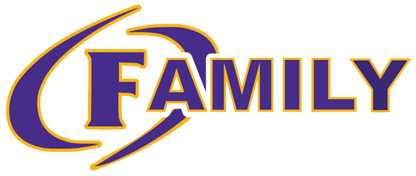
Governance Team
September 26th, 2023

- Welcome
  - Member Introduction:
    - Christy Jacobs: Principal
    - Jennifer Newell: Certified Staff Member
    - DeDee Braddy: Certified Staff Member
    - Melissa Hannon: Classified Staff Member
    - Jason Cowart: Business Owner
    - Jason Floyd: Community Member
    - Melissa Burch: Parent
    - Kadijah Keeno: Parent
- Agenda Approval
- Review of Bylaws
- Election of Officers
  - Co-Chair
  - Secretary
- Mandated Reporters
- School Improvement Plan Goals
  - Overarching Needs & Goals:
    - Need: Cultivate a climate and culture of achievement through reading that supports students as independent thinkers who are successful through all aspects of the Science of Reading.
      - Goal: At Ben Hill County Primary School, 60% of students will be reading at or above grade level at the end of the SY24 according to Acadience data.
    - Need: Cultivate a climate and culture of achievement through math instruction and student achievement.
      - Goal: At Ben Hill County Primary School, 60% of students will meet expected growth in mathematics from Fall assessment until Spring assessment using MAP.
    - Need: Cultivate a climate and culture to improve student growth from the beginning of the year writing samples to the end of the year writing samples.
      - Goal: Increase all students’ writing skills to improve reading comprehension.
    - Need: Cultivate a culture and climate that prioritizes communication and collaboration with all stakeholders that aligns with achievement for all students.
      - Goal: Increase communication with all stakeholders to occur on a weekly (staff) and monthly (parents/guardians) basis to support academic involvement and achievement for all students.
- Safety Update:
  - Scheduled Drills:
    - 2 Fire Drills
    - 1 Lockdown Drill
    - 1 Intruder Drill
  - Improvements to Building
- School Data- Review
  - BOY Testing:
    - Acadience
    - MAP
- Curriculum Update & Grades
  - Reading Curriculum: Into Reading
    - Science, Social Studies, & Social Emotional Learning tied into each module
  - Math Curriculum: GaDOE Standards & Tasks
  - Science: SMART Lab
  - Social Studies: Media Center
  - Writing:
    - Incorporated with Into Reading
    - Creative writing incorporated in Art
  - Real Life Connections & Exposure
  - Talent Development
- Student- Staff Recognition
  - Student Monthly
  - Staff Monthly
  - TOTY- Ms. Braddy
  - Student Attendance- Quarterly
  - Random Acts of Kindness Initiative:
    - Oct. 2nd- November 13th
- Budget:
  - $10,000
- Upcoming Events:
  - Sept. 29th:
    - Rock Your School
    - Student of the Month- September
  - Oct. 3rd
    - 12 Noon: Doughnut Orders Due
    - 5:30: PTO Meeting in Media Center
  - Oct. 4th: 1st Grade Field Trip: My Family, My Community
  - Oct. 5th: Greenhouse Ribbon Cutting @ 10:15
  - Oct. 6th:
    - 1st Grade Team B Pride Program
    - Doughnut Order Pickup
    - TOTY during Halftime
  - Oct. 9th-13th: Fall Break
  - Oct. 16th-20th: Homecoming Week
    - Oct. 19th: Homecoming Parade
  - Oct. 26th: AR Night + Fall Festival
    - Reading is Spooktacular!
  - Oct. 27th: 1st Grade Team A Pride Program
  - Nov. 1st: Fall Picture Day
- Meeting Dates: 4th Tuesday of each month
  - October 24th
  - November 28th
  - January 23rd
  - February 27th
  - March 26th
  - April 23rd
- Adjournment

