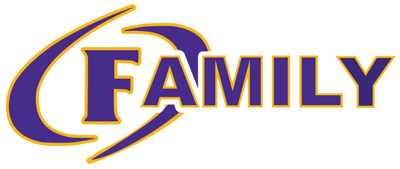
Governance Team
November 28th, 2023

- Welcome
- Agenda Approval
- School Improvement Plan Goals
  - Overarching Needs & Goals:
    - Need: Cultivate a climate and culture of achievement through reading that supports students as independent thinkers who are successful through all aspects of the Science of Reading.
      - Goal: At Ben Hill County Primary School, 60% of students will be reading at or above grade level at the end of the SY24 according to Acadience data.
    - Need: Cultivate a climate and culture of achievement through math instruction and student achievement.
      - Goal: At Ben Hill County Primary School, 60% of students will meet expected growth in mathematics from Fall assessment until Spring assessment using MAP.
    - Need: Cultivate a climate and culture to improve student growth from the beginning of the year writing samples to the end of the year writing samples.
      - Goal: Increase all students’ writing skills to improve reading comprehension.
    - Need: Cultivate a culture and climate that prioritizes communication and collaboration with all stakeholders that aligns with achievement for all students.
      - Goal: Increase communication with all stakeholders to occur on a weekly (staff) and monthly (parents/guardians) basis to support academic involvement and achievement for all students.
- Safety Update:
  - Improvements to Building Completed
  - Additional request for safety need to BOE by Ms. Jacobs
- School Data
  - Acadience:
    - The testing team was retrained to ensure that we are delivering the assessment with validity school wide
      - The testing team has multiple practice sessions this week to ensure consistency in grading.
    - Testing Procedures:
      - Dec. 4-8th:
        - 4th: Second grade (2:15 Hrs.)
        - 5th-6th: 1st Grade 1.5 Hrs. each day
        - 7th-8th: Kindergarten 1.5 Hrs. each day
      - Proctors will introduce themselves to the classes they are testing by Friday 12.1
      - Hallways will be closed off starting at 8:15
      - Students who are tardy will be walked to the back doors to not disrupt testing.
    - Data Review: Jan. 4th-5th by grade level
      - Goal: 60% of students will be reading at or above grade level by end of Sy 23-24
        - BOY Percentages:
          - K:
            - RCS: 61%
              - Reading Composite Score- Not a growth measure (each administration is a stand alone)
            - FSF: 52%
              - First Sound Fluency
            - PSF: Not Administered
              - Phoneme Segmentation Fluency
            - NWF: Not Administered
              - Nonsense Word Fluency
          - 1st:
            - RCS: 48%
              - Reading Composite Score- Not a growth measure (each administration is a stand alone)
            - PSF: 57%
              - Phoneme Segmentation Fluency
            - NWF: 51%
              - Nonsense Word Fluency- Correct Letter Sounds
            - NWF: 45%
              - Nonsense Word Fluency- Whole Words Read
            - ORF: Not Administered
              - Oral Reading Fluency- Words Correct
            - ORF: Not Administered
              - Oral Reading Fluency- Accuracy
            - ORF: Not Administered
              - Oral Reading Fluency- Retell
          - 2nd:
            - RCS: 58%
              - Reading Composite Score- Not a growth measure (each administration is a stand alone)
            - NWF: 39%
              - Nonsense Word Fluency- Correct Letter Sounds
            - NWF: 47%
              - Nonsense Word Fluency- Whole Words Read
            - ORF: 50%
              - Oral Reading Fluency- Words Correct
            - ORF: 59%
              - Oral Reading Fluency- Accuracy
            - ORF: 56%
              - Oral Reading Fluency- Retell
            - ORF: Not Administered
              - Oral Reading Fluency- Retell Quality
- Curriculum Update & Grades
  - Math Curriculum:
    - Schedule Changes:
      - Math: Whole group tier 1
      - Math WIN: Differentiated groups
        - Remediation & acceleration
  - HMH:
    - All Grade Levels: Module 4
      - K: 9 Total
      - 1st & 2nd: 12 Total
    - Started after Labor Day
    - High Quality Instructional Materials (Consent)
      - The State Board of Education approved the list of High-Quality Instructional Materials for teaching students in kindergarten through third grade to read, as outlined in the Georgia Early Literacy Act (House Bill 538). Georgia Language Arts Supervisors (GLAS) facilitated the Instructional Materials Review by forming a committee of literacy curriculum leaders from each congressional district, along with representatives from the GOSA, members of higher education, GACIS.

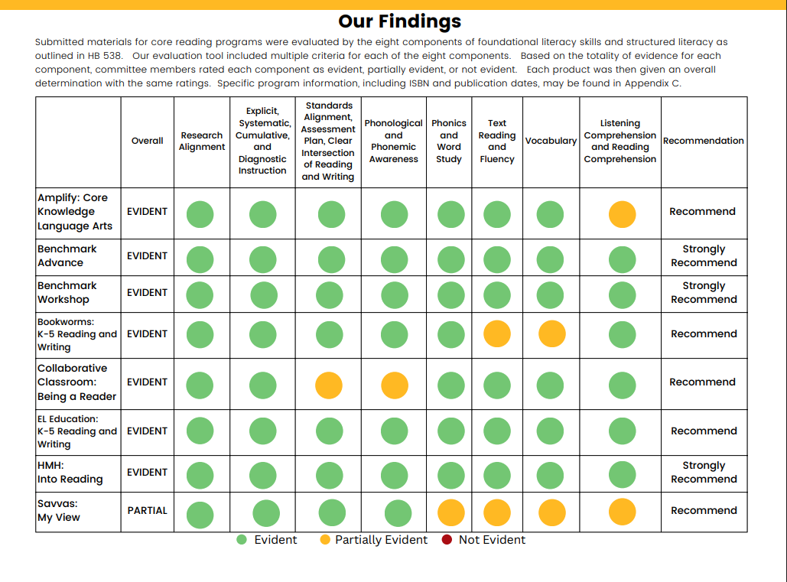

- Communication:
  - Parent Monthly Curriculum Newsletters & Parent Involvement Opportunities
    - Combining Oct. & Nov.

- Budget:
  - $10,000
    - Sensory Proposal
    - Pickup Proposal
    - Outdoor Courtyard Update
    - In Kind Letters
- Upcoming Events:
  - Dec. 1st: Picture Retakes
  - Dec. 4th-8th: Acadience Testing
  - Dec. 11th-15th: MAP Testing
  - Dec. 15th: Kindergarten Team B Pride Program
  - Dec. 18th-20th: Holly Jolly Days
    - 18th: Candy Cane & Behavior Reward Day
      - Glow Party during activity for students with zero office referrals
      - American Lit Students from FHSCCA reading to all classrooms
    - 19th: The Grinch Day
      - Classroom Parties
      - Santa Flyover
    - 20th: Polar Express Day
      - Snow Machines @ Car and Bus Drop Off
      - Gloves & Beanies for each student
      - Hot chocolate provided by PTO
- Meeting Dates: 4th Tuesday of each month
  - January 23rd
  - February 27th
  - March 26th
  - April 23rd
- Adjournment

