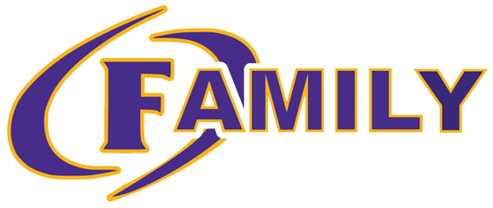
Governance Team
October 24th, 2023

- Welcome
- Agenda Approval
- School Improvement Plan Goals
  - Overarching Needs & Goals:
    - Need: Cultivate a climate and culture of achievement through reading that supports students as independent thinkers who are successful through all aspects of the Science of Reading.
      - Goal: At Ben Hill County Primary School, 60% of students will be reading at or above grade level at the end of the SY24 according to Acadience data.
    - Need: Cultivate a climate and culture of achievement through math instruction and student achievement.
      - Goal: At Ben Hill County Primary School, 60% of students will meet expected growth in mathematics from Fall assessment until Spring assessment using MAP.
    - Need: Cultivate a climate and culture to improve student growth from the beginning of the year writing samples to the end of the year writing samples.
      - Goal: Increase all students’ writing skills to improve reading comprehension.
    - Need: Cultivate a culture and climate that prioritizes communication and collaboration with all stakeholders that aligns with achievement for all students.
      - Goal: Increase communication with all stakeholders to occur on a weekly (staff) and monthly (parents/guardians) basis to support academic involvement and achievement for all students.
- Safety Update:
  - Improvements to Building Update
- School Data
  - BOY Testing: Parents will receive copies of their child’s test results at their conference on Friday, October 27th
    - Acadience
    - MAP
  - Acadience:
    - The staff received training on reading and utilizing their results from Acadience on Tuesday, October 17th
      - The data dig will support leveled groups during reading
    - The testing team will be retrained to ensure that we are delivering the assessment with validity school wide
      - 4- 30 minute virtual sessions will be offered and 1- 1 hour face to face session prior to Thanksgiving break.
- Curriculum Update & Grades
  - Grades:
    - Reading Curriculum: Into Reading: Spirals-based on each individual quarter
    - Math Curriculum: GaDOE Standards & Tasks: Does not spiral- a change to cumulative average for the year has been made
      - Reteach-Retest-Replace
  - Writing:
    - Improvement will be determined based on samples from BOY to EOY.
- Communication:
  - Parent Monthly Curriculum Newsletters & Parent Involvement Opportunities
  - Staff Week at a Glance Communication
  - Dojo & Facebook Updates
  - Website Updates
  - All Call System through IC
  - Grade level newsletters
  - Student- Staff Recognition
    - Student Monthly
    - Staff Monthly
    - Student Attendance- Quarterly
    - Random Acts of Kindness Initiative:
      - Oct. 2nd- November 13th
- Budget:
  - $10,000
- Upcoming Events:
  - Oct. 26th: AR Night + Fall Festival
    - Reading is Spooktacular!
  - Oct. 26th: 1st Grade Team A Pride Program
  - Oct. 27th: Virtual Day for Student Led Conferences
  - Nov. 1st: Fall Picture Day
- Meeting Dates: 4th Tuesday of each month
  - November 28th
  - January 23rd
  - February 27th
  - March 26th
  - April 23rd
- Adjournment

