Mr. C’s
Topics to cover
Consumer Ed
Supply/Demand
- Free enterprise system
- US Economy
Simple Contracts
- Marriage 
- Divorce
- Sales
Careers
Credit
- Credit Cards 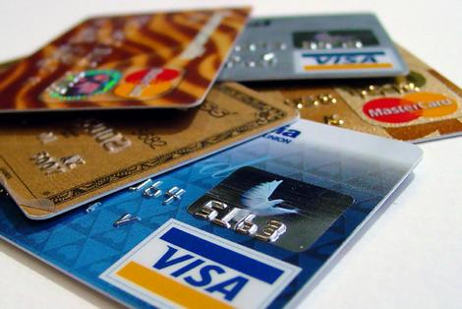
- Home Financing
Insurance
- Auto 
- Home 
- Life 
- Health 
Taxes
- Income
- Estate
- Capital Gains
Finance/Banking
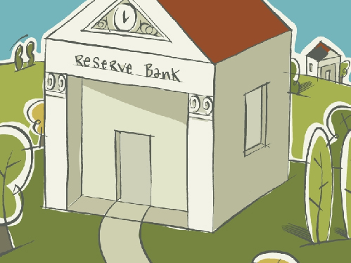
- Savings and investing
- Checking accounts
- Mortgage’s
- Home ownership/Renting
Budgeting
- Sound City

