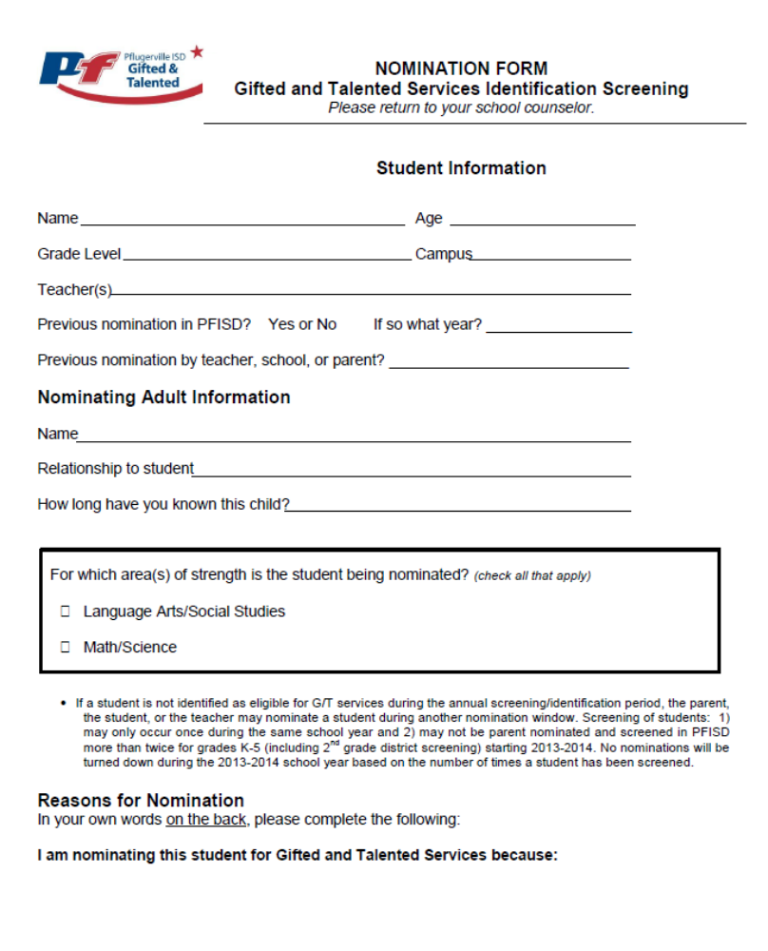
Due to the School Counselor by November 21, 2014

