
Start a Destination Imagination Team!

What is the Destination Imagination Challenge Experience?

The Destination Imagination Challenge Program is a fun, hands-on method of learning that fosters students’ creativity, curiosity, and courage through academic Challenges.

Every year Destination Imagination impacts more than 150,000 students in 45+ states and in 30 countries!
In Destination Imagination, student teams in grades K-12, as well as University Level, solve open-ended Challenges and present their solutions at Tournaments. Teams of 3-7 students are tested to think on their feet, work together, and devise original solutions that satisfy the requirements of the Challenges. Participants gain more than just basic knowledge of problem solving—they learn to unleash their imaginations and become a part of a global community of confident creators by developing essential skills needed to thrive in school, future professions, and beyond.
This is an enrichment program that incorporates science, technology, engineering, math, (STEM) and the arts, and prepares your child for the future. Kids from all backgrounds and abilities learn to work together and appreciate each other, and they learn to be confident leaders and communicators. These are the job skills needed for your child to be successful in the 21st century!
The Destination Imagination Challenges are designed by educators, for educators, to complement the curriculum. Teachers report better attention and participation from students engaged in Destination Imagination (DI).

To learn more, please go to: http://www.destinationimagination.org/

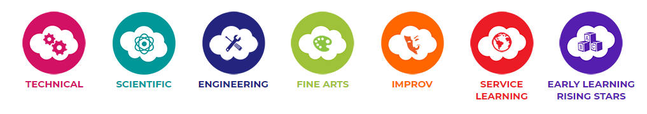

How do we get started?
The first thing that students interested in DI need to do is find a parent or adult that will act as the Team Manager. Then, teams will receive Challenge Materials from the DI campus contact or download materials from the DI site. All resources needed for ice-breakers, the Central Challenge and Instant Challenge practices are included in the Challenge Materials. Teams then meet, usually on a weekly basis, to begin to build the team and to develop a solution to the selected Challenge.
Team Challenges have varying focuses, they have specific requirements that must be met, and they can take weeks or months to solve. Challenges for 2018-2019 include:

- Technical: On Target
- Scientific: Medical Mystery
- Engineering: Monster Effects
- Fine Arts: Game On
- Improvisational: Heads Up
- Service Learning: Escape Artists
- Early Learning (Rising Stars): Pop Up

For more information on 2018-2019 Challenges, go to:
https://www.destinationimagination.org/challenge-program/2018-19-challenge-previews/
PfISD will be supporting each campus by providing enrichment funding that can be used to pay for team memberships and tournament registration. Campuses and/or families may elect to purchase additional team memberships beyond what the district is able to support financially, particularly for teams that wish to compete in more than one challenge. Complete team information must be submitted to the DI Campus Contact by October 19, 2018, to be funded by the district. Team information includes team members, team manager(s), and appraisers.
- At the beginning of the season, teams meet weekly and participate in ice-breaking activities and focus on learning about each other’s skills, talents, and personalities.
- In the next stage, each team begins to work on the solution for the Team Challenge.
- Over the course of the entire DI season, teams practice Instant Challenges. Instant Challenges make up a fourth of each team's Tournament score, so it’s important for every team to be comfortable with them.
- At the culmination of the season, teams go to Tournament and present their Team Challenge solutions to Appraisers and live audiences. At Tournaments, teams are scored for how well they meet the requirements of their Team Challenges and the Instant Challenge and for their creativity and teamwork. The Regional Tournament for 2018-2019 will be held on:
February 23, 2019 at John B. Connally High School, Pflugerville, TX.
Please complete this 2-page form and return to your child’s teacher (elementary) or the PFLEX elective teacher (middle school) by October 5, 2018 to indicate interest in your child participating in Destination Imagination!
Yes! My child is interested in participating in Destination Imagination and can commit to being on a team (attending weekly practices after school and some weekends) and attending the tournament on February 23, 2019.

Returning DI Team Member Yes No
If your child is already part of a team, new or returning, please list the team members’ names, their grade level, and current school in which they are enrolled:
1.______________________________ 2.____________________________
3._____________________________ 4.____________________________
5._____________________________ 6. ____________________________

Participant’s Name: ____________________________________________________
School: _____________________________________________________________
Grade: ______________________________________________________________
Teacher: ____________________________________________________________
Parent/Guardian Name: _________________________________________________
Parent/Guardian email: _________________________________________________
Parent/Guardian phone: _________________________________________________
Parent/Guardian Signature______________________________________________Date__________

We need volunteers to manage and work with our teams! The success of a program like Destination Imagination rests completely on our volunteers and cannot happen without adults (parents) willing to take on that role!!!!
Without volunteers, we cannot have Destination Imagination teams!! Please indicate how you will be volunteering to help the team:
______ Team Manager or Co-Manager; responsibilities include:
- Attend Manager Training
- Read through Challenge Materials with team members
- Organize and supervise weekly/bi-weekly team practices
- Attend regional competition with the team on February 23, 2019

______ Instant Challenge Coach (optional); responsibilities include:
- Prepare the team to compete in the Instant Challenge portion of the competition
- Organize Instant Challenge practices
- Attend Instant Challenge workshops with the team (these are optional but extremely helpful in preparing for competition!)
All Team Managers and IC Coaches must complete the volunteer application on the PfISD website:
http://www.pfisd.net/Domain/81

______ Team Appraiser (every team must provide two appraisers)
- Attend appraiser training on February 9, 2019
- Commit to appraising at the tournament February 23, 2019

Please complete this form front and back and return to your child’s teacher (elementary) or the PFLEX elective teacher (middle school) by October 5 to indicate interest in your child participating in Destination Imagination!

