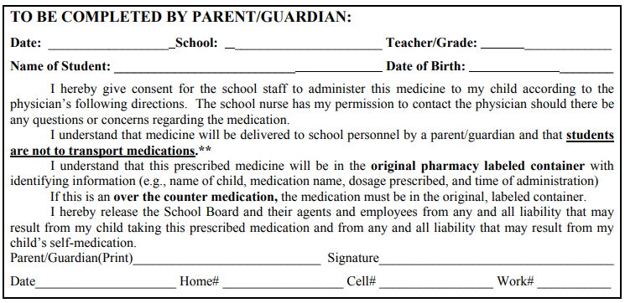
ONSLOW COUNTY SCHOOLS STUDENT HEALTH SERVICES
Permission for Prescribed Medication to Be Given During School Hours

