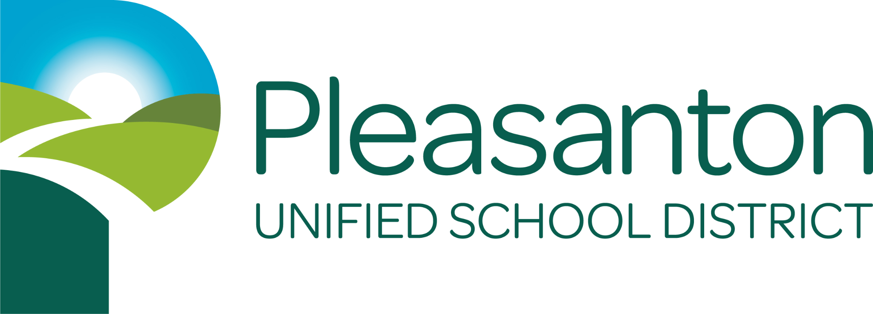
Dear Parents/Guardians:
Each year all students who are English Learners are assessed on their English Language Proficiency through the English Learner Proficiency Assessment in California (ELPAC), and all students in grades 3-8 and grade 11 are assessed for their mastery of California English Language Arts, Math, and Science standards with the California Assessment of Student Performance and Progress (CAASPP). The California Department of Education has developed an electronic process for each school district to share student score reports for ELPAC and CAASPP. All State Assessment Student Score Reports will be available electronically in PDF format through the ParentVUE portal of our student information system, Synergy:

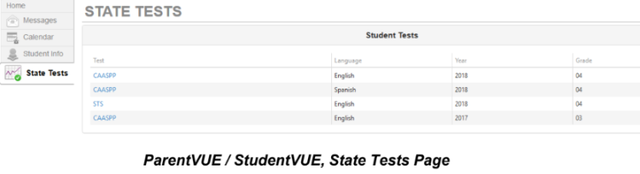
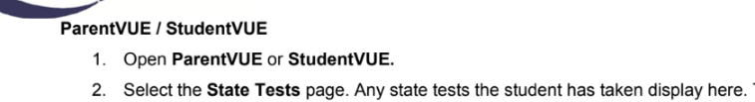
The Research and Evaluation Department will also email Annual Parent Notification letters to parents of English Learner students every September with the results of the previous spring’s ELPAC assessment.

This process for accessing Student Score reports helps us to maintain an efficient and timely delivery of student score reports to parents and guardians. For parents/guardians without access to the internet enabled devices, it is possible to request a printed copy of the CAASPP or ELPAC Student Score Report from your student’s school site administrator.
Please contact the Research and Evaluation Department with any questions.
Kevin Bradley
Senior Director of Research and Evaluation
Pleasanton Unified School District
(925) 426-4350
kbradley@pleasantonusd.net

