Edison Dress Code Philosophy
Edison Elementary’s student dress code supports equitable educational access. Dress code standards reflect pride and dignity and demonstrate that school is a place to study and learn. Our standards support student safety and promote a focused, orderly school climate.

Allowable Dress & Grooming
- Closed toe shoes to support safety of student feet. Tennis shoes are required for PE days.
- Students must wear clothing including both a shirt with pants or skirt, or the equivalent and shoes.
- Shirts and dresses must have fabric in the front and on the sides. No pinning or tying shirts. Shirts must go to the waistband (no skin showing). Shirts must cover shoulders (no tank tops, no spaghetti straps).
- Clothing must cover undergarments; fabric covering all private parts must not be see through.
- Clothing must be suitable for all scheduled classroom activities including physical education.
- For bathroom accidents, parent/guardians are welcome to pack a change of clothes in backpack.

Non-Allowable Dress & Grooming
- Hoods, hats, and other headwear cannot be worn in the building—only allowable at recess or for cultural/religious exceptions.
- Clothing may not depict, advertise, or advocate the use of alcohol, tobacco, marijuana, or other controlled substances.
- Clothing may not depict cuss words, pornography, nudity, or sexual acts.
- Clothing may not use or depict hate speech targeting groups based on race, ethnicity, gender, sexual orientation, gender identity, religious affiliation, or any other protected groups.
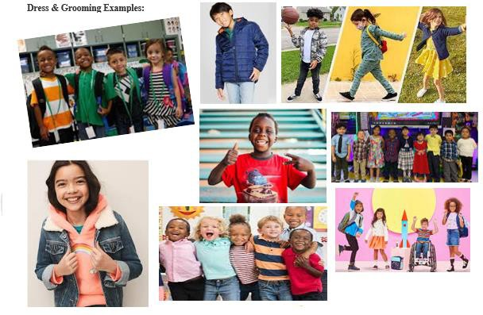
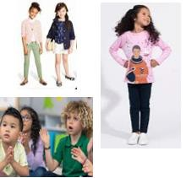
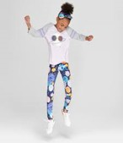
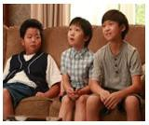
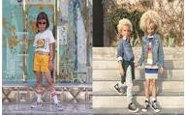
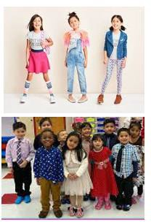
- For safety, no open toe shoes (i.e., flip flops, slides or sandals). No shoes with wheels (i.e., Heelys).

