Athletic Sponsorship Packages
2024 – 2025

Business-based sponsorships
- Packages can be purchased to sponsor a specific team or general athletic department
- If sponsoring a specific team, announcing “spots”, banner placement, social media options will be geared toward that specific sport and profit will be given to that sport.
- If sponsoring “general athletics”, announcing “spots”, banner placement, social media options will be geared towards media put out by the athletic director. Profit will be put toward general athletic department needs – travel, awards, student recognition, leadership training, athletic equipment, rental fees, tournament entry fees, and other needs as necessary.
- Must be able to provide clean .jpeg version of business logo for use in social media and website use. Smaller file sizes are typically preferred.
- Must be able to provide clean usable logo to BizCard Xpress (Orange City) to bcxorangecity@gmail.com to use in creating banners. Preferred file types are pdf vector, .svg, or .eps Acceptable file types are .pdf, .png, .jpeg (300 dpi minimum). Larger files are typically preferred.
- Must be able to provide a 10 – 20 second “script” or “spot” for advertising of business during sporting events, where applicable.
- Graphics and “spots” must be school appropriate and school approved prior to use.
- Sponsorship partners that include alcohol, marijuana/cannabis, tobacco, adult entertainment and the like will not be approved.
- Venue options are as follows:
  - Inside – Gym
  - Outside – Game Field (Football/Soccer/Flag Football), Baseball Field, Softball Field, Tennis Courts, Swimming (during UHS events only)
- Sponsorship application must be turned into slhahn@volusia.k12.fl.us and appropriate Head Coach of sport if sponsoring a specific sport. See attached list of Head Coaches.
- Please allow 2 weeks from artwork submission for banners to be produced and hung.
- Packages are good for 1 school year.

The athletic department and TAA will be responsible for making sure banners are ordered and purchased, not the sponsor.
Banners will be made and purchased from:
BizCard Xpress
1209 Saxon Blvd. #4, Orange City, FL 32763
386-218-5940
bcxorangecity@gmail.com
X (Twitter) Followers
School Account – 1,655 followers
Athletic Account – 277 followers

Instagram Followers
School Account – 1252 followers
Athletic Account – 654 followers

3’ by 4’ mesh banner – design is as follows

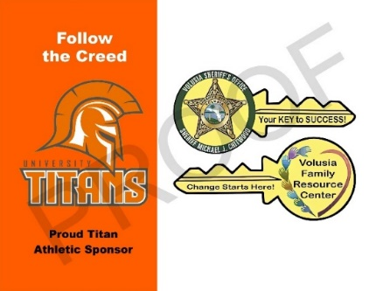
Basic Package - $250
- 1 banner – choice of inside or outside venue
- Name and Logo listed on athletic webpage of sponsors (List view) – www.uhstitans.com

Basic Plus Package - $350
  - 2 banners – 1 inside venue and 1 outside venue
  - Name and Logo listed on athletic webpage of sponsors (List view) – www.uhstitans.com

White Package - $500
  - 1 banner – choice of inside or outside venue
  - Name and Logo listed on athletic webpage of sponsors (1/3 page across size)– www.uhstitans.com
  - Business recognition via advertising “spot”, 10-20 seconds in length at sporting events based on team or general athletic sponsorship.
  - “Shout-outs” via team and/or athletic twitter, Instagram and facebook – a minimum of 3 times throughout the season.

White Plus Package - $600
  - 2 banner – 1 inside venue and 1 outside venue
  - Name and Logo listed on athletic webpage of sponsors (1/3 page across size)– www.uhstitans.com
  - Business recognition via advertising “spot”, 10-20 seconds in length at sporting events based on team or general athletic sponsorship.
  - “Shout-outs” via team and/or athletic twitter, Instagram and facebook – a minimum of 3 times throughout the season.

Image representing 1/3 page across advertising.

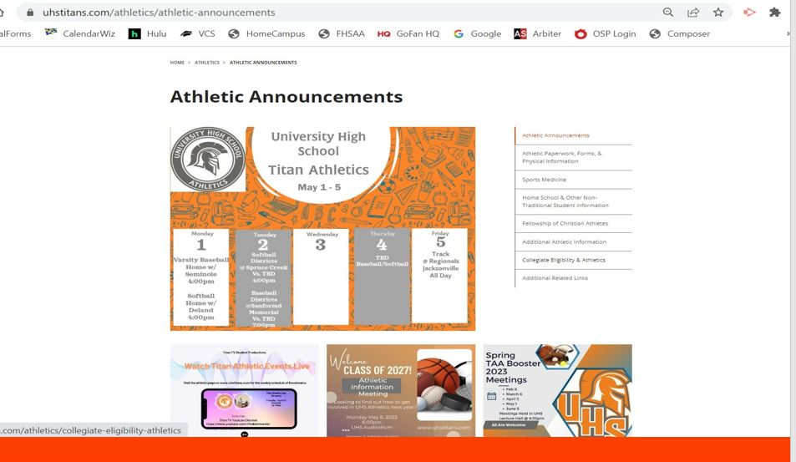
Orange Package - $1000
Limited Quantities of these packages are available and will awarded on a first come, what’s available basis.
  - 1 banner – choice of inside or outside venue
  - Name and Logo listed on athletic webpage of sponsors (1/2 page across size)– www.uhstitans.com
  - Business recognition via advertising “spot”, 10-20 seconds in length at any sporting events with announcing capabilities
  - “Shout-outs” via team and/or athletic twitter, Instagram and facebook – a minimum of 3 times throughout the season.
  - Sponsorship of a specific type of social media graphic
    - Game Day Sponsor – sport specific sponsorship, up to 10 “Game Days”
    - Final Score Sponsor – sport specific sponsorship, up to 10 “Final Scores”
    - Weekly Calendar Post – General Athletics, up to 5 weeks of sponsorship
    - Season Schedule Poster – sport specific sponsorship – 1 time but used in various situations through the season and year

Orange Plus Package - $1300
Limited Quantities of these packages are available and will awarded on a first come, what’s available basis.
  - 3 banners – choice of venues
  - Name and Logo listed on athletic webpage of sponsors (1/2 page across size) – www.uhstitans.com
  - Business recognition via advertising “spot”, 10-20 seconds in length at any sporting events with announcing capabilities
  - “Shout-outs” via team and/or athletic twitter, Instagram and facebook – a minimum of 3 times throughout the season.
  - Sponsorship of a specific type of social media graphic
    - Game Day Sponsor – sport specific sponsorship, up to 10 “Game Days”
    - Final Score Sponsor – sport specific sponsorship, up to 10 “Final Scores”
    - Weekly Calendar Post – General Athletics, up to 5 weeks of sponsorship
    - Season Schedule Poster – sport specific sponsorship – 1 time but used in various situations through the season and year

Image representing 1/2 page across advertising.

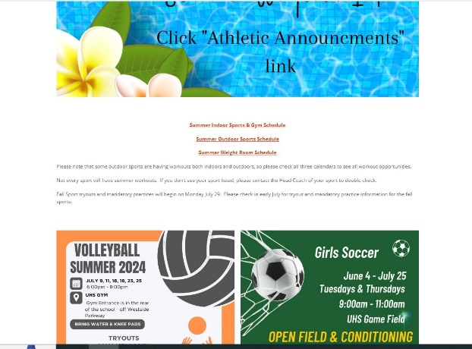

Silver Package – $2000
Limited Quantities of these packages are available and will awarded on a first come, what’s available basis.
  - 3 banners – choice of venues
  - Name and Logo listed on athletic webpage of sponsors (full page across size)– www.uhstitans.com
  - Business recognition via advertising “spot”, 10-20 seconds in length at any sporting events with announcing capabilities
  - Individual Business “Shout-outs” via team and/or athletic twitter, Instagram and facebook – a minimum of 3 times throughout the season.
  - Business identification on any live stream broadcasts of athletic events. Number of live stream events to be determined. This may include both graphics in the broadcast and verbal recognition by on-air broadcasters.
  - Sponsorship of a specific type of social media graphic – choose 2 options below
    - Game Day Sponsor – sport specific sponsorship, all “Game Days” for a season
    - Final Score Sponsor – sport specific sponsorship, up to 10 “Final Scores”
    - Weekly Calendar Post – General Athletics, up to 10 weeks of sponsorship
    - Season Schedule Poster – sport specific sponsorship – 1 time but used in various situations through the season and year
- Two All Sport Passes to UHS Home Regular season games

Image representing full page across advertising.

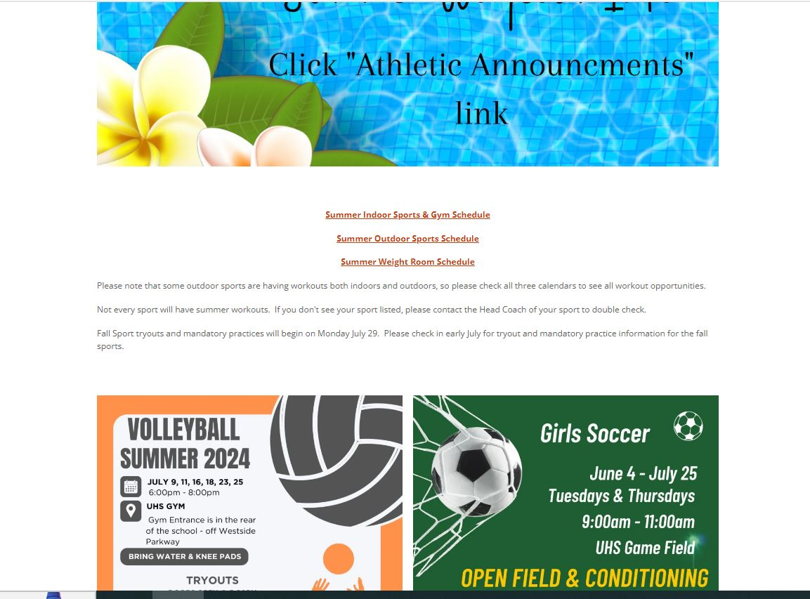

Sample Social Media Graphics
Graphics are created with sample sponsors, no indication of actual sponsors are made.

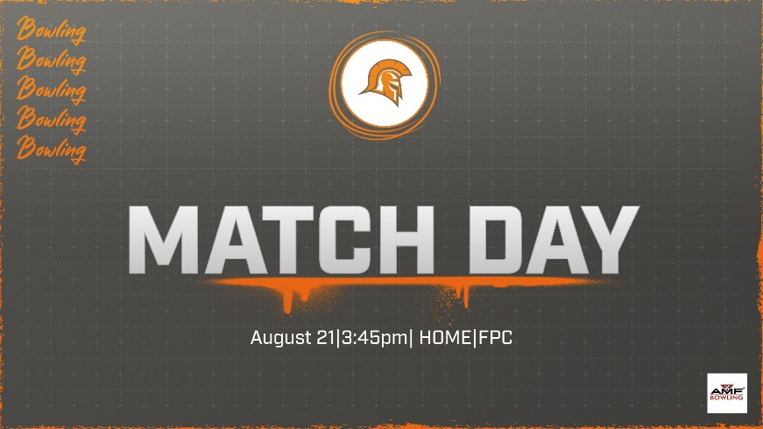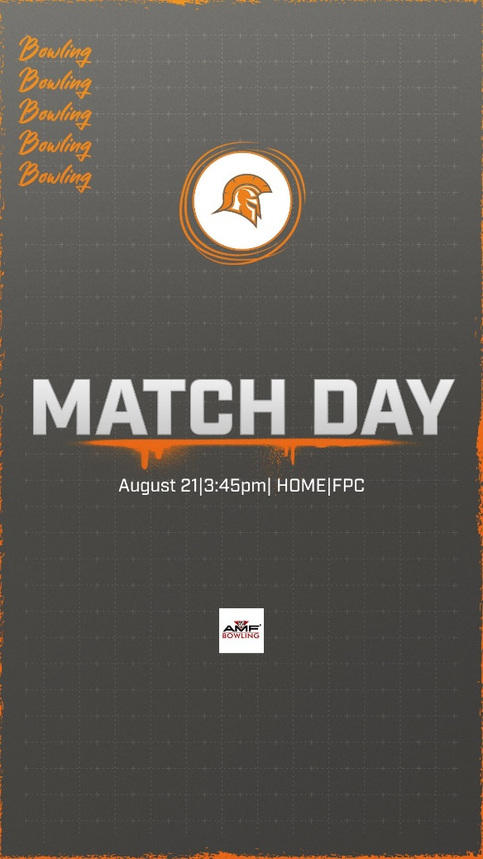
Sample Game Day Posts with Sponsorship Logos

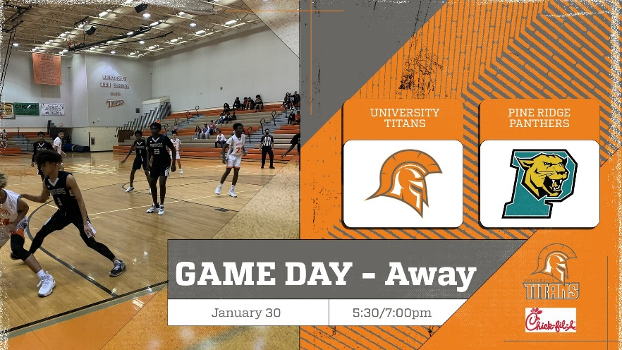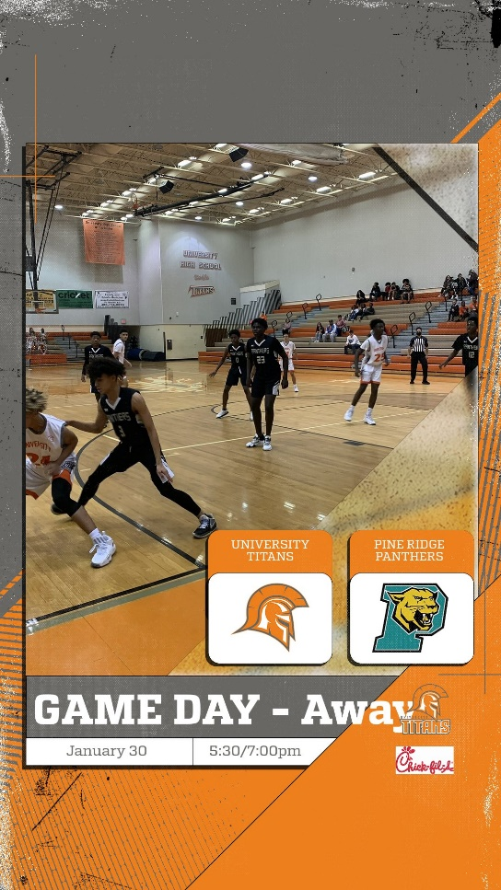

Sample Season Poster with sponsor logo
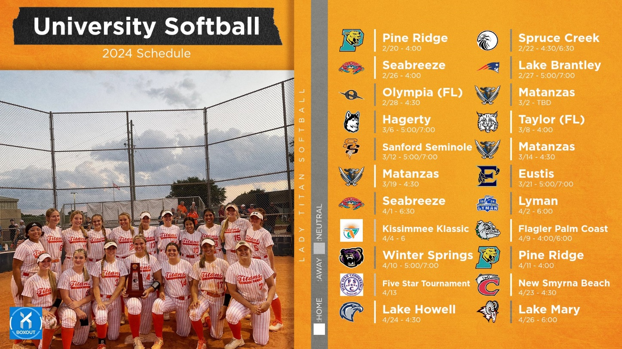

Weekly Calendar posts with sponsor logos

