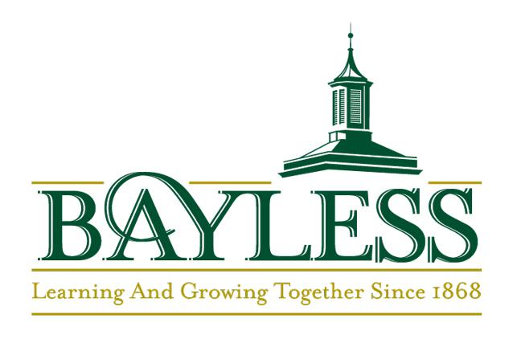  Printed Student Name  Bayless High School A+ Program  Participation Agreement | Anticipated Graduation Year
Name: | Grad. Year:

I am a citizen or permanent resident of the United States. YES NO

I wish to participate in the A+ Schools Program at Bayless High School.
Provided state funds are available, and Bayless High School maintains designation as an A+ School before my graduation, I will receive reimbursement for the college expenses determined by the Missouri General Assembly while attending a Missouri public community college or public career-technical school full-time. This reimbursement will be for the unpaid tuition and general fees balance after federal post-secondary financial assistance funds (that do not require repayment) have been applied. This is on the condition that I meet the following requirements:
- Attend Bayless High School or an A+ designated high school for 80% of instructional days before graduation.
- Graduate from high school with a grade point average of 2.5 or higher on an unweighted, unrounded 4.0 scale.
- Have at least a ninety-five percent (95%) attendance record for grades 9-12.
- Graduate with fifty (50) documented hours of unpaid tutoring in approved settings.
- Maintain a record of good citizenship.
- Achieve a qualifying math assessment score.
- Make a good faith effort to secure federal post-secondary student financial assistance funds during the last semester of the senior year to obtain the A+ financial incentive.

To maintain eligibility after high school graduation, I understand that I must meet the following requirements:
- Enroll and attend a Missouri public community college or public career-technical school full-time.
- Maintain a grade point average of 2.5 or higher on a 4.0 scale.

The financial incentives of the A+ Schools Program are dependent upon Bayless High School’s designation as an A+ School and state appropriations from the Missouri General Assembly. They are not the funding responsibility of the Bayless School District.

Bayless High School A+ Program
Citizenship Agreement

Printed Student Name | Anticipated Graduation Year
Name: | Grad. Year:

Students participating in the A+ Schools Program must maintain a record of good citizenship as defined by law and stated in the Bayless High School Code of Conduct in the Student Handbook. Certification of good citizenship will be based on the official discipline record maintained in the administrative offices. All four years are a part of the citizenship record. The A+ Coordinator will verify good citizenship each semester. Students who do not meet the citizenship requirement will not be eligible for the A+ financial incentive.

Citizenship Review

If a Citizenship Review occurs, the student and parent will be notified in writing. Appeal, probation, or removal from A+ could occur as a result.
- Student accumulates more than 10 PMDs during high school
- Student accumulates more than 4 Thinkery assignments during high school
- Unlawfully used or possessed drugs, drug paraphernalia, or alcohol on or off school property (Board Policy JFCL)
- Student unlawfully used or possessed drugs, drug paraphernalia, or alcohol on or off school property (Board Policy JFCL)

Disciplinary Appeals Process
The following process may be used by students/parents to appeal a disciplinary decision that may affect the student’s A+ qualification:
- Students/parents will have 30 days from the date of disqualification notification to appeal a decision dealing with discipline or probation. Anyone appealing should use the A+ Appeal of Citizenship Form from the A+ Schools Coordinator.
- The basis of the appeal and documentation must be submitted in writing through the office of the A+ Schools Coordinator.
- The A+ Coordinator will facilitate the A+ Citizenship Review Committee. The parents will be notified in writing after the A+ Citizenship Review Committee decides.

All A+ Schools participants must sign and return this acknowledgment of the A+ Schools Program Citizenship Guidelines to the A+ Coordinator.
We have received, studied, and understand the A+ Schools Program Citizenship Guidelines.

Bayless High School A+ Program
Tutoring Agreement

Printed Student Name | Anticipated Graduation Year
Name: | Grad. Year:

Student/Parent Agreement

As a student earning tutoring hours through the Bayless High School A+ Schools Program, I accept the responsibility to:
- Obtain approval for tutoring assignments through the A+ Schools Program office.
- Provide 50 hours of unpaid tutoring supervised by certified Bayless staff in approved settings.
- Arrive promptly and attend regularly. (In an emergency, I will notify both the A+ Coordinator and the supervising teacher.)
- Work with a positive attitude and willingly assume assigned tasks.
- Treat all supervising administrators, teachers, and students with respect.
- Be sensitive to the needs of all students and respect the principle of confidentiality.
- Wear clothing appropriate to the activity and wear A+ ID visibly.
- Follow the Bayless High School Disciplinary guidelines.
- Review and understand the A+ Tutor Course Syllabus.

I would like to participate in the A+ Program at Bayless High School, and I understand the program's requirements and what I need to do to maintain my eligibility during high school and beyond. I have read the citizenship agreement form and understand that my eligibility to receive A+ funding can be lost if I do not meet the citizenship requirement. I agree to accept the opportunities and obligations associated with the tutoring component of the A+ Schools Program at Bayless High School. I understand I may be dismissed from the program for failure to comply with the program's guidelines. (In doing so, I would no longer be eligible for benefits through the A+ Schools Program.)

Student signature________________________________________________ Date _____________

I would like my child to participate in the A+ Program at Bayless High School. We understand the program's requirements and what my child needs to do to maintain A+ eligibility during high school and beyond. I have reviewed the citizenship agreement with my child, and we understand that the eligibility to receive A+ funding can be lost if my child does not maintain a good citizenship record throughout high school. My child has discussed the tutoring component of the A+ Schools Program at Bayless High School, and I give my permission and support for my child to participate in the required tutoring activities. I understand that my son/daughter (not the school district) is responsible for his/her transportation to and from these activities.

Parent signature _____________________________________________Date _________________

