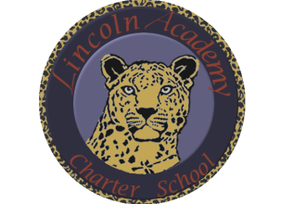

The Mission of Lincoln Academy is to help students attain their highest social and academic potential through an academically rigorous, content-rich educational program in a safe, orderly, and caring environment.

Lincoln Academy Board of Directors
Regular Business Meeting
Agenda for Monday, October 12, 2015
Lincoln Academy
Student Center
6:30 p.m.

Time Allotted(min) Motion
- Preliminaries (Doug Neely) 5:00
  - Call to Order
  - Welcome to Guests and Introductions
  - Roll Call
  - Hearing of Persons
- Consent Agenda (Doug Neely) 1:00
  - Approve Minutes of Last Board Meeting
  - Approve Agenda
- Reports to Board
  - Principal’s Report (Janelle Johnson) 15:00
- Committee Reports
  - Governance (Derek Luyk) 5:00
  - Facilities () 5:00
  - Facilities Growth Committee (Phil Courtney) 60:00
    - Board recommendations for review
  - Finance (Jeff Baucum) 10:00
    - Approve Current year budget
  - School Accountability Committee (Ben DeGrow) 5:00
  - Development (Kristi Geisz) 5:00
- Old Business
  - Board Training Modules (Doug Neely) 5:00
- New Business
  - Board Visits to Classrooms (Doug Neely) 5:00
  - Principal Evaluation (Doug Neely) 5:00
  - New Website (Doug Neely) 5:00
- Board Lessons Learned and Action Items 5:00
- Announcements 1:00
- Adjourn
Board Training Modules – Please review these modules prior to the next board meeting:
- Administrator Selection, Review, and Support
- Accountability and Program Assessment
- Contract Renewal and Accreditation

