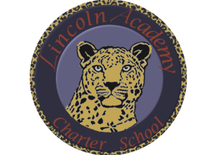
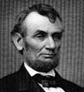
The Mission of Lincoln Academy is to help students attain their highest social and academic potential through an academically rigorous, content-rich educational program in a safe, orderly, and caring environment.

Lincoln Academy Board of Directors
Regular Business Meeting
Agenda for Monday, December 14, 2015
Lincoln Academy
Student Center
6:30 p.m.

Time Allotted(min) Motion
- Preliminaries (Doug Neely) 5:00
  - Call to Order
  - Welcome to Guests and Introductions
  - Roll Call
  - Hearing of Persons
- Consent Agenda (Doug Neely) 1:00
  - Approve Minutes of Last Board Meeting
  - Approve Agenda
- Reports to Board
  - Middle School (Lindsy Tomsick) 10:00
  - Principal’s Report (Janelle Johnson) 15:00
  - Board Candidates (Doug Neely) 30:00
- Committee Reports
  - Governance () 5:00
  - Facilities () 5:00
  - Facilities Growth Committee (Phil Courtney) 10:00
  - Finance (Jeff Baucum) 10:00
    - Approve Year End Financials
  - School Accountability Committee () 5:00
  - Development (Kristi Geisz) 5:00
- Old Business
  - Board Training Modules (Doug Neely) 5:00
  - Uniform Improvement Plan (Janelle Johnson) 5:00
- New Business
  - New Board Members (Doug Neely) 5:00
  - Core Knowledge Training (Doug Neely) 5:00
- Board Lessons Learned and Action Items 5:00
- Announcements 1:00
- Adjourn

Board Training Modules – Please review these modules prior to the next board meeting:
- Board Officer Roles and Responsibilities
- Professional Development and Training
- Strategic Planning
Core Knowledge Training
- Read Chapters 1-2 of The Schools We Need and Why We Don’t Have Them by E.D. Hirsch, Jr.

