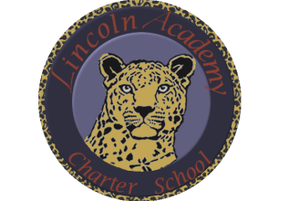

The Mission of Lincoln Academy is to help students attain their highest social and academic potential through an academically rigorous, content-rich educational program in a safe, orderly, and caring environment.

Lincoln Academy Board of Directors
Special Business Meeting
Agenda for Saturday, May 21, 2016
Lincoln Academy
Student Center
8:30 a.m.

Time Allotted(min) Motion
- Preliminaries (Doug Neely) 5:00
  - Call to Order
  - Roll Call
- New Business
  - Approve Jeffco Contract Addendum (Doug Neely) 10:00 Yes
- Adjourn

