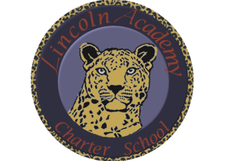

The Mission of Lincoln Academy is to help students attain their highest social and academic potential through an academically rigorous, content-rich educational program in a safe, orderly, and caring environment.

Lincoln Academy Board of Directors
Regular Business Meeting
Agenda for Friday, August 19, 2016
Lincoln Academy
Student Center
6:30 p.m.

Time Allotted(min) Motion
- Preliminaries (Doug Neely) 5:00
  - Call to Order
  - Welcome to Guests and Introductions
  - Roll Call
  - Hearing of Persons
- New Business
  - Approve Final Modular Budget (Doug Neely) 45:00 Yes
- Board Lessons Learned and Action Items 5:00
- Announcements 1:00
- Adjourn

