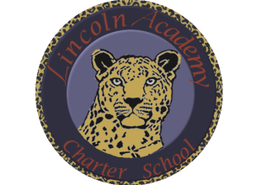

The Mission of Lincoln Academy is to help students attain their highest social and academic potential through an academically rigorous, content-rich educational program in a safe, orderly, and caring environment.

Lincoln Academy Board of Directors
Special Meeting
Agenda for Thursday, November 30, 2017
Lincoln Academy
Student Center
6:30 p.m.

Time Allotted(min) Motion
- Preliminaries (Phil Courtney) 5:00
  - Call to Order
  - Welcome to Guests and Introductions
  - Roll Call
- Adjourn to Executive Session per C.R.S. § 24-6-402(4)(f) (Personnel Matters)
  - Interim performance evaluation of the Principal

