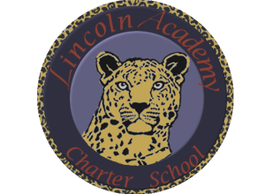

The Mission of Lincoln Academy is to help students attain their highest social and academic potential through an academically rigorous, content-rich educational program in a safe, orderly, and caring environment.

Lincoln Academy Board of Directors
Special Meeting
Agenda for Tuesday, September 4, 2018
Lincoln Academy
Student Center
6:00 p.m.

- Preliminaries
  - Call to Order
  - Welcome to Guests and Introductions
  - Roll Call
- Consent Agenda
- New Business
  - Lincoln Academy Board of Directors Strategic Planning Session
- Board Action Items
- Adjourn

