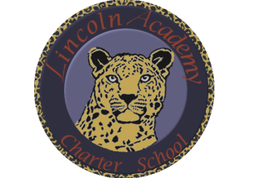

The Mission of Lincoln Academy is to help students attain their highest social and academic potential through an academically rigorous, content-rich educational program in a safe, orderly, and caring environment.

Lincoln Academy Board of Directors
Special Meeting
Agenda for Monday, November 5, 2018
Lincoln Academy
Student Center
6:30 p.m.

Time Allotted(min) Motion
- Preliminaries (Phil Courtney) 5:00
  - Call to Order
  - Welcome to Guests and Introductions
  - Roll Call
  - Hearing of Persons
- Consent Agenda (Phil Courtney) 1:00
  - Approve Agenda
- New Business
  - Adjourn to Executive Session per C.R.S. § 24-6-402(4)(f) (Personnel Matters)
    - Interim Performance Evaluation of the Principal 90:00 Yes
- Adjourn

