


Executive Director Report
March 12, 2024

P LINCOLN ACADEMY MISSION AND VISION

- The Mission of Lincoln Academy is to help students attain their highest social and academic potential through an academically rigorous, content-rich educational program in a safe, orderly, and caring environment.

- Our Vision is to prepare all students for their future endeavors by providing a comprehensive Core Knowledge Education.
TABLE OF CONTENTS
ENROLLMENT UPDATE_______________________ 4
PTO BOOSTERTHON FUNDRAISER _____________5
STAFF PLAUDITS AND GREAT EVENTS__________6-9

enrollment UPDATE

 | Budgeted Number | Number Enrolled for 24-25 | Fill to | Outstanding Offers | Siblings Waiting | Number Waiting as of 3-6
K | 88 | 83 | 92 | 0 | 0 | 0
1 | 88 | 93 | 92 | 0 | 1 | 17
2 | 84 | 88 | 87 | 0 | 0 | 10
3 | 84 | 87 | 87 | 0 | 0 | 14
4 | 84 | 87 | 87 | 0 | 0 | 13
5 | 84 | 90 | 89 | 0 | 0 | 10
6 | 84 | 87 | 89 | 0 | 0 | 0
7 | 84 | 83 | 83 | 0 | 0 | 8
8 | 84 | 77 | 77 | 0 | 0 | 9
Total | 764 | 775 | 783 |  |  | 81

Students Leaving Lincoln in 2024-2025
Grade in 2024-2025 | Reason for Leaving
2 | other Jeffco school
4 | other Jeffco school
4 | other Jeffco school
5 | other Jeffco school
6 | other Jeffco school
6 | other Jeffco school
6 | other Jeffco school
6 | other Jeffco school
6 | other Jeffco school
6 | other Jeffco school
6 | other Jeffco school
6 | BVSD
7 | other Jeffco school
7 | other Jeffco school

PTO Boosterthon Fundraiser

We want to thank each and every one of our students and families who worked so hard on PTO’s recent Leopards’ Glow Run fundraiser. We appreciate the time and effort you took to reach out to your network of friends and families, raise funds and donate to the school. We are so very excited to start the purchasing process for these great instructional tools. Our entire community will benefit from your generosity.
Thank you so much Lincoln Academy PTO for sponsoring such an amazing event. We have the most amazing PTO in the Universe! We have officially raised over $43,000 for Promethean boards!!!

Human Sundae Mr. Hurst
https://www.facebook.com/LincolnAcademyCharter/videos/1269900767256731

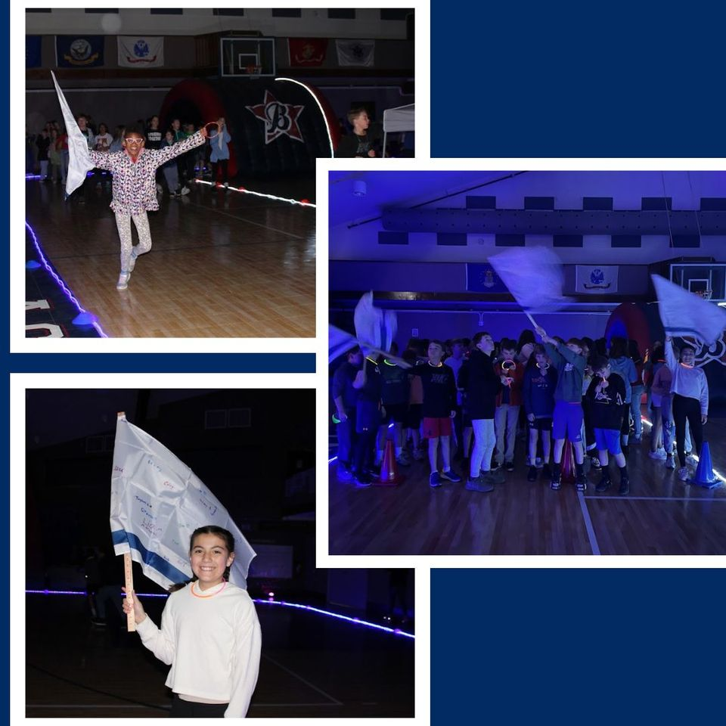

Staff Plaudits

Lily Castro, Richie Baker, Sydney Nixon (2nd Grade Teachers) – The 2nd grade-team has done a great job over the last couple of months in engaging in coaching, unit planning, and looking closely at data in math. They have demonstrated significant improvement with their whole group instruction as well as providing more targeted support to better meet the needs of individual students. Thank you, 2nd grade teachers, for putting in significant time and effort in order to improve on your instruction.

Taegen Haller (6th Grade Math) – Taegen has worked very hard in her first full year as a teacher to carve out strong relationships with her students. She demonstrates her care for them through her words and actions. Taegen has also taken to heart coaching support and feedback in a way that has allowed her to grow tremendously as a math teacher. She has a great desire to grow into an excellent teacher.

Calee Schrock (Instructional Coach) – This year I have worked very closely with Calee in supporting teams and individual teachers. I have marveled at how she has further grown into the coaching role. She is incredibly thoughtful in assessing needs including hearing from the teachers. She recognizes next steps and can provide feedback in ways that teachers can implement strategies almost immediately. She also helps teachers see the growth they are making, and she is a great advocate for their recognition and further needs.

Quentin Terry (PE Teacher) – On a daily basis, Quentin epitomizes being hard-working, showing excellence, and being kind. Quentin has started a leadership group for 8th grade boys. Outcomes have included how to be a leader, how can you leave Lincoln Academy in a great way, and how can Lincoln be a better school for students into the future. Quentin has such a heart for all students and wants to continue to be such a strong supporter of them now and into the future.

Leigh-Anne Turano (Middle School Educational Assistant) – Leigh-Anne is the epitome of a hard- working LA staff member. She is a trusted confidante to both staff and students and always puts forth quality work. Leigh-Anne is a vital member of the LA staff.

Ansley Cowan (Kindergarten) – Ansley as a second-year teacher already demonstrates great leadership and wisdom beyond her years. She consistently demonstrates a great understanding of the academic and social/emotional needs of her students. She shows thoughtfulness, kindness, integrity, and competence on a daily basis.

"Say! I like green eggs and ham! I do!" PreK tried it and they liked it too!


4th Grade Concert
https://www.facebook.com/LincolnAcademyCharter/videos/1236563560669436

5th-8th Grade Concert
https://www.facebook.com/LincolnAcademyCharter/videos/1061332405127915

Working Together in 2nd Grade



3rd Grade Anatomy Lesson
