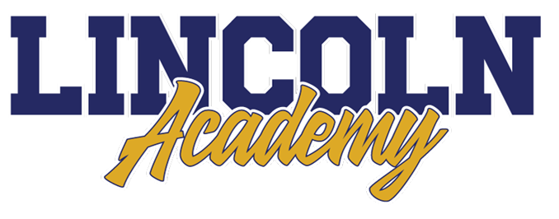


Executive Director Report
April 16, 2024

P LINCOLN ACADEMY MISSION AND VISION

- The Mission of Lincoln Academy is to help students attain their highest social and academic potential through an academically rigorous, content-rich educational program in a safe, orderly, and caring environment.

- Our Vision is to prepare all students for their future endeavors by providing a comprehensive Core Knowledge Education.
TABLE OF CONTENTS
STAFF PRESENTATION (QUENTIN TERRY) _____4
PROMETHEAN BOARDS_____________________ 5
ENROLLMENT UPDATE _____________________ 6
CHARTER RENEWAL PROCESS ______________7
STATE TESTING UPDATE ___________________ 8-9

Staff Presentation (Quentin Terry)

Quentin is going to share some valuable insights about the 8th-grade Leadership Group at Lincoln Academy. He will talk about what inspired the start of this group, the outcomes achieved, and the hard work put in by the students. Additionally, Quentin will discuss his greatest hopes for this group of students and other future student leaders at the academy. It's always inspiring to see young students take on leadership roles and make a positive impact on their school, their community, and themselves.

Promethean Boards
Thanks to the PTO’s Leopard Glow Run Fundraiser, Lincoln Academy will be able to purchase 26 new Promethean Boards for classrooms. We are prioritizing classrooms with the oldest projectors for this major upgrade. Over the next couple of years, we will be able to upgrade the remaining classrooms. Without the money raised from this fundraiser, it would have taken many years to upgrade most of the classrooms. Again, thank you so much PTO and families for supporting our school in such a great way!

Enrollment update

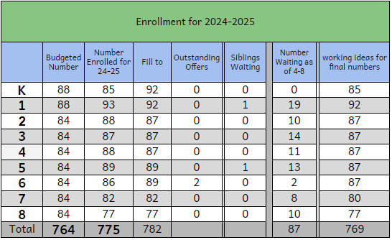
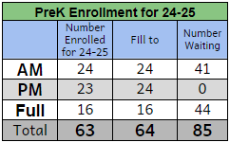

CHARTER RENEWAL PROCESS

The Colorado Charter School Act stipulates that charter schools operate under a contract agreed to by the authorizer's Board of Education (Jeffco) and each school's individual Board of Directors. The Jeffco Board votes on charter renewal on or before February 1 of the year in which the contract expires. The current contract for Lincoln Academy expires in 2025.

The application includes the following sections.

- Academic Performance and Educational Program
- Organizational Health
- Financial Performance

The application will be submitted during the first trimester of the 2024-2025 school year. Information from the application will then be presented to the Jeffco Board of Education before February 1st by the Lincoln Academy Administrative Team.

See Charter Renewal Application Draft for 2024-2025

STATE TESTING UPDATE

Testing Dates
3rd grade Math and English Language Arts April 16-18
4th grade Math and English Language Arts April 9-11
5th grade Science April 15, 17
8th grade Science April 11, 12,
5th and 6th grades Math and English Language Arts April 9-11
7th and 8th grades Math and English Language Arts April 16-18

Why is the CMAS important? How is the data used?
- Colorado state assessments provide valuable information about your child’s performance and the performance of our school. Having a statewide measure against a set of academic standards adds important insight to your student’s strengths and areas of need.
- Students taking the CMAS are provided with more practice with taking comprehensive tests.
- The CMAS assessment is used as part of a body of evidence in determining placement in courses at Lincoln as well as in High School.
- CMAS data is an important part of the Charter School renewal application.

How can I support my child in taking the assessment?
- Please get your students here on time, so they do not miss the start of any test. Students who arrive after their test session begins will wait in the office until the session is over and will make up the test later.
- Please have your students eat a healthy breakfast in the morning to help with their stamina and energy.
- Staying calm will help your child stay calm. Place an emphasis on giving your best effort over all else.

Grade Level | Number of Students Opting Out of All CMAS Testing  2020-2021 | Number of Students Opting Out of All CMAS Testing  2021-2022 | Number of Students Opting Out of All CMAS Testing  2022-2023 | Number of Students Opting Out of All CMAS Testing  2023-2024
3 | 8 | 0 | 2 | 4
4 | 8 | 3 | 2 | 9
5 | 21 | 3 | 5 | 4
6 | 21 | 11 | 5 | 5
7 | 25 | 9 | 14 | 5
8 | 12 | 31 | 13 | 30
TOTALS | 95 | 57 | 41 | 57

