The scientific method (controlled experiment)
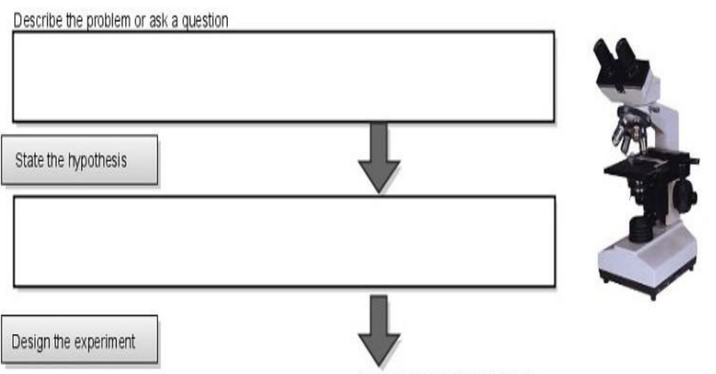
(What do you want to find out?)

(Make a guess…. I think….)

Make a draft

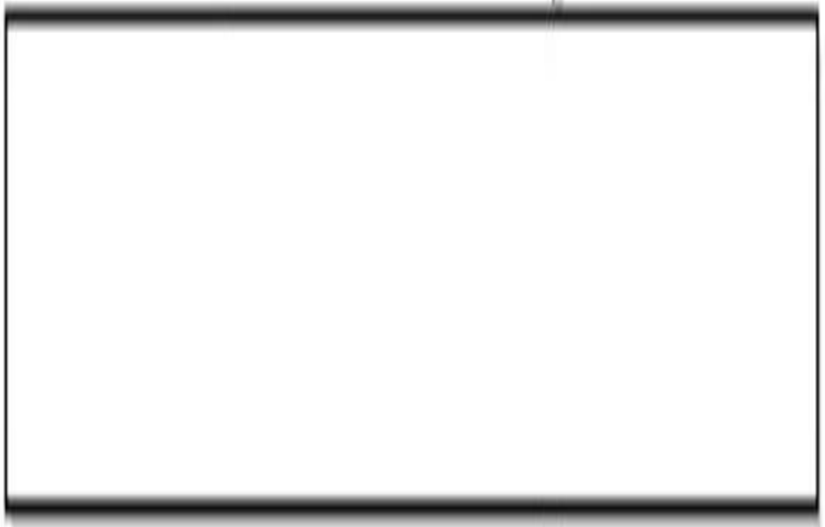

Materials | Permanent | Controlled Variable



Collect Data
1.  2.  3.  4.  5. | 6.  7.  8.  9.  10.

Analyze and draw conclusions

Report or Revise?

- Is your HYPOTHESIS FALSE? Try again with another hypothesis…

- Is your HYPOTHESIS RIGHT? Report it to the scientific community!!!

