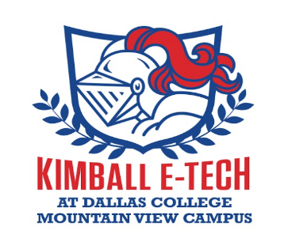

Justin F. Kimball E-Tech Collegiate Academy
Dallas College Mountain View Campus
Admission Policy for Enrollment

The focus of Justin F. Kimball Collegiate Academy School program is to provide students from underrepresented backgrounds (i.e at-risk, low income and/or first-generation college attendees) the opportunity to earn 60 plus college credits hours free of charge while attending high school. Pathways to Technology (P-TECH) Collegiate programs place emphasis on targeting students form underrepresented backgrounds; yet we encourage students of all backgrounds to apply.

P-TECH Collegiate High School is available to any incoming 9th grade students that meet the following requirements:
- Attend the interview process about their desire to be in the P-TECH Collegiate High School.
- The student’s parent must be apart of the interview process and provide approval for students to participate.
- The parent and student must agree to comply with all Dallas ISD, campus and collegiate policies of the Collegiate High School.
- The parent and student must agree that the goal of the P-TECH is to graduate from high school and earned college credits as arranged.

Collegiate Admission Process:
- Student and parent express an interest to pursue the P-TECH Collegiate Academy.
- Student and parent/guardian will complete the P-TECH application (schoolmint system) on-line.
- Review of the P-TECH application is done by the campus principal, collegiate administrator, counselor, teachers & staff of Justin F. Kimball Collegiate Department.
- Selected students are made eligible through the schoolmint system.
- Eligible students will receive notice of scheduled interview date.
- Selected students and parents will receive notification of acceptance.
- Students and parents have ten days to submit approval of acceptance.

