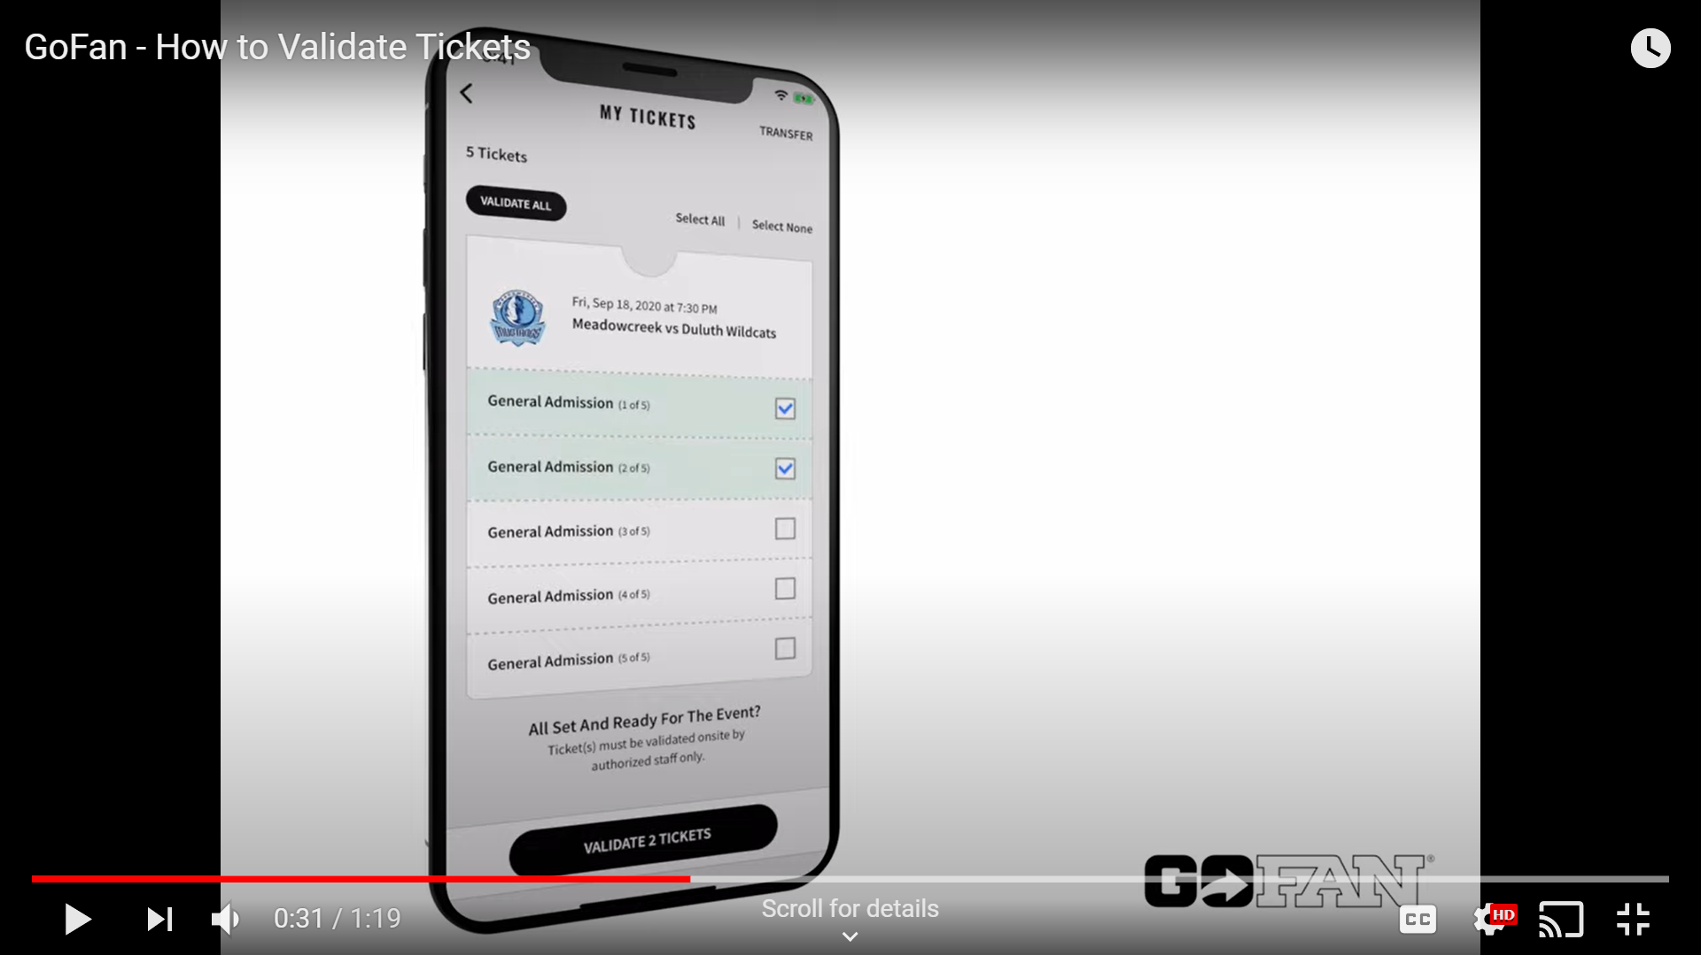
TO VALIDATE TICKETS:
- Have the spectator go to their ticket(s) in the GoFan App on their device.

- The Spectator selects the tickets that they want to redeem.

- Click on the “Validate Tickets” button at the bottom of the screen.

- Click “Validate All” if all spectators are in attendance at that time.
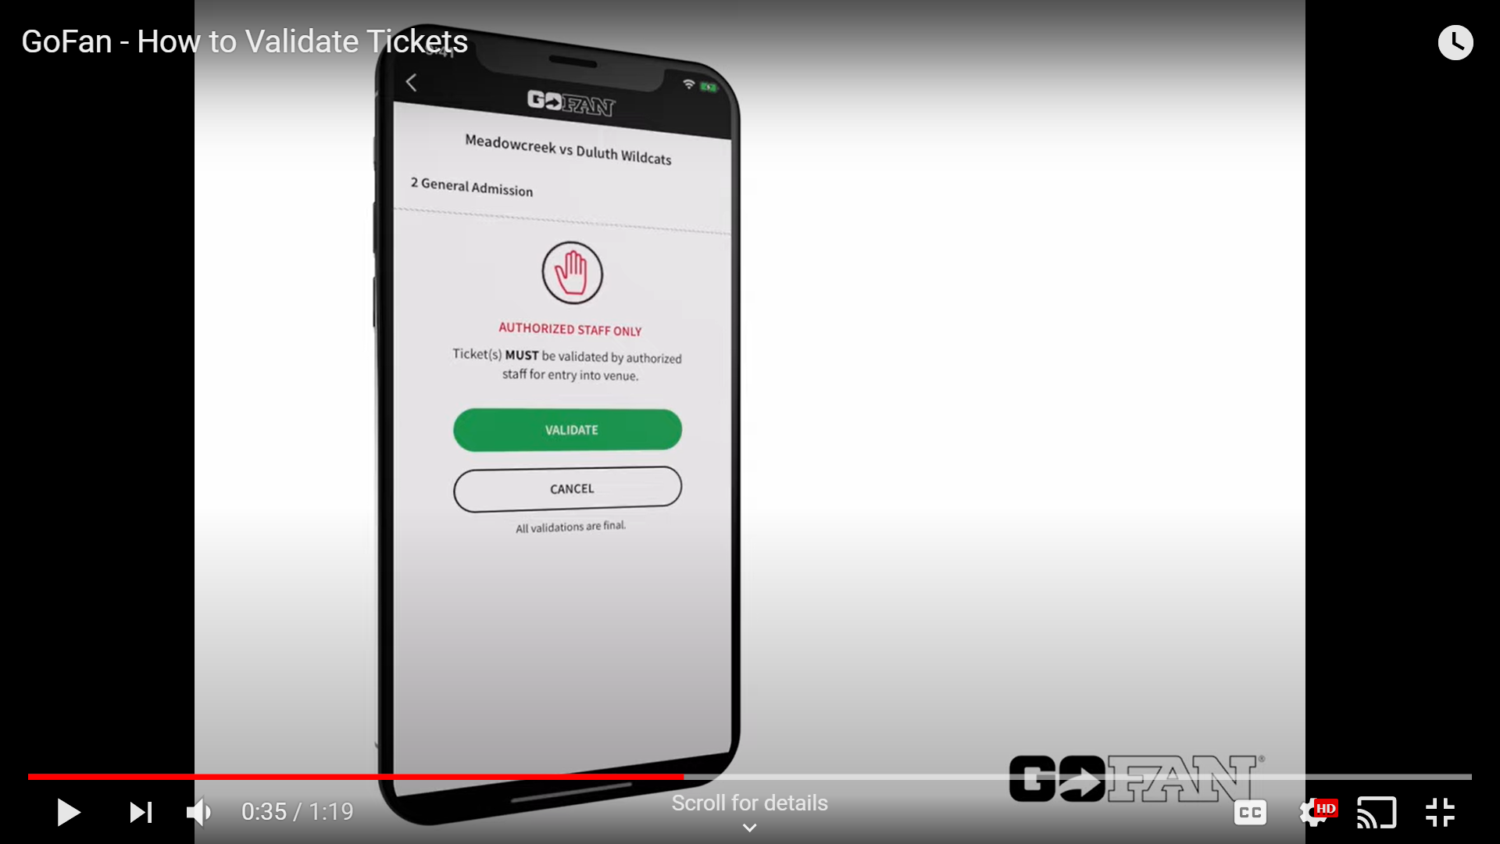
TO VALIDATE TICKETS:
- A Question Box will ask if you want to truly validate the tickets
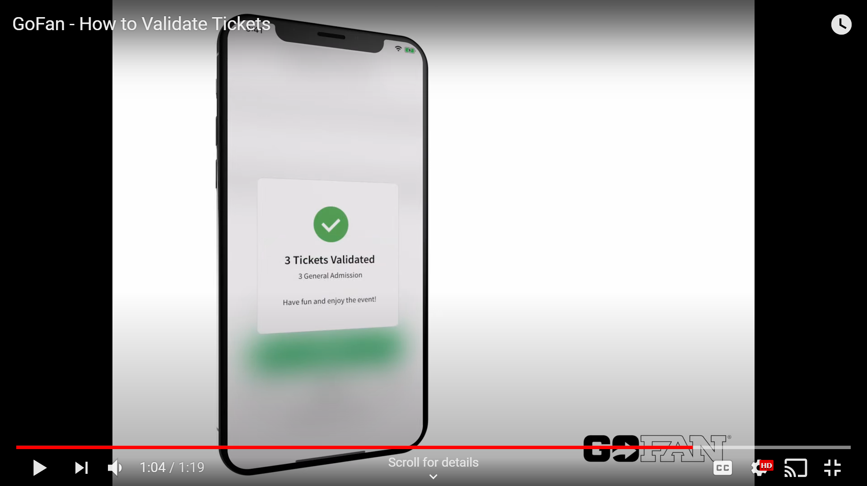
TO VALIDATE TICKETS:
- A Confirmation Box will confirm that the tickets have been validated.

- If the Spectator goes back to the ticket screen, the TIME and DATE stamp will indicate that the ticket has already been redeemed.

