


Pinkston High School
just keep livin Fitness and Wellness Program

Mondays and Wednesdays
4:30 p.m. – 6:30 P.M.

What is just keep livin?
The just keep livin foundation is dedicated to empowering high school students to lead active lives and make healthy choices so Come Break A Sweat, Eat Healthy and say Thank you!

Join and take part in:
Fitness Activities, Goal Setting, gratitude circle, Healthy Snacks, Community Service, Guest Speakers, Field Trips, and more!
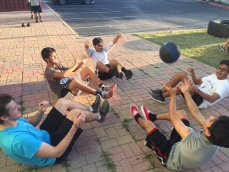
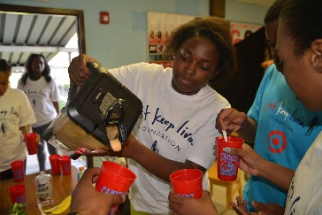



How to find out more and sign up?
If you have any questions, or want to pick up an invitation and packet please see
Mr. Jones- Room 107
Ms. Sanford- Room 341
Mr. McGee – parent center
Please come to the program dressed to workout. You must have your invitation and your parent signed permission slips to join the program.

