Registering on PowerSource

- Navigate to https://support.powerschool.com/signup/US2016TX110
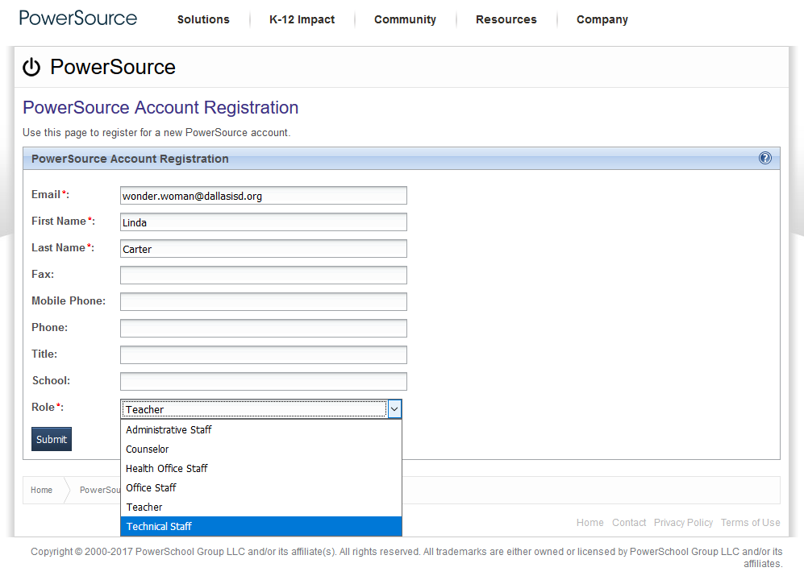
2.a.
2.b.
2.c.
2.d.

- Complete the PowerSource Account Registration page
  - Enter your Dallas ISD email address
  - Enter your first and last name
  - Select your role from the drop down menu
  - Click Submit

- The confirmation page will display
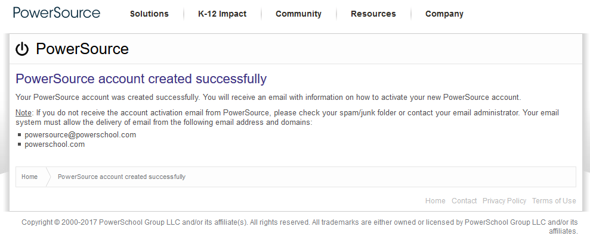

- Watch your email for directions on how to activate your new PowerSource account.
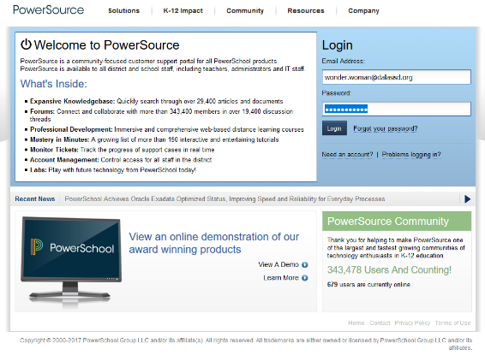
- Navigate to PowerSource: https://support.powerschool.com
5.a.
5.b..

  - Enter your PowerSource user name (your email address)
  - Enter your PowerSource password
NOTE: The password is case-sensitive (uppercase and lowercase matter), enter the password exactly as you set it up.

