Greene County Public Schools

Wellness Policy

2021-2024 Triennial Assessment

Overview & Purpose
In accordance with the Final Rule of the Federal Healthy, Hunger Free Kids Act of 2010 and the Virginia Administrative Code: 8VAC20-740, Greene County Public Schools (GCPS) presents the 2021-2024 Triennial Assessment which includes the timeframe of School Year 2021-2022 through School Year 2023-2024. The Triennial Assessment indicates updates on the progress and implementation of the GCPS Wellness Policy and wellness initiatives, and provides required documentation of actions, steps, and information as outlined in the Final Rule. The school(s) included in this Triennial Assessment are: Nathanael Greene Primary School, Nathanael Greene Elementary School, Ruckersville Elementary School, William Monroe Middle School and William Monroe High School.

GCPS Wellness Policy and Comprehensive Wellness Plan
The GCPS Wellness Policy can be found on the GCPS website at: https://go.boarddocs.com/va/gcs/Board.nsf/vpublic?open. GCPS updates or modifies the Wellness Policy as needed following review, and at least every three years following the triennial assessment. The policy is made available to the public through the GCPS website and GCPS-wide communications. In addition to the GCPS Wellness Policy, the GCPS Comprehensive Wellness Plan exists as a more comprehensive document that expands on goals and procedures of the GCPS Wellness Policy, and can be used as a tool by the school community to accomplish those goals. The GCPS Comprehensive Wellness Plan is available internally to Wellness Committee members and may be made available to school community members interested by contacting the Director of Administrative Services at 434-939-9000. The document is updated or modified as needed following GCPS Wellness Committee review.

GCPS Wellness Committee
GCPS established a GCPS Wellness Committee (hereto referred to as the WC) that meets throughout the year to establish goals for and oversee wellness policies and programs, including development, implementation and periodic review and updating of the GCPS Wellness Policy and Comprehensive Wellness Plan. The WC meets at least once annually for periodic review and update of the Wellness Policy. The WC membership represents all school levels including, but not limited to: parents, students, physical education teachers, school nurses, administrators, school nutrition staff, and administrative service staff. The designated official for oversight of the WC and compliance to the Wellness Policy across the district is the Director of Administrative Services who may be contacted at 434-939-9000. The general public and all members of the school community are allowed and encouraged to participate in the WC processes. Annually, GCPS publicizes the name and contact information of the committee chairperson leading and coordinating the committee, as well as information on how the public can get involved with the school wellness committee.

Quality of Wellness Policy
GCPS must conduct an assessment of the Wellness Policy every three years, at a minimum. As part of the assessment, Wellness Policy leadership compared the GCPS Wellness Policy and Comprehensive Plan to the WellSAT3.0 to ensure compliance, comprehensiveness, and strength of policy language. Both the WellSAT3.0 and Alliance for a Healthier Generation’s model policy template is in compliance with the requirements set forth in the final rule. After comparison, the GCPS Wellness Policy and Comprehensive Plan was updated based on recommendations.
Comparison to WellSAT3.0
A WellSAT3.0 assessment was completed in June 2024 by the GCPS Wellness Coordinator. The overall comprehensiveness score was 100 and the strength score was 72 (of note, the scores are not interpreted like letter grades). Overall scores of each area are shown below in Table 1. The comprehensive score indicates that GCPS policy and plan is compliant with state and federal regulation. The strength score indicates where areas of improvement can be made. In the assessment, all questions were answered with either a “1” or “2” rating by the GCPS Wellness Coordinator. Having no “0” scores indicates all federal requirements were met. Questions rated as a “1” indicated a “weak” policy statement according to the assessment. After review of those questions, and other questions rated “1”, updates were made to the policy and plan. The full WellSAT3.0 assessment results can be found in Appendix A.
Table 1. General WellSAT3.0 Results
Section | Comprehensiveness Score | Strength Score
Section 1. Nutrition Education | 100 | 75
Section 2. Standards for USDA Child Nutrition Programs and School meals | 100 | 100
Section 3: Nutrition Standards for Competitive and Other Foods and Beverages | 100 | 62
Section 4: Physical Education Physical Activity | 100 | 67
Section 5: Wellness Promotion and Marketing | 100 | 50
Section 6: Implementation, Evaluation, and Communication | 100 | 75
Overall District Policy Score | 100 | 72

Wellness Policy Compliance
GCPS must conduct an assessment of the Wellness Policy every three years, at a minimum. The final rule requires State Agencies to assess compliance with the Wellness Policy requirements as a part of the general areas of the Administrative Review every three years. An administrative review was completed for GCPS for the school year 2023-2024. GCPS did not meet all local school wellness policy requirements. The following policy language suggestions were made and added to the policy: language clearly stating that a district wellness committee is established and actively engaged, language clearly defining nutrition standards for food provided but not sold in schools after the school day, language clearly defining nutrition standards for food sold in schools after the school day. Updates are reflected in the current Wellness Policy and will be presented as an informational item on August 14th.
In order to assess further compliance, the standardized School Level Report Card was distributed to all school principals. This report card addressed compliance with USDA and Virginia regulations as well as the GCPS specific goals in the GCPS Wellness Policy at the school level. Table 3 below shows how schools were in compliance with USDA and Virginia regulations required in the Wellness Policy. After results were collected, the School Nutrition Director reviewed standards marked as not met to determine if this was accurately marked or if more education was needed at the school level on these requirements. The standard, “Our school meets the requirements for nutrition standards for all foods and beverages provided, but not sold, to students during the school day (e.g. in classroom parties, classroom snacks brought by parents, or other foods given as incentives)” was found to be in compliance at all schools, however further clarification was needed on those nutrition standards at the school level.

Table 3. School Level Report Card Part 2 - Compliance with USDA and Virginia Standards/Guidelines
Met | Standards and Nutrition Guidelines for All Foods and Beverages Sold
5/5 | Our school meets the standards and nutrition guidelines for all foods and beverages sold to students on the school campus during the school day that are consistent with federal and state regulations:
5/5 | We follow federal school meal nutrition standards for all foods and beverages available for sale on campus during the school day.
4/5 | We have adopted and implemented Smart Snacks nutrition standards for ALL items sold during school hours, including a la carte offerings and food sold in school stores and vending machines.

Met | Standards for All Foods and Beverages Provided, but Not Sold
5/5 | Our school meets the requirements for nutrition standards for all foods and beverages provided, but not sold, to students during the school day (e.g. in classroom parties, classroom snacks brought by parents, or other foods given as incentives)

Met | Policy for Food and Beverage Marketing
5/5 | Our school meets the standards that allow marketing and advertising of only those foods and/or beverages that meet the Smart Snacks nutrition standards.
5/5 | All food and beverage marketing meets Smart Snacks nutrition standards.

Met | Policy for Virginia Fundraising Requirements
5/5 | Our school meets the standards that all food and beverage fundraisers meet Smart Snack Guidelines. Each school is allowed up to 30 exempt fundraisers, which will be tracked by building administration or designee. Food and Beverage fundraisers do not occur during meal times.

Progress towards Goals
The School Level Report Card was distributed to all school principals and was also used to determine how well each school, and therefore the district, is doing in regards to attaining goals indicated in the GCPS Wellness Policy and Comprehensive Plan. Table 4 below shows Part 1 of the assessment tool which assessed how schools met the GCPS-specific goals in the wellness policy. Principals either marked “met” or “not met”.
Under “Nutrition Promotion and Education,” answers indicate that nutrition education is received, however more coordination between classroom and foodservice staff is indicated. Nutrition education activities could also be strengthened in school health programs.
Table 4. School Level Report Card Part 1
Met | Nutrition Promotion and Education
5/5 | Students receive nutrition education that teaches the skills they need to adopt and maintain healthy eating behaviors.
5/5 | Nutrition education is offered in the school cafeteria as well as in the classroom, with coordination between the foodservice staff and other school personnel, including teachers.
5/5 | Students receive consistent nutrition messages from all aspects of the school program.
5/5 | Division health education curriculum standards and guidelines address both nutrition and physical education.
5/5 | Nutrition is integrated into the health education or core curricula (e.g., math, science, language arts).
2/5 | Schools link nutrition education activities with the coordinated school health program. Staff who provide nutrition education have appropriate training.
5/5 | The level of student participation in the school breakfast and school lunch programs is appropriate.
5/5 | The school meal programs aim to improve the diet and health of school children, help mitigate childhood obesity, model healthy eating to support the development of lifelong healthy eating patterns and support healthy choices while accommodating cultural food preferences and special dietary needs.
5/5 | All schools within GCPS are committed to offering school meals through the NSLP and SBP programs, and other applicable Federal child nutrition programs
5/5 | All school nutrition program directors, managers and staff will meet or exceed hiring and annual continuing education/training requirements in the USDA professional standards for child nutrition professionals
5/5 | Nutrition promotion and education positively influence lifelong eating behaviors by using evidence-based techniques and nutrition messages, and by creating food environments that encourage healthy nutrition choices and encourage participation in school meal programs
5/5 | GCPS will promote healthy food and beverage choices for all students throughout the school campus, as well as encourage participation in school meal programs.

Met | Physical Activity
5/5 | Students are given opportunities for physical activity during the school day through physical education (PE) classes, daily recess periods for elementary school students and the integration of physical activity into the academic curriculum where appropriate.
5/5 | Students are given opportunities for physical activity through a range of before- and/or after-school programs including, but not limited to, intramurals, interscholastic athletics and physical activity clubs.
5/5 | Schools encourage parents and guardians to support their children's participation in physical activity, to be physically active role models and to include physical activity in family events.
5/5 | Schools provide training to enable staff to promote enjoyable, lifelong physical activity among students.

Met | Other School Based Activities
5/5 | An adequate amount of time is allowed for students to eat meals in adequate lunchroom facilities.
5/5 | The availability of subsidized food programs is adequately publicized in ways designed to reach families eligible to participate in the programs.
5/5 | Environmentally-friendly practices such as the use of locally grown and seasonal foods, school gardens and non-disposable tableware have been considered and implemented where appropriate
5/5 | Physical activities and/or nutrition services or programs designed to benefit staff health have been considered and, to the extent practical, implemented.

Wellness Objectives/Goals for Next 3 Years
Results of the GCPS Wellness Assessment Tool and the Healthy Districts Assessment, along with dialogue during WC meetings, were used to shape goals for the next school year and the next 3 year period.

2024-25 School Year
- Promote healthy food and beverage choices and school meals using appropriate marketing and merchandising techniques.
- All schools will be in compliance with USDA Smart Snack standards.
- Re-introduce the Get for Greene 5k

Next Three Years

- Continuous improvement process to implement school health policies
- Student and family involvement in the school meal programs and other foods and beverages sold, served, and offered on campus
- Farm to School Activities
- Promote Staff participation in healthier eating habits and weight management

Appendix A.

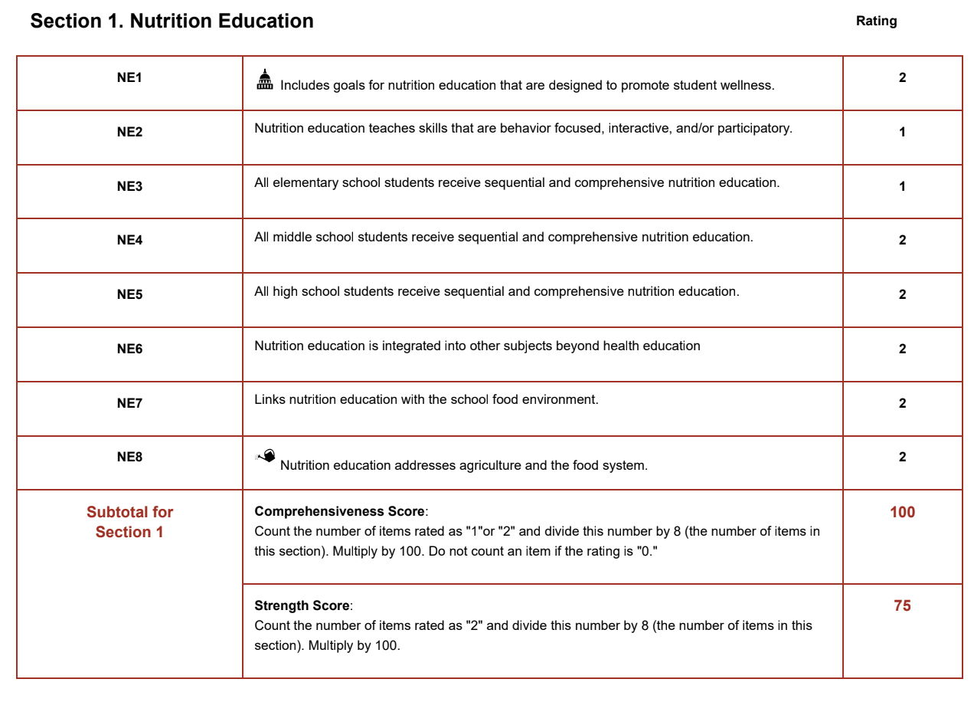
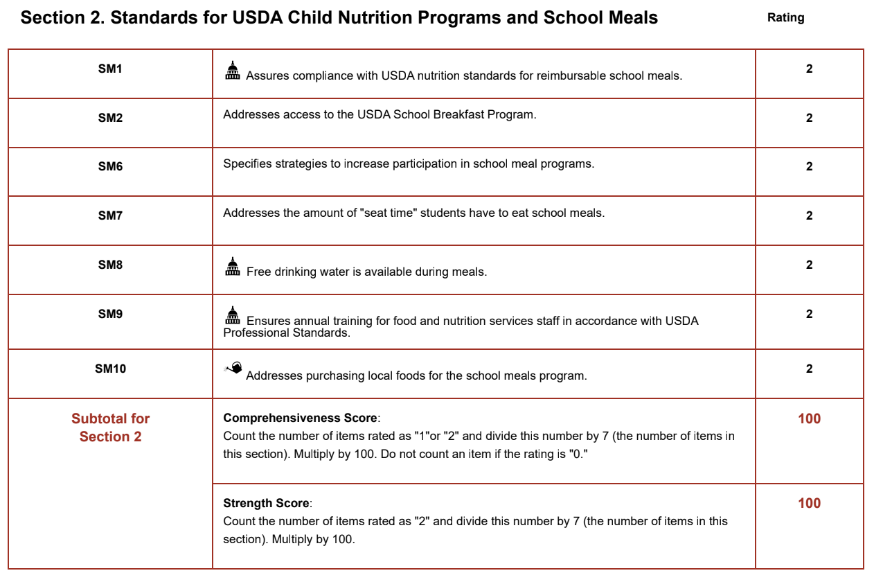
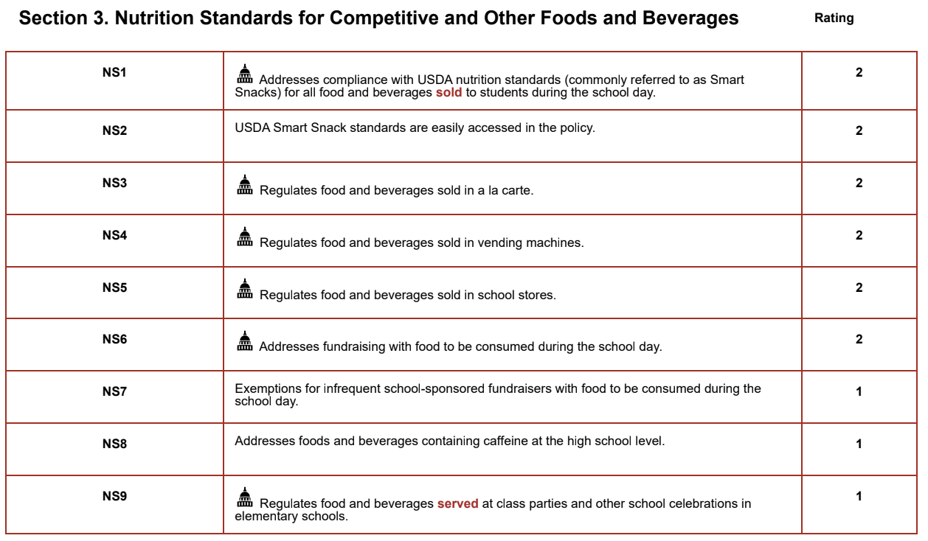

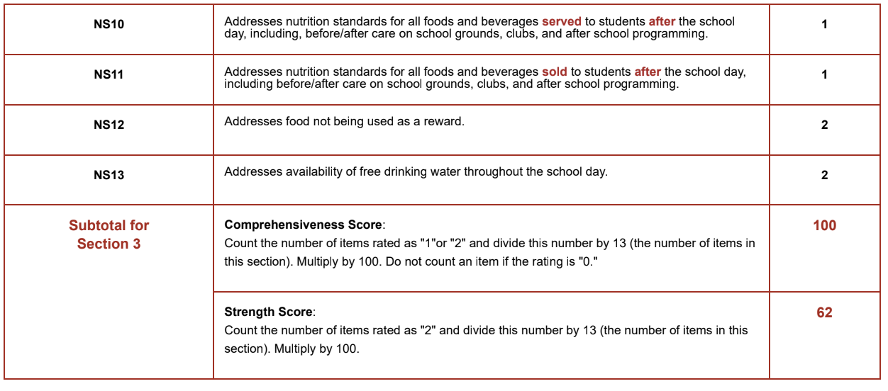
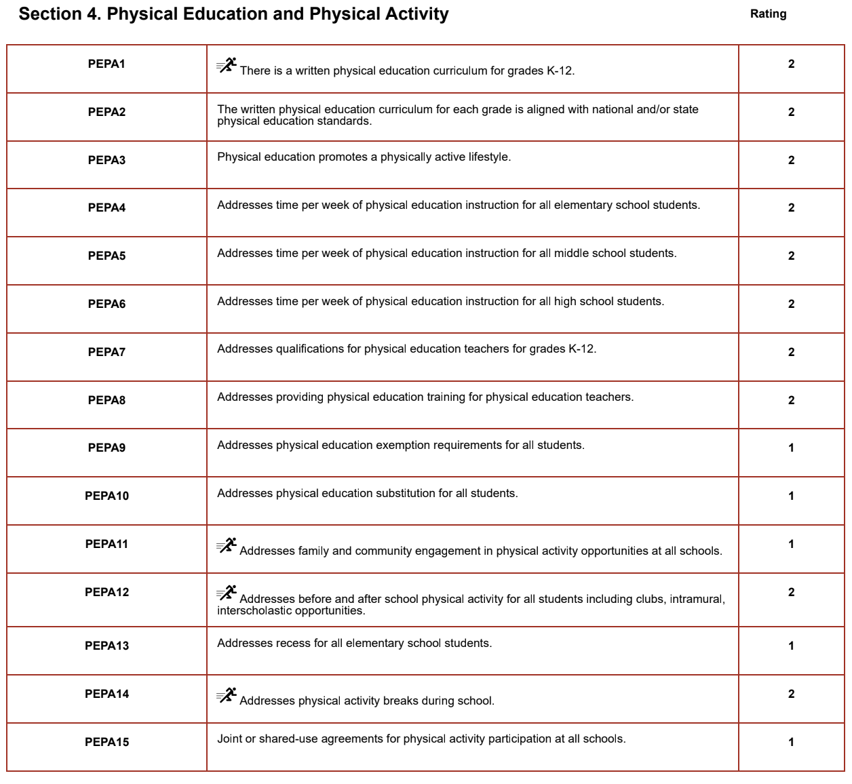
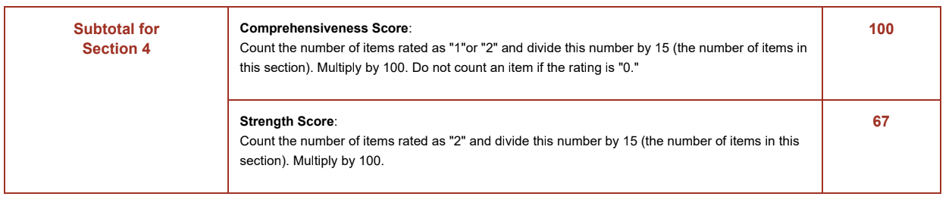
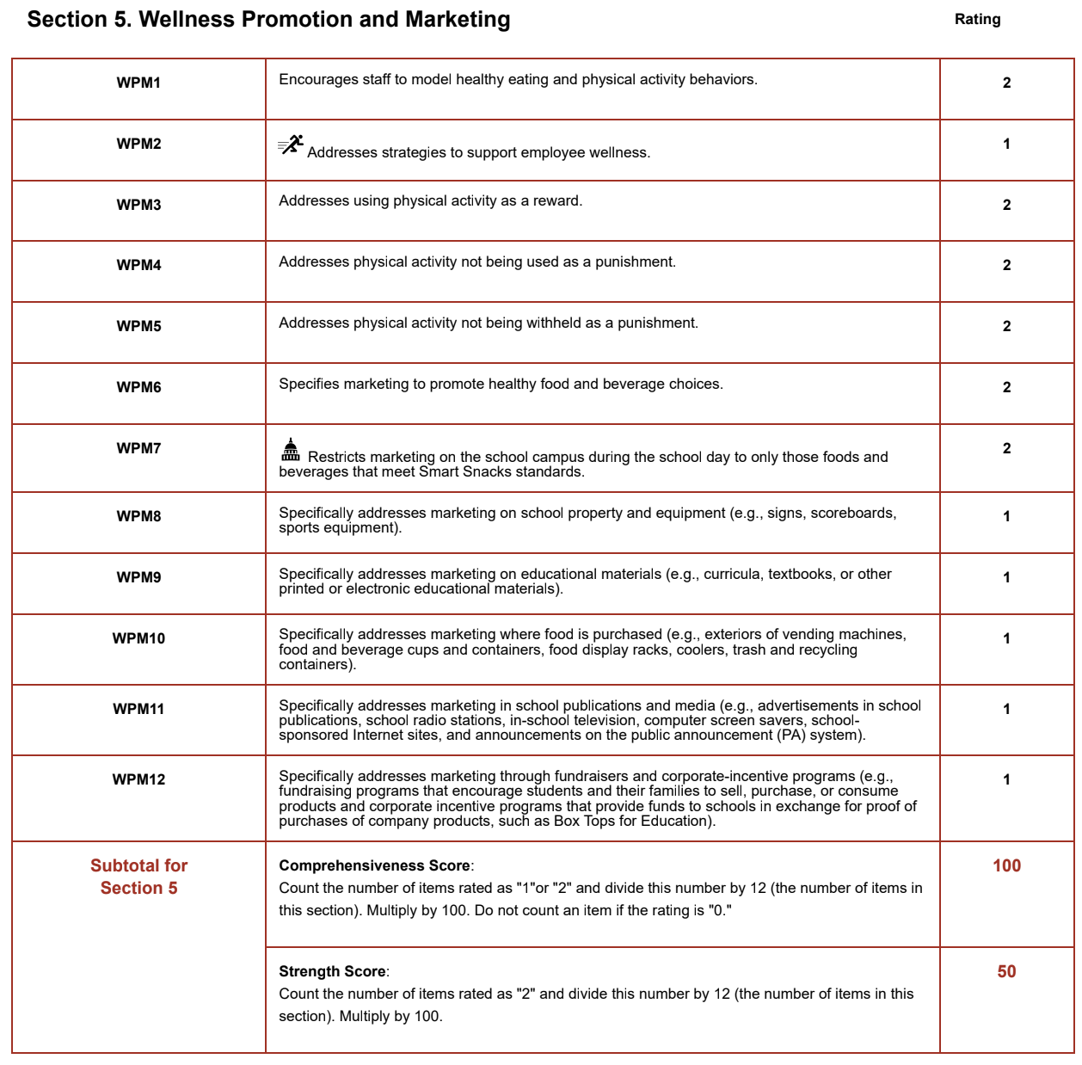

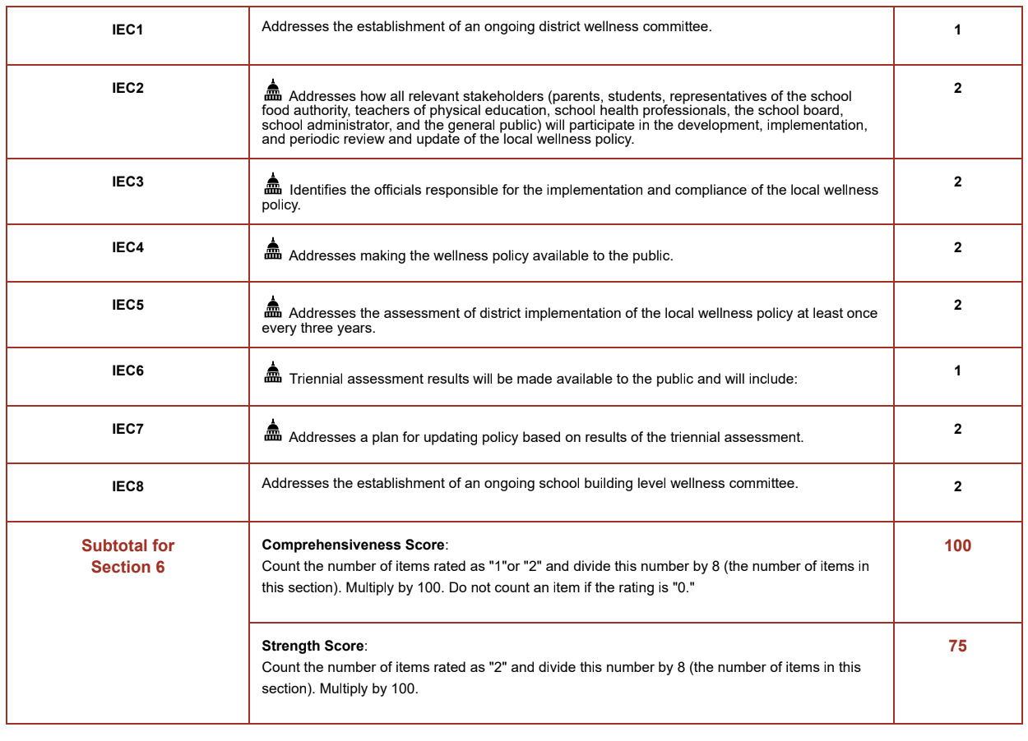

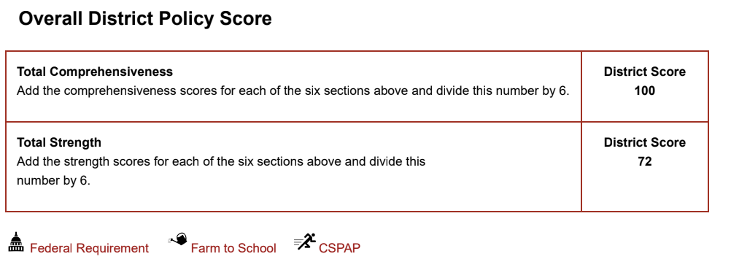

In accordance with federal civil rights law and U.S. Department of Agriculture (USDA) civil rights regulations and policies, this institution is prohibited from discriminating on the basis of race, color, national origin, sex (including gender identity and sexual orientation), disability, age, or reprisal or retaliation for prior civil rights activity.
Program information may be made available in languages other than English. Persons with disabilities who require alternative means of communication to obtain program information (e.g., Braille, large print, audiotape, American Sign Language), should contact the responsible state or local agency that administers the program or USDA’s TARGET Center at (202) 720-2600 (voice and TTY) or contact USDA through the Federal Relay Service at (800) 877-8339.
To file a program discrimination complaint, a Complainant should complete a Form AD-3027, USDA Program Discrimination Complaint Form which can be obtained online at: https://www.usda.gov/sites/default/files/documents/ad-3027.pdf, from any USDA office, by calling (866) 632-9992, or by writing a letter addressed to USDA. The letter must contain the complainant’s name, address, telephone number, and a written description of the alleged discriminatory action in sufficient detail to inform the Assistant Secretary for Civil Rights (ASCR) about the nature and date of an alleged civil rights violation. The completed AD-3027 form or letter must be submitted to USDA by:
- mail:
U.S. Department of Agriculture
Office of the Assistant Secretary for Civil Rights
1400 Independence Avenue, SW
Washington, D.C. 20250-9410; or
- fax:
(833) 256-1665 or (202) 690-7442; or
- email:
Program.Intake@usda.gov

This institution is an equal opportunity provider.

