LIGHTHOUSE ISLAND ACADEMY

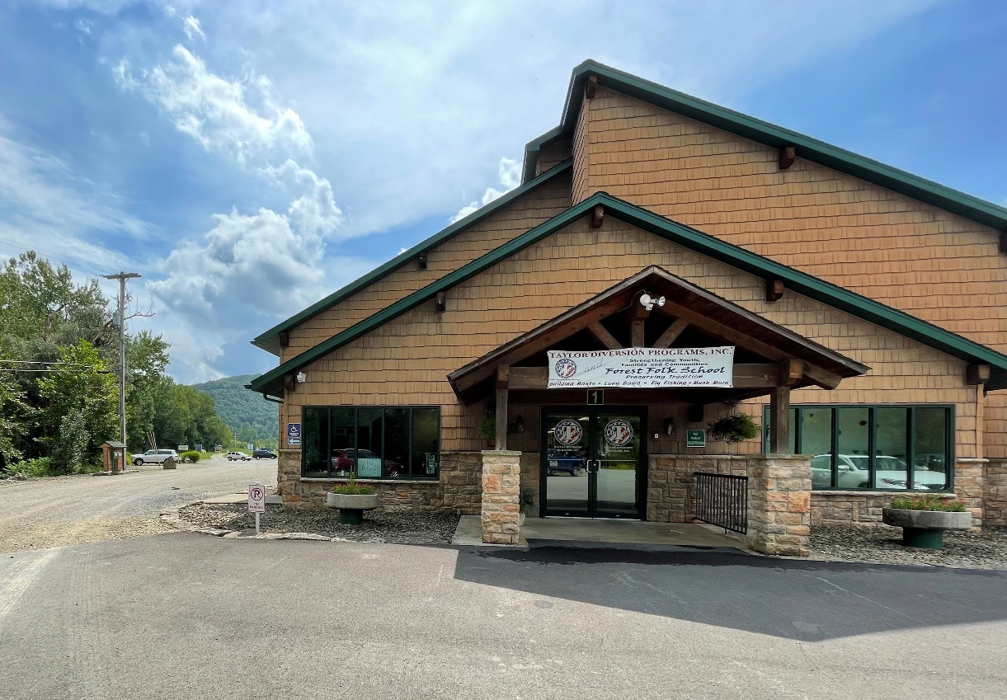

COVID-19 Health & Safety Plan
Goals are for continued Continuity of Services as well as continued Safe Return to In-Person Instruction.

Initial Effective Date: August 30, 2021 Date of Last Board Review: August 30, 2021
Date of Last Revision: August 30, 2021 Date of Board Approval: August 30, 2021


ARP ESSER Health and Safety Plan
LIGHTHOUSE ISLAND ACADEMY
Tionesta, PA 16353
Section 2001(i)(1) of the American Rescue Plan (ARP) Act requires each local education agency (LEA) that receives funding under the ARP Elementary and Secondary School Emergency Relief (ESSER) Fund to develop and make publicly available on the LEA’s website a Safe Return to In-Person Instruction and Continuity of Services Plan, hereinafter referred to as a Health and Safety Plan.
This plan addresses how Lighthouse Island Academy (LIA) maintain the health and safety of students, educators, and other staff, and will serve as local guidelines for all instructional and non-instructional school activities during the period of our ARP ESSER grant. The Health and Safety Plan should be tailored to the unique needs of each program and location of our services and must take into account public comment related to the development of, and subsequent revisions to, the Health and Safety Plan.
We will be continuously monitoring our Health and Safety Plan throughout the year and update as needed. All revisions should be reviewed and approved by our governing body prior to posting on the school entity’s public website.

- Lighthouse Island Academy, a private academic school grades 9-12 for at-risk students, recognizes that our school entity is unique and the goal is to implement the Health and Safety Plans within the school/learning environment in which we operate. All staff and students will follow this plan and the Education Director will be responsible for keeping staff and students abreast of which phase of the plan we are in.

- Our Health & Safety plan is designed to address three major prongs: (1) safe operations, (2) teaching and learning procedures, and (3) staff and student wellness.

- Our Health & Safety plan is designed to follow the guidance of the Center for Disease Control and Prevention (CDC) in cooperation with the PA Department of Education and PA Department of Public Health.
Table of Contents
Introduction ………………………………………………………………………... 1
Section 1: Type of Reopening ………………………………………………………………………... 3
Section 2: Key Questions ………………………………………………………………………... 4
Section 3: Requirements Being Met ………………………………………………………………………... 7
Section 4: Additional Resources ………………………………………………………………………... 8
Section 5: Pandemic Coordinator / Team …………………………………………..……………………... 9
Section 6: Summary ……………………………..........………………………..…………... 10
Section 7: Board Affirmation ……………………………………..........………………..…………... 11

Health and Safety Plan: LIGHTHOUSE ISLAND ACADEMY
Section 1: Type of Reopening
All decision-makers should be mindful that as long as there are cases of COVID-19 in the community, there are no strategies that can completely eliminate transmission risk within a school population. The goal is to keep transmission as low as possible to safely continue school activities. All school activities must be informed by the latest CDC regulations and guidance. The administration has categorized reopening in-person instruction into four broad phases based on the safety precautions that are being recommended at the Federal, State, and Local levels with consideration to the transmission levels and number of identified cases in each school setting or community setting:
- FULL IN-PERSON instruction = students and staff attending daily for full days
- HYBRID instruction = some combination/rotation of in-person and virtual teaching
- TEMPORARILY VIRTUAL instruction = 0-4 weeks of virtual instruction
(4) FULL VIRTUAL instruction = 1 month or more of all virtual instruction due to local, State, or Federal shut down of schools.
Depending upon the public health conditions in any county within the Commonwealth, there could be additional actions, orders, or guidance provided by the Pennsylvania Department of Education (PDE), the Pennsylvania Department of Health (DOH), and/or the CDC, which will influence the decisions made by the local administration. Each LIA staff member is expected to follow the plan for school. Some counties may not experience a straight path from 1 to 2 to 3 to 4, instead, cycling back and forth between less restrictive to more restrictive designations as public health indicators improve or worsen. This means that each staff member should account for changing conditions in your local Health and Safety Plan to ensure fluid transition from more to less restrictive conditions in each of the designations as needed.
Section 2: Key Questions
- How will Lighthouse Island Academy, to the greatest extent practicable, implement prevention and mitigation policies in line with the most up-to-date guidance from the Centers for Disease Control and Prevention (CDC) for the reopening and operation of school facilities in order to continuously and safely open and operate schools for in-person learning?

Answer: The LIA Administration will follow the latest CDC guidelines and have regional leadership meetings to keep up to date. Information will be passed to staff through their local school leaders and supervisors as well as through RIU6 leadership for safety and security protocols and response to situations and outbreaks.

- How will Lighthouse Island Academy ensure continuity of services, including but not limited to services to address the students’ academic needs, and students’ and staff members’ social, emotional, mental health, and other needs, which may include student health and food services?

Answer: The LIA and Riverview Intermediate Unit 6 (RIU) will utilize a vast array of service providers to ensure students needs are met through the IEP process and daily instruction (whether in-person or virtual). We utilize special education teachers, Training and Consultation (TAC) facilitators, specialists in autism and behavior, social workers, occupational therapists, physical therapists, and speech therapists to help students and staff members with their social, emotional, and mental health needs, as well as cooperate with the local school personnel to meet the students’ health and nutrition needs. In these realms, we will continue to provide professional development to staff, research best practices, and follow the latest CDC guidelines.

- How will LIA maintain the health and safety of students, educators, and other staff and the extent to which it has adopted policies, and a description of any such policy on each of the following safety recommendations established by the CDC?

Answer: The RIU6 Administration will follow the latest CDC guidelines to the greatest extent practical within the context of the local environment for which education is occurring. We will have staff training on the items quarterly throughout the year with in-service days. Information will be passed to staff through their local school leaders and supervisors as well as through RIU6 leadership for safety and security protocols and response to situations and outbreaks. Below is the list of safety recommendations and how we are treating them at the local level:

  - Universal and correct wearing of masks:
General Rule is required of all staff and students
    - Masks are required for all persons on transportation to and from school and in-school.
    - Exceptions to wearing a mask one in the school setting, during the school day, are only those permitted through law and CDC guidelines (young age, education exceptions, and vaccination status)

  - Modifying facilities to allow for physical distancing (e.g., use of cohorts/podding):
CDC guidelines will continue to be followed emphasizing 6 feet where able at all times, however reducing to 3 feet in classrooms where masks are universal and transmission levels are not high.

  - Handwashing and respiratory etiquette:
Frequent hand washing emphasized per CDC regulations.
    - Before, during, and after preparing food
    - Before and after eating food
    - Before and after caring for someone at home who is sick with vomiting or diarrhea
    - Before and after treating a cut or wound
    - After using the toilet
    - After changing diapers or cleaning up a child who has used the toilet
    - After blowing your nose, coughing, or sneezing
    - After touching an animal, animal feed, or animal waste
    - After handling pet food or pet treats
    - After touching garbage

  - Cleaning and maintaining healthy facilities, including improving ventilation:
Cleaning and disinfection will occur daily and after use of high touch areas and if someone was sick. For ventilation, open windows and use of fans for “Air Out” procedures will be emphasized for improvement.

  - Contact tracing in combination with isolation and quarantine, in collaboration with State and local health departments:
CDC guidelines will continue to be followed for contract tracing, isolation, and quarantines. Cohorting and special emphasis on limiting contact in general routines will be utilized to aid in the limitation of exposure if a student or staff member is exposed/sick. Consultation will continue with local health officials and the state DOH for situations of reporting and tracing transmission levels.

  - Diagnostic and screening testing:
CDC guidelines will continue to be followed for diagnosis and screening procedures. Daily temperature and symptom checks will continue to occur and returning from quarantine and isolation will require negative test results where available.

  - Efforts to provide COVID-19 vaccinations to school communities:
We will continue to support our local medial providers in distribution of the vaccine and are open to hosting a vaccination clinic again in the future if the need arises.

  - Appropriate accommodations for children with disabilities with respect to health and safety policies; and
Any accommodations for children with disabilities with respect to health and safety will continue to be a priority in IEP team decisions and implementation. All of our staff will continuously receive professional development related to best practices and legally defensible IEPs in order to best meet the needs of each student within the guidance of the law.

  - Coordination with state and local health officials
Ongoing school leadership meetings will occur throughout the school year to track and develop policies and procedures. Our leadership will notify our local School District (Forest Area Schools), PDE, DOH, and RIU6 officials if an outbreak would occur so as to help ensure that best practices are being followed.
Section 3: Requirements Being Met
- The Lighthouse Island Academy’s Health and Safety Plan must be approved by its governing body and posted on the LEA’s publicly available website by September 30, 2021.
- The plan also must be provided in an alternative format accessible, upon request, by a parent who is an individual with a disability as defined by the Americans with Disabilities Act.
- Lighthouse Island Academy will upload in the eGrants system its updated Health and Safety Plan and webpage URL where the plan is located on the LEA’s publicly available website.
- The ARP Act requires LEAs to review their Health and Safety Plans at least every six months during the period of the LEA’s ARP ESSER grant.
- LEAs also must review and update their plans whenever there are significant changes to the CDC recommendations for K-12 schools.
- Like the development of the plan, all revisions must be informed by community input and reviewed and approved by the governing body prior to posting on the LEA’s publicly available website.
- Lighthouse Island Academy may use the template to revise their current Health and Safety Plans to meet ARP requirements and ensure all stakeholders are fully informed of the LEA’s plan to safely resume instructional and non-instructional school activities, including in-person learning, for the current school year.
- Lighthouse Island Academy may use a different plan template or format provided it includes all the elements required by the ARP Act, as listed above.
Section 4: Additional Resources
The following resources were reviewed in the development of the LIA’s Health and Safety Plan:
- LIA’s Reopening Health & Safety Plan 2020
- CDC K-12 School Operational Strategy
- PDE Resources for School Communities During COVID-19
- PDE Roadmap for Education Leaders
- PDE Accelerated Learning Thorough an Integrated System of Support
- PA Department of Health - COVID-19 in Pennsylvania
Section 5: Pandemic Coordinator / Team
Individual(s) | Stakeholder Group Represented | Pandemic Team Roles and Responsibilities  (Options Above)
Michael Cummings | Executive Director | Plan Development and Response Team
Debra Cummings | Assistant Executive Director | Plan Development and Response Team
Brad Geer | Education Director | Plan Development and Response Team
Jill Faulkner | Department of Special Education | Plan Development and Response Team
Jack Rice | Program Director | Plan Development
Jena Hollidge | Clinical Director | Plan Development and Response Team
Alisha Maxwell | Nurse Supervisor | Plan Development
Kathleen Smith | Education Administrator | Plan Development
Heidi Ryding | HR Director | Plan Development and Response Team
Shannon Simmons | CTE and Work Readiness Director | Plan Development and Response Team

Section 6: Summary of Responses:
Staff and students return to physical buildings will be guided by the LIA Education Director and staff. School staff will follow the guidance of this plan and will work with their Education Director, along with Executive Director to implement it most effectively. LIA classrooms already have size restrictions so we will be closely monitoring social distancing in those settings. Engagement of stakeholders will be done through our network of meetings with our school leaders, as well as our staff in-service days. LIA’s email networks will communicate the plan to our local communities and our local LEA, Forest Area School District. The plan will be reviewed and provided to parents as part of IEP meetings and program information at the start of the school year or when a student enters LIA. IEP teams will be utilized for tracking social, emotional, and mental health needs of students and strategies for improvement in those areas. School closures, significant modifications to operations, and ongoing monitoring will be coordinated through our Executive Director and Education Director. Face-to-Face instruction will be utilized to the extent feasible based on the local context and the mitigation recommendations of local, state, and federal officials at the time, with distance learning (virtual and correspondence) as the next step either in hybrid, temporary, or long term as deemed fit.

Section 7: Governing Body Affirmation Statement

The Board of Directors for Lighthouse Island Academy reviewed and approved the Phased School Reopening Health and Safety Plan on August 30, 2021.
The plan was approved by a vote of: Yes No
- Affirmed on this date of August 30, 2021, by

Dr. Nancy Sayre
Signature of Board President Printed Name of Board President

Michael S. Cummings
Signature of Executive Director Printed Name of Executive Director

