Grade 3 Math Vocabulary For Module 2:
Place Value & Units of Measure

About: with reference to rounding and estimation, an answer that is not precise

Addend: the numbers that are added together in an addition equation
Example: 4 + 5
Addend + Addend

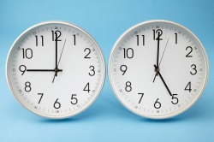
Analog clock: a clock that is not digital; face clock


Capacity: the amount of liquid that a particular container can hold

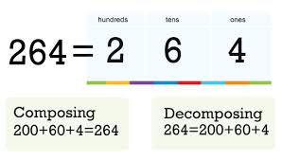
Compose : change 10 smaller units for 1 of the next larger unit
on the place value chart


Continuous: reference to time as an ongoing measurement

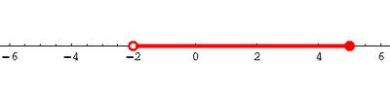
Endpoint : used with rounding on the number line; the numbers that mark the beginning and end of a given interval

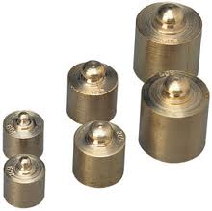
Gram (g): metric unit of measure for weight

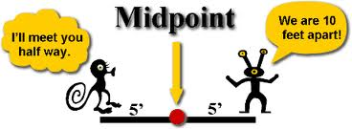
Halfway : reference to a number line, the midpoint between two numbers

Interval: time passed or a segment on the number line
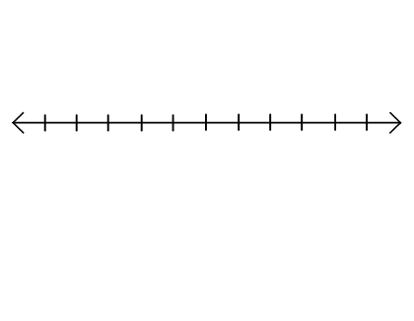

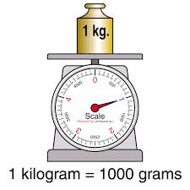
Kilogram (kg): metric unit of measure for mass equal to 1,000 grams


Liquid volume : the space a liquid takes up

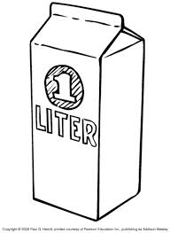

Liter (L): metric unit of measure for liquid volume

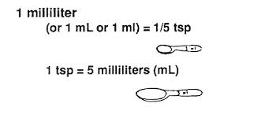
Milliliter (mL): metric unit of measure for liquid volume

Plot: locate and label a point on a number line
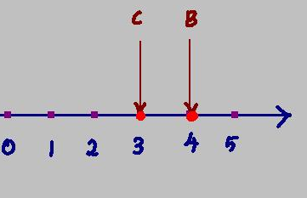

Point : a specific location on the number line 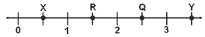

Reasonable: reference to how plausible an answer is
e.g., “Is my answer reasonable? Does it make sense?”

Rename: regroup units e.g., when solving with the standard algorithm
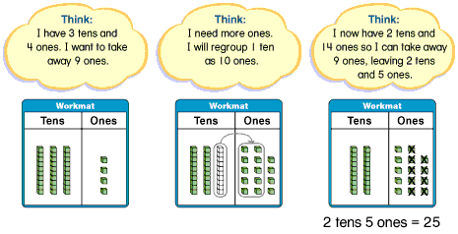

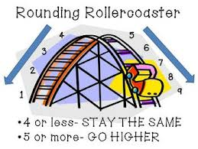
Round : estimate a number to the
nearest 10 or 100 using place value

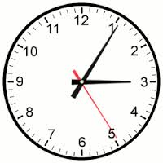
Seconds: a unit of time

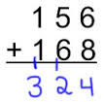
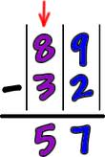
Standard algorithm : for addition and subtraction

≈ :symbol used to show that an answer is approximate

Familiar Terms and Symbols:
Centimeter: cm, metric unit of measurement 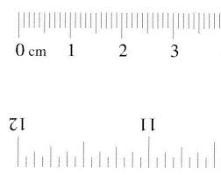
Divide: splitting into equal parts or groups. It is the result of "fair sharing".


÷ or e.g., 4 ÷ 2 = 2 2 4

Estimate: approximation of the value of a quantity or number
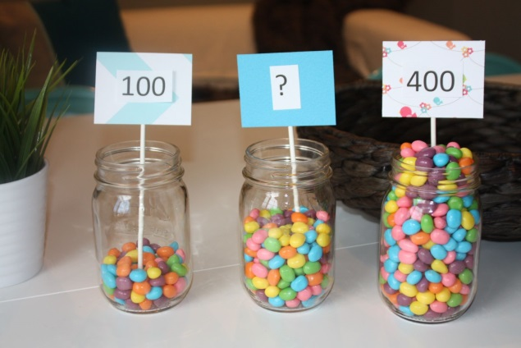

Horizontal with reference to how an equation is written,
e.g., 3 + 4 =7 is written horizontally

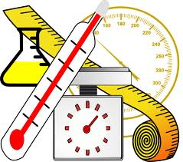
Measure: a quantity representing a
weight or liquid volume, or
the act of finding the size or
amount of something


Mental math: calculations performed in one’s head,
without paper and pencil

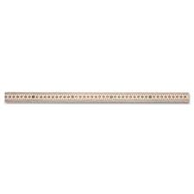
Meter: m, a metric unit of linear measurement

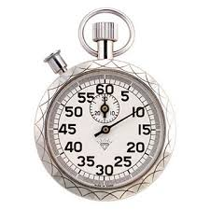

Minute: a unit of time equal to 60 seconds

Multiply: The common method of a multiplying that everyone knows and uses
X is the symbol e.g., 2 × 3 = 6

Number line: A line marked with numerals at evenly spaced intervals that may be vertical or horizontal
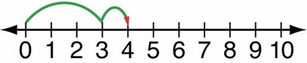

Simplifying strategy: transitional (in between) strategies that move students toward mental math
e.g., “make ten” to add 7 and 6,
(7 + 3) + 3 = 13

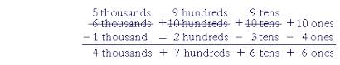
Unbundle: regroup units,
e.g., in the standard algorithm

Vertical: with reference to how an equation is written; equations solved using the standard algorithm are typically written vertically

