Name: __________________________ Mod:______
Accessing Google Docs
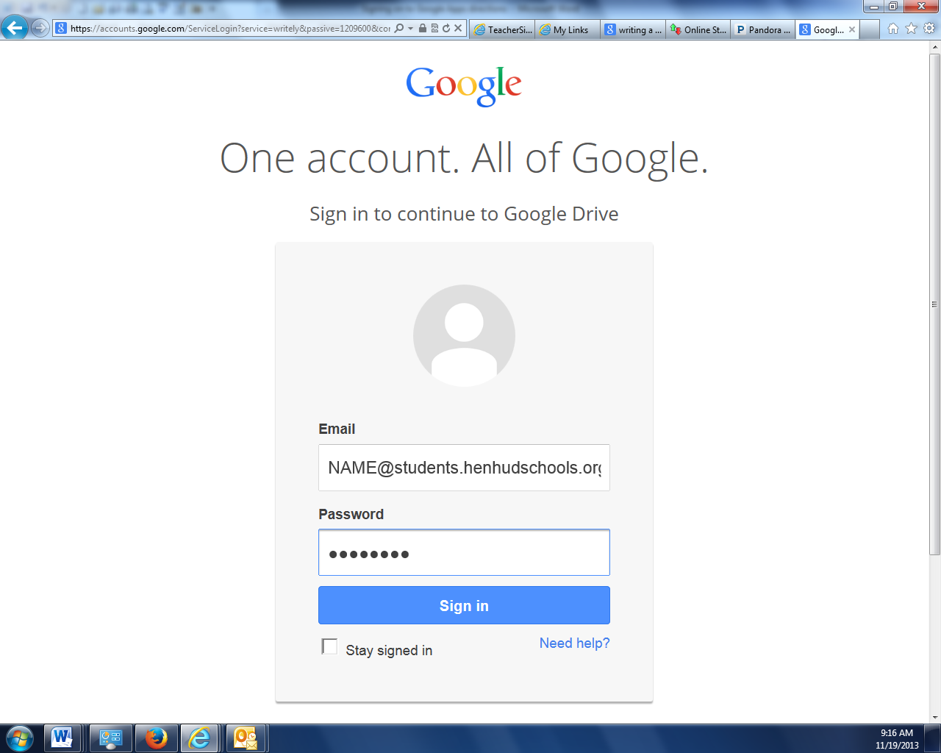
STEP 1: Go to docs.google.com
STEP 2: Log in using the following:
Email= schoolusername@students.henhudschools.org
Password= your 8 digit computer password

Creating a New Document

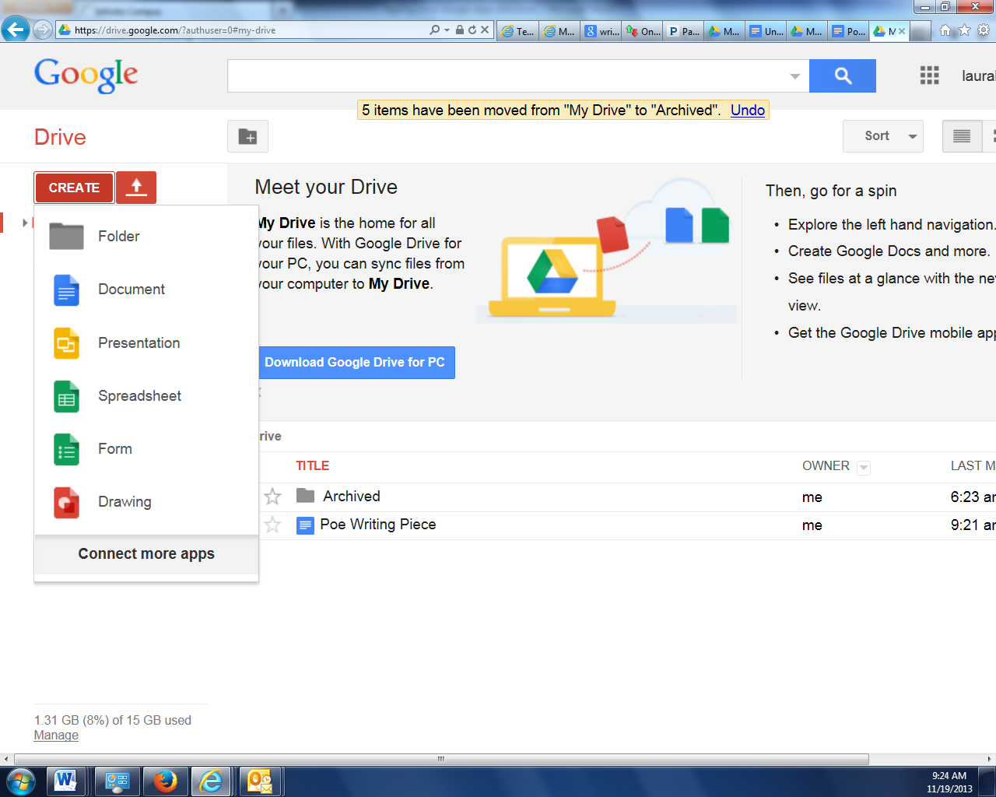
Step 1: Click on ‘CREATE’ under ‘Drive’ on right hand side.
Step 2: Choose ‘Document’ from the drop down menu.
(over)

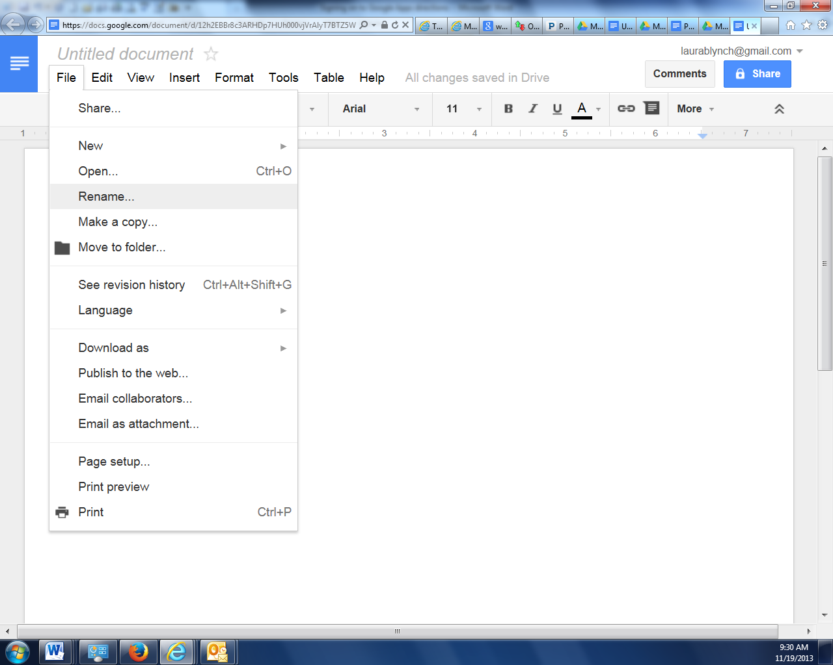
Step 3: Click on File tab on top right hand side.
Step 4: Choose ‘Rename’ from the drop down menu.

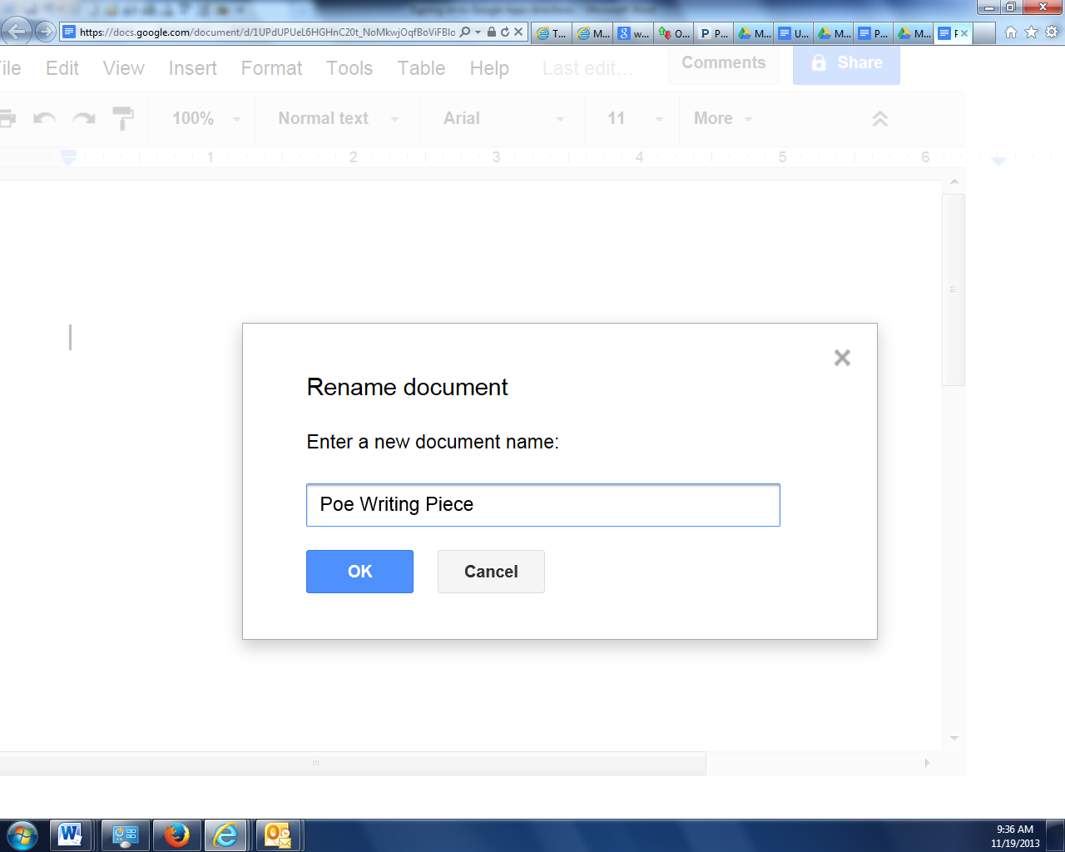
Step 5: Enter a document title.

Step 6: Click ‘OK’

*NOTE: ALL changes to your document will be saved AUTOMATICALLY to your account.

Accessing Saved Documents
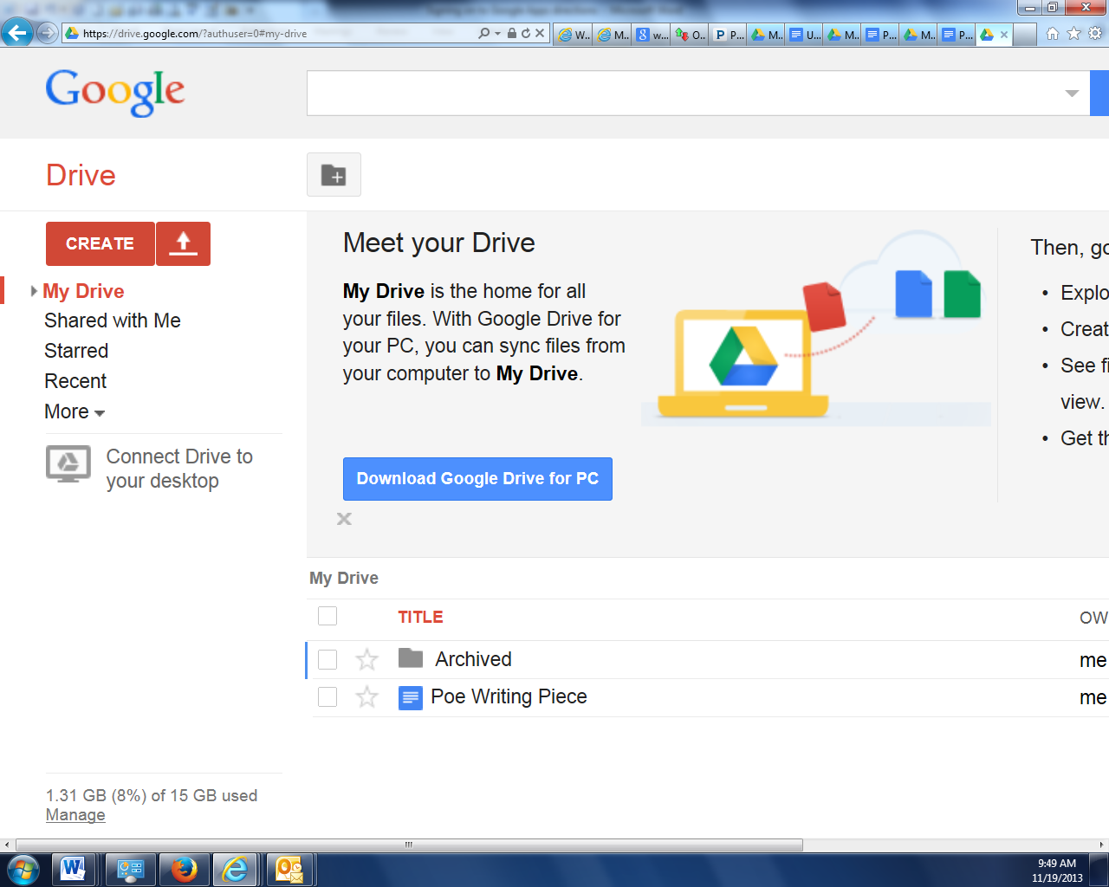
Step 1: Locate document under ‘My Drive’
Step 2: Click on desired document.

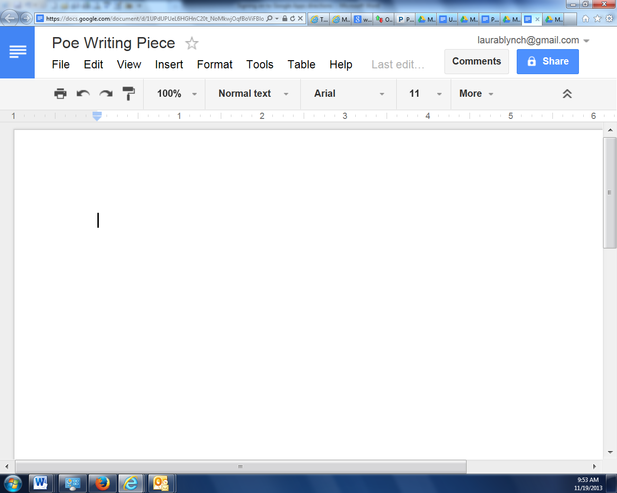
Step 3: Add or delete text as needed.
Remember: ALL changes to your document will be saved AUTOMATICALLY to your account.

