Quantitative vs. Qualitative Observations
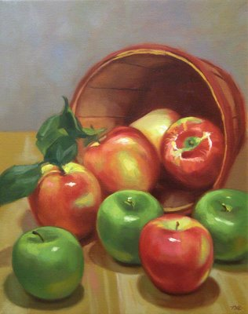
- What is the quantity of apples in the basket?
- What is the quality of apples in the basket?

Quantitative: Observations using numbers to describe what you observe.
Qualitative: Observations using descriptions of information gathered using your senses.
Qualitative data:  - blue/green color, gold frame  - smells old and musty  - texture shows brush strokes of oil paint  - peaceful scene of the country  - masterful brush strokes | Quantitative data:  - picture is 10" by 14"  - with frame 14" by 18"  - weighs 8.5 pounds  - surface area of painting is 140 sq. in.  - cost $300
  Example 1:  Oil Painting | 
  Example 1:
  Oil Painting
Qualitative data:  - robust aroma  - frothy appearance  - strong taste  - burgundy cup | Quantitative data:  - 12 ounces of latte  - serving temperature 150º F.  - serving cup 7 inches in height  - cost $4.95
  Example 2:  Latte | 
  Example 2:
  Latte
Qualitative data:  - friendly demeanors  - civic minded  - environmentalists  - positive school spirit | Quantitative data:  - 672 students  - 394 girls, 278 boys  - 68% on honor roll  - 150 students accelerated in mathematics
  Example 3:  Freshman Class | 
  Example 3:
  Freshman Class
Example 4: Cat-fish  Qualitative data: | Example 4: Cat fish  Quantitative data:

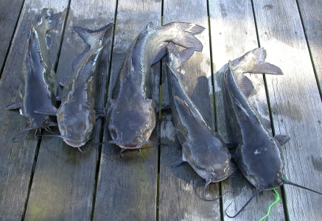

Activity #1:
Describe a penny
Qualitative | Quantitative

Activity #2:

Match the terms!!!

