Mixtures | Solutions | Compounds | Elements
Two or more substances mixed (put) together, but not chemically combined.  Homogeneous- looks the same  Ex. Milk, coffee  Heterogeneous- looks different  Ex. Ice cream sundae, soup, granite, salad  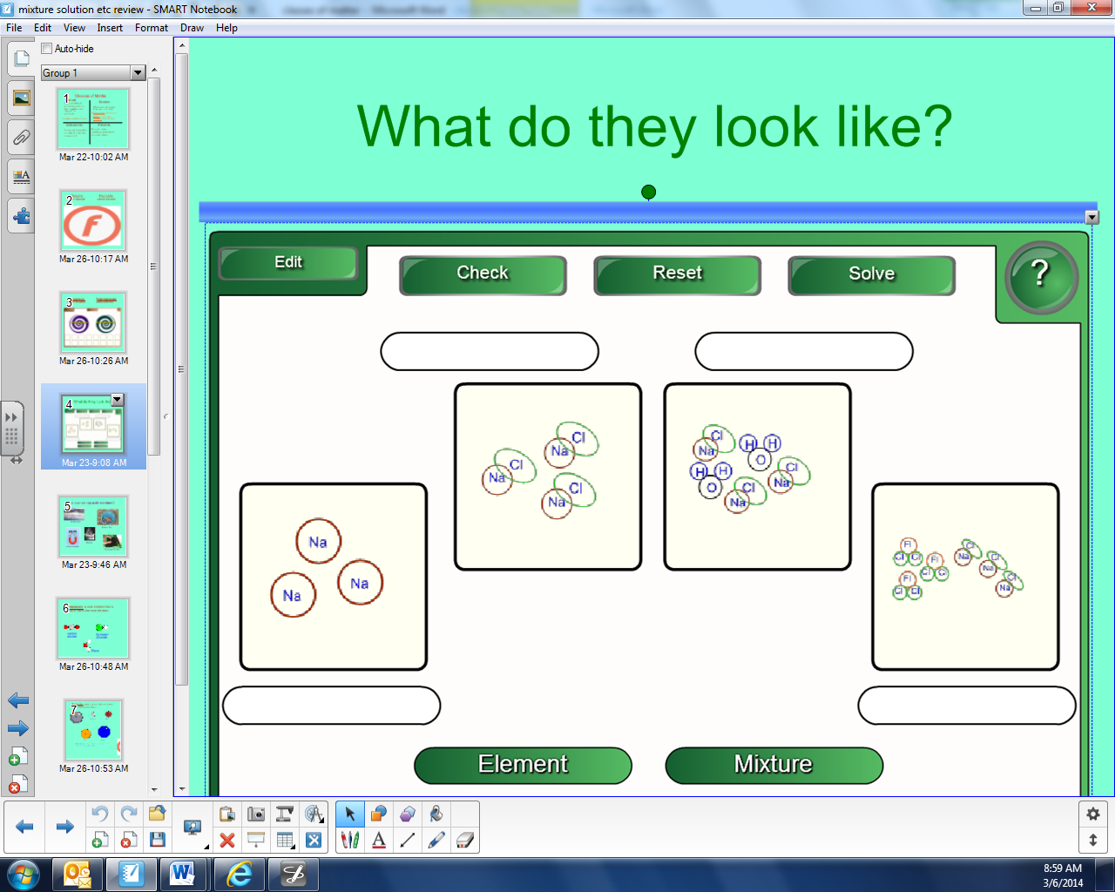 | A type of homogeneous mixture, where one substance dissolves in another.  Two parts:  - Solute- is dissolved  - Solvent- does the dissolving  Insoluble- will not dissolve in water | A pure substance made of more than one element.  Ex. Water- H2O  Salt- NaCl  - Can be broken down  - Made of molecules | Simplest pure substance made of one type of atom.
Most Complex --------------------------------------------------------------------------------------------------------------------------------------- Simplest

