Turnitin.com: Directions for Creating and/or Opening Your School Account
“I have never used TurnItIn at HenHud High School” – Step 1: Setting up Your Account
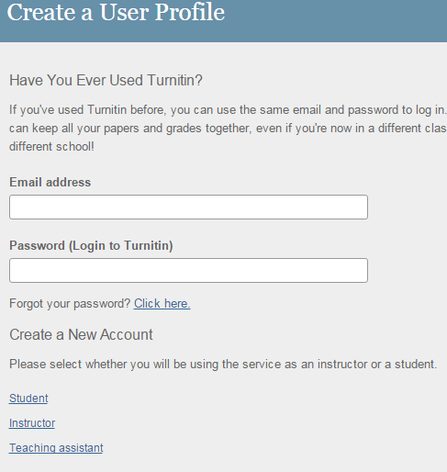
- Navigate to TurnItIn.com at http://www.turnitin.com.
- Select the Create account button in the top right corner.
- Select Student at the bottom of the dialog box.
- Enter the Course/class ID and enroll codes as provided by your teacher.
- Enter your first and last names. Capitalize first letters.
- Enter your school email address which is your username@students.henhudschools.org.
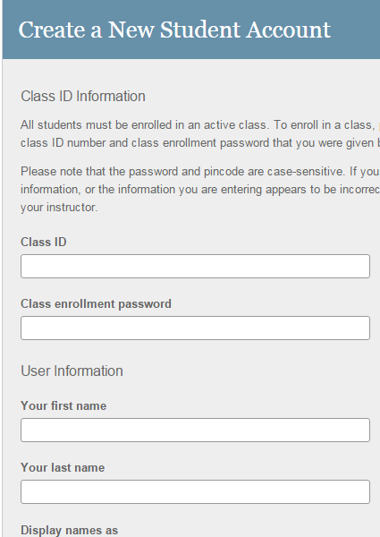
- Create and enter a password using the following convention. Your password is your eight number password with your first and last name initials. (example: 23452345TA) Record your password in a safe place from which you can retrieve it quickly and easily both at home and in school – throughout your high school career. Note: TurnItIn is case sensitive.
- Select a security question from the menu provided. Tip: Always choose a security question for which the answer is stable over time. Avoid using your favorite book/song/actor/musical group/movie as the answer to these questions will most likely change over time. Record your security response for future reference. Note: TurnItIn is case sensitive.
- Agree to the end user agreement. Sign in.
- Proceed to the section on Submitting an Assignment.

“I already have an active TurnItIn account at HenHud HS” – Step1: Setting up Your Account
- Log in to your TurnItIn account.
- Enroll in the class using the Course/Class ID and the enrollment code provided by the course teacher.
- Proceed to the section on Submitting an Assignment.

“I already created an account but it isn’t working” – Step 1: Setting up Your Account
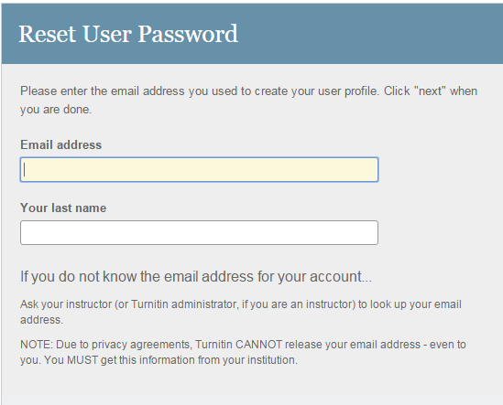
- This may happen if the account creation process was incomplete or if you have lost/forgotten your password. To check and fix the problem, use the Reset Your Password script.
- Log in to your SCHOOL Gmail account.
- Locate and open the email message from Turnitin.
- You will see both a link to Turnitin AND a temporary password.
- Right click to open a NEW tab in your browser. Navigate to http://www.Turnitin.com. Select Reset Password option on the Log In page.
- Enter your school email address. [It is your school GMAIL address.] Type in your Last name as requested.
- If you see the following message, your account was not created completely. Create a new account from scratch. The email/name combination you entered is not in our system. Please try again.
- If you are prompted to reset your password, remember the conventions and be sure to record the password in a safe and easy to retrieve location. Your password is your eight number password with your first and last name initials. (example: 23452345TA)
- Enter the course/class ID and the enrollment code as provided by the course teacher.
- Proceed to the section on Submitting an Assignment.
Step 2: Submitting an Assignment
- Navigate to http://www.turnitin.com
- Log in to your account (at the top right of the screen). Remember: your username is your school email address.
- Find your course/class period.
- Check that your first and last names are appearing correctly in the submission form.
- Enter a Submission Title. This is the title of your paper/presentation or assignment. It is not necessary to match the title on the “paper” itself.
- Click on the file source where you have saved the assignment. Select Google Drive or Dropbox or your My Documents. Browse to find your file. Upload/Submit the selected file.
- You will a preview of your submitted assignment. Remember that this is only a PORTION of your paper. The rest is there! Click Confirm under the box.
- You will see a Receipt if your “paper” was correctly submitted. Report any problems with the upload/submission.
- *If you want, return to the course page to view your paper. Click the originality button at the top of the screen/window.
- Interpreting the Originality results means seeing your “paper” on the left and the originality results on the right. Any highlighted portions of your paper that are highlighted (in pink) are attributed to another source. This includes quotations. Be sure that your quotations are identified in your paper through proper in text citations. Check assignment requirements for directions regarding use of quotations and citations.
Resubmitting and/or deleting an assignment
- Your teacher may enable the TurnItIn feature that permits resubmission of assignments. Check with your teacher regarding this option.
- On your course/class dashboard, locate the assignment that has already been submitted.
- Click on the Resubmit button.
- Note: You can override a mistake in your assignment, but you cannot delete anything.

