Meeker & Wright Special Education Cooperative
Early Intervention
Developmental History

The purpose of this form is to gather information on your observations about your child and issues that may affect your child’s development. Your ideas and information are an important part of the evaluation process and will be included in the Evaluation Summary Report. Answer as many items as you feel comfortable sharing.

Parent Information
Today’s Date: / /

Child’s Full Name: __________________________________________________________________
(First, Middle, Last)
Birthdate: / / □ Male □ Female
Address:
Street City State Zip
Phone(s) Home: Work: Cell:
Email address:________________________________________________________________________

Mother’s Name: Age:

Address if different from above:____________________ Occupation:__________ Education Level:___

Marital Status: Single Married Separated Divorced Widowed

Father’s Name: Age:

Address if different from above:___________________ Occupation:__________ Education Level:

Marital Status: Single Married Separated Divorced Widowed

Child’s Ethnicity/ Race:
Hispanic /Latino American Indian or Alaska Native Asian White / Caucasian Black / African American
Native Hawaiian or Other Pacific Islander

Child’s Primary Language spoken in the home:_____________________________________________

Does your child attend daycare? Yes No If yes, when?

Name of Provider: Phone:

Address:
Street City State Zip

Child’s Primary Physician or Pediatrician:

Doctor’s Name: Clinic/Hospital Name:

Address:
Street City State Zip

Phone: Fax:

Early Childhood Screening:
If over age 3, has your child participated in early childhood screening? Y / N
If yes, did your child pass the following?
Vision__Y/N Hearing__Y/N Developmental screening__Y/N Speech/language screening__Y/N

Medical Information

Has your child been evaluated by or received services from any of the following (check all that apply):

Physician Dental School Hearing Vision

Speech & Language Orthopedic Neurological Psychological University or Hospital/Clinic

Please list the provider of the services (if needed use separate page to list all,).

1. Name: Type of Service:

Address:

Phone: Fax: Date of Service:

2. Name: Type of Service:

Address:

Phone: Fax: Date of Service:

Has your child had any of the following illnesses or conditions?

Illness/Condition | Yes | No | Age | Treatment / Comments
Colic
Chronic Lung Conditions
Kidney Problems
Seizure Problems
Cytomegalovirus (CMV)
Meningitis/encephalitis (circle)
Severe Reaction to Immunizations
Scarlet Fever/Strep Infection (circle)
Frequent Colds
Ear Infect./Middle Ear Fluid (circle)
Sinus Infections
Tonsillitis/Bronchitis (circle)
Pneumonia/RSV (circle)
High Fevers
Allergies (include foods)
Growth Concerns
Exposure to Tuberculosis or Hepatitis
Head Injury (concussion/skull fracture)
Loss of Consciousness
Serious Accident/Poisoning (circle)
Other

Is your child currently on a long term medication? Yes No Type:

Has your child been hospitalized since birth? Yes No How many times?

Hospital Name Reason Age Length of Stay Dr.’s Name

Immunizations: Are all your child’s immunizations up to date? Yes No

PRENATAL HISTORY:

Pregnancy Condition | Yes | No | Months | Treatment
Nutritional Problems/Vomiting/Anemia (circle)
Bleeding/Spotting
Toxemia/High Blood Pressure/PreEclampsia (circle)
Accident/Injuries (circle)
Pre-Term Labor
Cigarettes/Alcohol/Drug Use (circle)
Medications
Ultrasound/X-rays (circle)
Amniocentesis/Chorionic Villus Sampling (CVS) (circle)
Rash, Measles, Mumps, Chicken Pox (circle)
Diabetes
Cytomegalovirus (CVM)
Rh Incompatibility
Seizures
Depression/Emotional Stress
Illness/Infection

Mother’s Age at Delivery: Month of pregnancy that prenatal care began:

BIRTH HISTORY:

Was your child adopted? Yes No If yes, at what age:

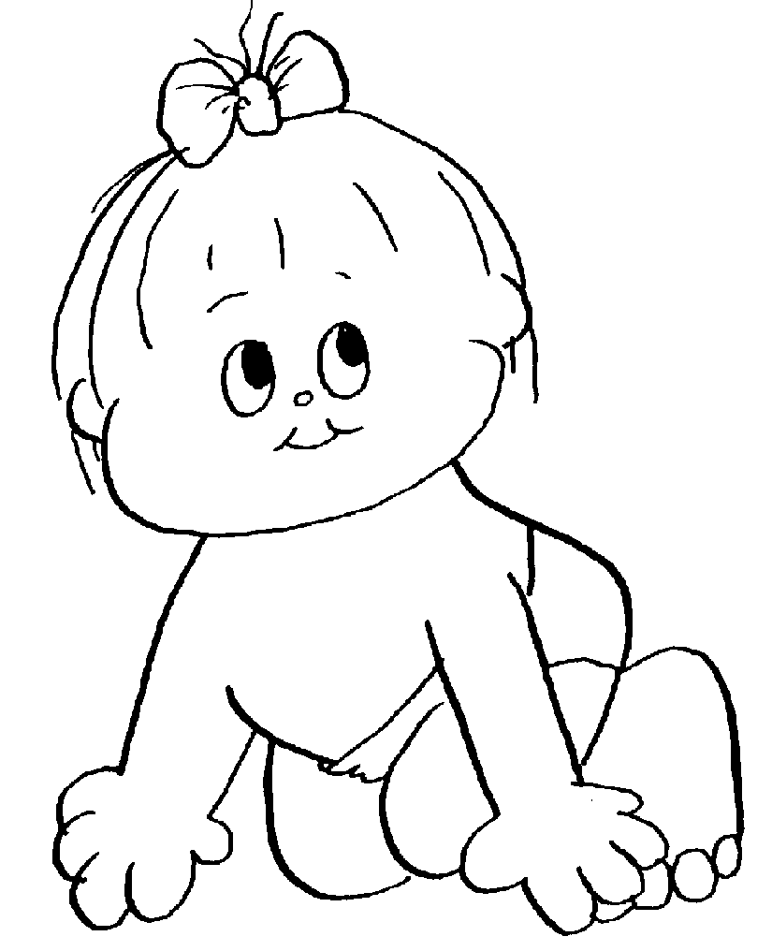
Length of pregnancy (# of weeks): Duration of labor:

Birth Weight. Birth Length. Head Circumference___________

How was your child delivered?:

Head First Breech (butt first) Footling (feet first) Caesarean
Yes No Was this a multiple birth?
Yes No Was oxygen required for baby?
Yes No Was the umbilical cord wrapped around the baby’s neck?
Yes No Did baby have difficulty with sucking or crying when first brought to mother?
Yes No Was labor induced? If yes, why?
Yes No Did baby go to an NICU? If yes, where?
Yes No Was baby on an apnea and/or heart rate monitor?

Did baby breathe on own? Immediately Delayed If delayed, how long?

NEONATAL HISTORY:

Did any of the following occur within the first 28 days of life? Please check all that apply.
Anemia Failure to thrive Chemical (withdrawal symptoms)
CMV Jaundice Cyanosis (turning blue)
HIV/AIDS Respiratory Difficulties Seizures/Convulsions
Excessive Wt. Loss Skin Problems (rashes) Transfusions
Fever Elimination Problems (diarrhea/constipation)
Infections (Types):
Physical Anomalies (Describe):
Other? (Describe):

Vision

Does your child exhibit any of the following:
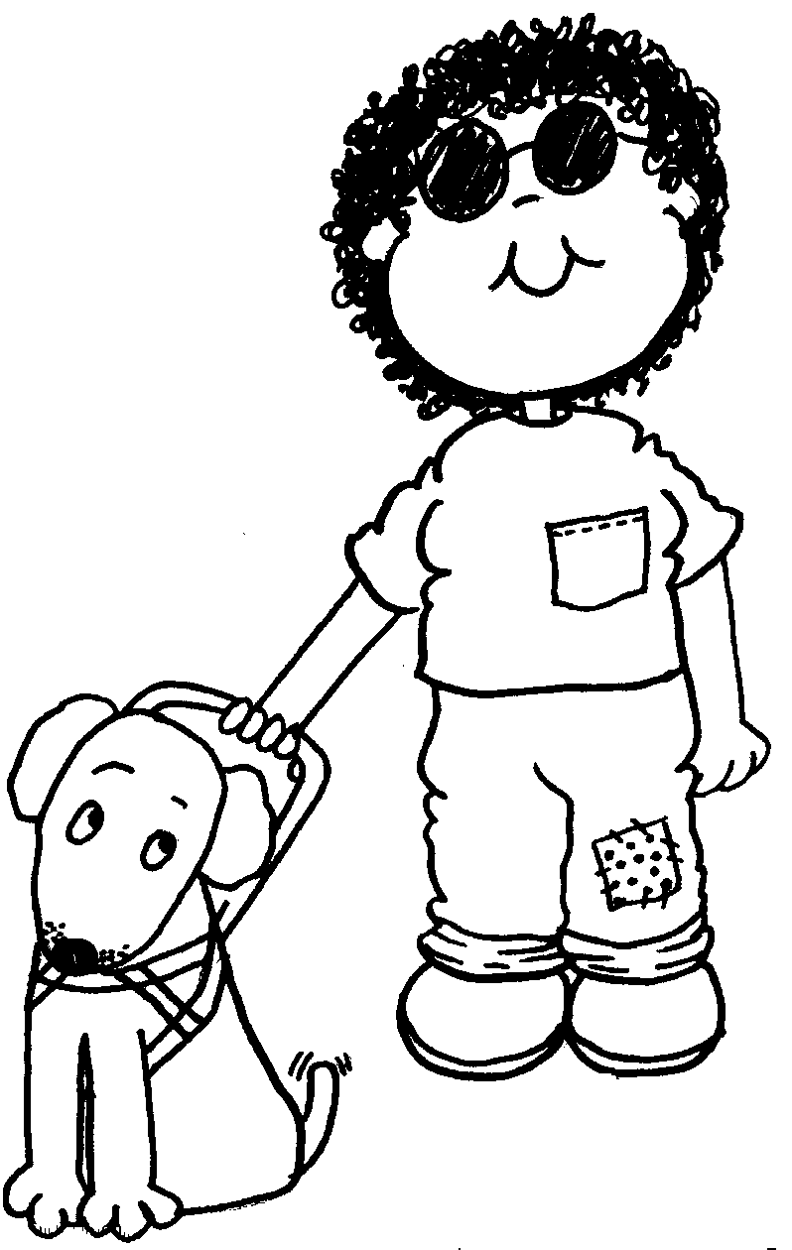
Redness / Watering
Rubbing
Squinting
Excessive staring
Eyes turn inward or out
Avoids eye contact
Hold objects close to eyes
Closes one eye when looking at objects
Show an unusual interest in mirrors/lights

Has your child ever had his/her vision tested? Yes No Date
Have glasses been prescribed for your child? Yes No
If yes, are they worn as prescribed? Yes No
Are you concerned about your child’s vision? Yes No

If yes, please describe:

Hearing

Please check all that apply:
Infection during pregnancy, or child had an infection when he/she was born (such as CMV, syphilis, German measles)
Changes in his/her head or face (such as no ear canal, cleft palate, etc.)
Your child has a medical syndrome (such as Down Syndrome).
Your child was given antibiotics known to cause hearing problems (example: Gentamicin, Vancomycin, etc.)
Your child had mumps or measles.
Your child has a progressive nervous system disease (such as neurofibromatosis, demyelinating disorder, etc.)
Your child did not pass his/her newborn hearing screening.

Does your child:
Startle at loud sounds? Yes No
Often need directions repeated in a louder voice? Yes No
Appear to be “deaf”, daydreaming or ignoring some sounds? Yes No
Seem to hear better on some days than on others? Yes No
Have difficulty hearing when he/she has a cold/earache? Yes No
Turn to find source of sound? Yes No
Watch your mouth or face intently when spoken to? Yes No
Respond consistently to voices or sounds? Yes No
Have tubes in his/her ears? Yes No
Have hearing aid(s) ever been prescribed? Yes No
Has your child had his/her ears checked by an audiologist? Yes No

Feeding Skills

Current Height / Length: Current Weight:

Eating Skills:
At what age did your child begin eating baby foods? Table foods?

Where there any difficulties making the transition between these foods? Yes No
If yes, please describe:
Does your child use his/her fingers, a spoon, or a fork to eat? Please describe

Does your child drink out of a bottle, sippy cup, or cup? Please describe

Does your child drool more than other children his/her age?
Has your child ever had difficulty gaining weight?

Does your child have any particular food preferences or dislikes? Please describe:

Is your child a picky eater? Please describe:

Does your child have food allergies? Please describe:

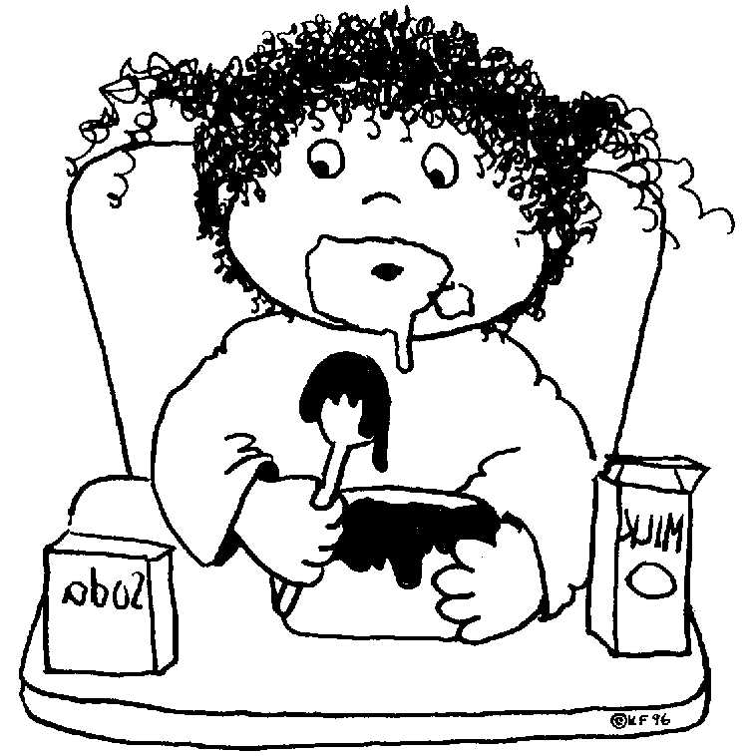
Does your child have any unusual cravings for things to eat or chew on?
Please describe:

Does your child have certain eating habits such as refusing to drink
from a transparent container, eating only hot (or cold) food,
eating only one or two foods, etc.? Please describe:

Has your child had any feeding difficulties? Please check each item that applies:
Difficulty sucking or nursing
Difficulty keeping tongue inside mouth
Takes an excessive amount of time to eat or drink
Regurgitates liquids or solids through the nose
Difficulty chewing or swallowing meats
Choking and/or gagging on certain foods

Describe any feeding challenges your child has experienced:

Speech & Language Development

Please indicate at what age your child began the following:
Coo/Babble Imitate sounds Imitate words
Say any single words Imitate Actions (i.e. clapping, give me 5, etc.)
Put 2-3 words together Speak in sentences

Please give examples of some of your child’s sounds, words, or phrases:

How does your child let you know his/her wants and needs?

Describe any concerns you have about your child’s speech and language

When did you first become concerned?

Does your child become frustrated when he/she is unable to communicate? Yes No
If yes, please describe:
What efforts does your child make when not understood by others?

How much of your child’s speech can you understand?

None 25% 50% 75% 100%

How much of your child’s speech can persons other than your immediate family understand?

None 25% 50% 75% 100%
Has your child’s speech development ever seemed to stop or regress for a time? □ Yes □ No
If yes, please describe:

Does your child use his/her index finger to point, to ask for something? Yes No
Dees your child use his/her index finger to point, to indicate interest in something? Yes No
Does your child bring objects over to you (parent) to show you something? Yes No
Does your child take an adult by the wrist to use adult’s hand to open a door, Yes No
get cookies, turn on the TV, ect.?

Does your child (check all that apply):
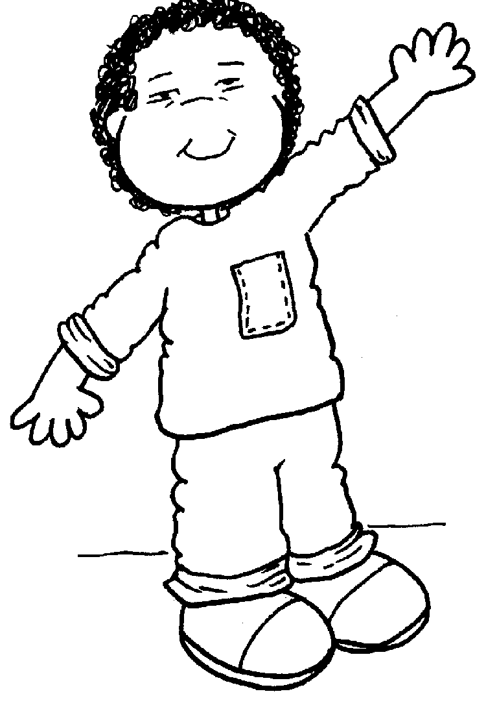
Responds to voices
Responds to his/her name
Points to objects / pictures when named
Understands most of what is said to him/her
Looks up at people (meets their eyes) when they are talking to him/her
Repeats phrases or sentences heard in the past that have little or no
relationship to the current situation

What directions does your child follow? Please give examples:

Motor Skills

MOTOR DEVELOPMENT:
At what age did your child do the following:
Hold his/her head up ________ Reach with arms to be picked up ________
Reach and grasp a toy ________ Roll over ________
Sit alone ________ Pull to stand by self ________
Crawl on hands and knees ________ Walk unassisted ________
Undress self ________

GROSS MOTOR: (large muscle)

Is your child able to independently walk up and down stairs? Yes / No
Does your child place one foot on each step/ two feet per step / hold the rail? (circle what applies)
Is your child able to catch a ball gently tossed? Yes / No
Is your child able to throw a ball with good aim towards a person? Yes / No

Does your child move a small riding toy using feet? Yes / No
Does your child independently pedal a trike? Yes / No
Does your child’s muscle tone seem unusually rigid (stiff) or floppy? Yes / No
If yes, please describe:______________________________________________

Do you have any concerns about your child’s ability to move around? Yes / No
If yes, please describe:______________________________________________

FINE MOTOR: (small muscle)

As an infant or toddler, does your child…….
Keep hands primarily open? Yes / No
Use both hands together? Yes / No
Move objects from one hand to the other? Yes / No
Use the thumb and pointer finger to pick up small items / food pieces? Yes / No
Scribble with a crayon or marker? Yes / No
Use one hand to hold and the other to play with a toy? Yes / No
Snip paper with scissors? Yes / No
Imitate vertical and circular scribbles? Yes / No
Stack at least 3 blocks on top of each other? Yes / No
Hold a crayon with fingers and not the fist? Yes / No

As a preschooler, does your child……
Use one hand to hold a paper and the other to color or cut? Yes / No
Cut on straight and curved lines on paper? Yes / No
Reach across the middle of the body from one side to the other without twisting the trunk? Yes / No
Show a dominant hand preference? Yes / No
Write the letters in their first name? Yes / No
Hold a pencil or crayon like an adult? Yes / No
Have you noticed any unusual trembling while your child is using his hands to play or eat? Yes / No If yes, please describe: ____________________________________________________________

Social/Emotional Development

Social History:
Check all of the following which best describe your child:
Quiet Cooperative Calm Happy
Sensitive Aggressive Shy Uncooperative
Moody Active Talkative Creative
Withdrawn Fussy Independent Easily angered
Other

How does your child respond to your attention? Please check all that apply:
Cuddles Reserved Doesn’t respond Avoids/runs away
Shows affection Withdraws Clings excessively
Other, Please describe:

Check all of the following which your child exhibits:
Short attention span Seeks attention Starts fights Nail biting
Thumb sucking Won’t leave mother Stutters Teases
Nightmares Sleep difficulties Temper tantrums Destructiveness
Other, Please describe:

Does your child have any unusual fears or behaviors? If yes, please describe:

Does your child have a “fussy” time? No Yes If yes, when?

How do you handle it?

What makes your child angry or upset?

How does your child usually react to being interrupted at what he/she is doing?

Rarely or never gets upset Sometimes gets mildly upset, rarely very upset Typically gets very upset

For children ages 3-5:
Does your child hit, pinch, bite or otherwise injure himself/herself or others more than usual?
Yes, self only Yes, others only
Yes, self and others No (not a problem)

Describe the methods of discipline you use with your child. What works best? What’s the most difficult?

Play Skills

Which of the following describes the type of play your child likes to engage in most often?
Putting toys in mouth Looking at books
Throwing toys Uses one object for another
Pushing/pulling toys Appropriate use of objects
Banging toys together Acting out familiar routines
Peek-a-boo/Hide-and-seek Role-playing / pretend play
Shaking toys Games with rules
Rough and tumble play

Which activities seem to hold your child’s attention for the longest period of time?

Is your child’s play easily distracted by any of the following?
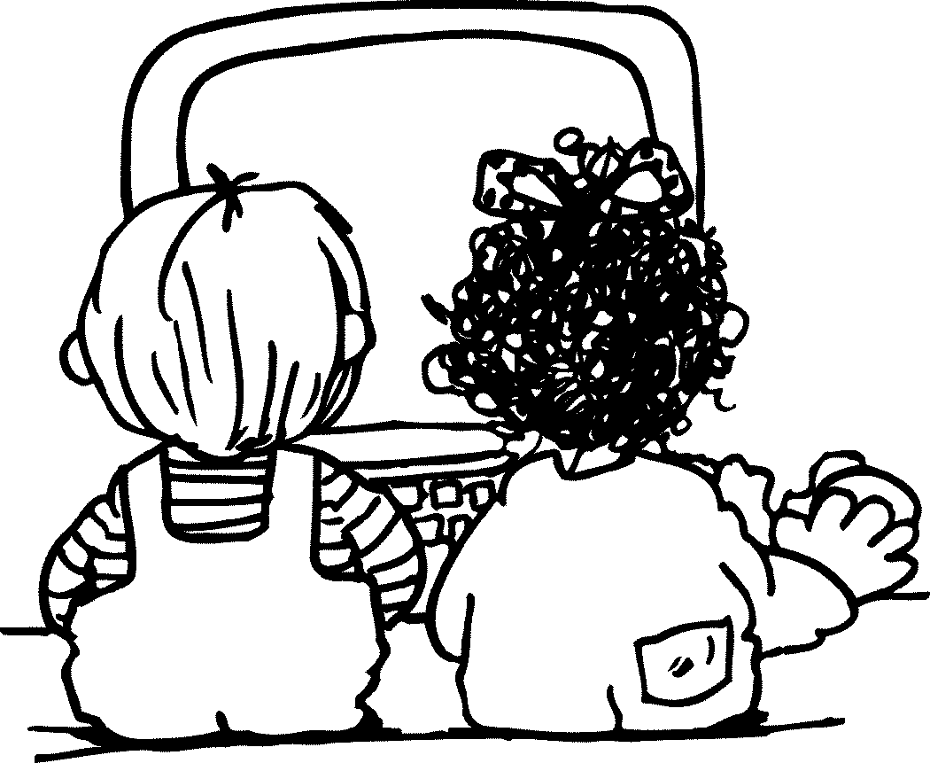
Nearby activities
Other people in the room
Visual stimuli (i.e., other toys or objects)
Auditory stimuli (i.e., voices, sounds outside, the TV)

Does your child take an interest in other children? No Yes

How much opportunity does your child have to play with other children the same age?

How does your child get along with his/her siblings?

Self Help Skills

How does your child participate in dressing / undressing?
Describe your child’s toileting skills:
Describe ways your child may be helpful around the house: __________________________________
Give a general description of your child’s day: _____________________________________________ ___________________________________________________________________________________Does your child sleep through the night? ___________
Does your child sleep in his/her own bed? __________
Generally, what time does your child:
wake up ______________ nap______________ go to bed______________

Sensory System

VESTIBULAR: (body movement through space)
Does/did your child:
Fall or trip often Yes No
Lose balance easily Yes No
Like to rock, swing or spin excessively Yes No
Have head-neck-shoulder rigidity Yes No
Resist movement activities Yes No
Bump into objects Yes No
Use one hand for two-handed activities Yes No

Other:
Comments:

PROPRIOCEPTIVE: (awareness of body position)
Does/did your child:
Flap hands, stamp, clap, jump to unusual degree Yes No
Toe-walk Yes No
Climb in inappropriate places Yes No
Bang head Yes No
Grind/clench teeth Yes No
Exhibit clumsy/awkward movements Yes No
Have difficulty positioning self on furniture Yes No
Become physically rough with others/objects Yes No

Other:
Comments:

TACTILE/TOUCH:
Does/did your child:
Become irritated or avoid certain clothing Yes No
Show sensitivity to certain textures/temperatures Yes No
Over/under react to mild pain Yes No
Resist bathing, brushing teeth, haircuts Yes No
Exhibit clingy behavior Yes No
Show discomfort when approached/touched Yes No
Insist on large personal space Yes No

Other:
Comments:

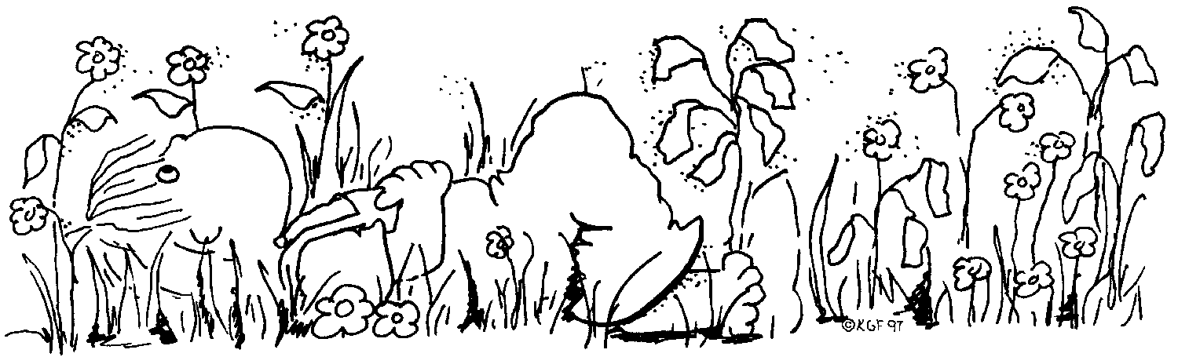
This Developmental History was compiled from a variety of sources, most of them informal samples from various districts. No intent was made to directly copy from another, but to take relevant questions and group them accordingly. The sole purpose is to gather accurate information on young children referred for a special education evaluation. The information will be summarized in the Evaluation Summary Report and remain part of the child’s special education record.

12-1-10
Revised by Meeker & Wright Special Education Cooperative in
conjunction with Little Crow Special Education Cooperative
and their 2002 revisions

